The evolution of signalling systems in animals: insights from vision and chemokines

Thesis submitted for the degree of Doctor of Philosophy at The University of Leicester

By

Alessandra Aleotti

Department of Genetics and Genome Biology

College of Life Sciences

University of Leicester

October 2023

### Abstract

Try to summarize key findings for the three main chapters..

### Acknowledgements

I would like to thank my supervisors: Roberto Feuda for allowing me to conduct my PhD project in his research group and for introducing me to phylogenetics and bioinformatics; and Flaviano Giorgini for his support and for providing useful inputs both scientifically and professionally.

I am extremely grateful to have been accompanied throughout these four years by awesome fellow PhD students. ‘’lunch breaks, parties, international dinners, games nights etc

I would like to thank particularly my little “siblings” Clifton, Matt, Julien, DaeNia and Frannie....

I would like to acknowledge my family and close friends for their encouragement throughout the years. Particularly my parents that have always gone above and beyond to support me.

### Table of Contents

Abstract i

Acknowledgements ii

Table of Contents iii

List of Figures vi

List of Tables vii

Chapter 1 1

General Introduction 1

General Introduction 2

The origin of multicellularity: a major evolutionary transition 2

Expansion of signal transduction systems in animals 3

General Aims of the Thesis 6

The origin and evolution of vision in animals 6

Aim 1: Reconstructing the evolution of the molecular components of photoreceptor cells. 8

Aim 2: Reconstructing the evolution of the retinol metabolism. 8

Evolution and molecular diversity of chemokine signalling systems. 8

Aim 1: Uncovering the relationships among canonical and non-canonical components. 9

Aim 2: Reconstructing the evolution of all canonical and non-canonical ligands. 9

Aim 3: Reconstructing the evolution of all canonical and non-canonical receptors. 10

References 11

Chapter 2 18

General Methods 18

General Methods 19

Phylogenetic analyses 19

Dataset preparation 19

Obtaining starting queries 19

Choice of species 20

Phylogenetic analyses 21

Initial sequence similarity-based data mining 21

Optimisation of final gene family datasets 22

Annotating Sequences 22

Multiple sequence alignment and trimming 23

Inferring phylogenetic trees for each gene family 23

Species trees 24

Gene tree to species tree reconciliation 25

Analyses of single-cell sequencing data 25

Preliminary steps 26

Choice of species and obtaining datasets 26

Clustering cells into “metacells” 26

Identifying photoreceptor cells and cross species comparisons 27

Identification of candidates PRCs 27

Exploration of the regulatory genes expressed in candidate PRCs 27

Comparisons across species 27

References 28

Chapter 4 32

The Evolution of Retinol Metabolism and Implications for the Origin of Vision 32

Abstract 33

Introduction 34

Results and Discussion 38

Enzymes involved in retinol metabolism belong to 12 major orthogroups. 38

Reconstructing phylogenetic histories of retinol metabolism orthogroups. 43

RETSAT 43

PNPLA4 45

ALDH1 47

BCMO1/RPE65 49

LRAT 51

RDH/DHRS 53

DGAT1 56

DGAT2LA4 58

CYP 60

AOX 62

ADH 64

UGT 66

Conclusions 68

Methods 72

Identification of orthogroups for retinol metabolism enzymes. 72

Species list and species tree 72

Data mining 73

Orthogroup inference 73

OrthoFinder 73

Broccoli 73

Filtering and annotation of orthogroups 74

Comparison of OrthoFinder and Broccoli results and definition of final orthogroups 74

Reconstructing the evolutionary history for each orthogroup. 75

Phylogenetic Trees 75

Identifying clusters of orthologs with Possvm 75

Reconstructing evolutionary events with GeneRax 75

Data Availability 77

Acknowledgements 77

References 77

### List of Figures

**Figure 4.1. Retinol metabolism pathway.** The pathway used as reference in this study is based on the KEGG map00830 (Kanehisa et al. 2021). 35

### List of Tables

**No table of figures entries found.**

# Chapter 1

## General Introduction

### General Introduction

#### The origin of multicellularity: a major evolutionary transition

The astonishing diversity of life on Earth showcases the profound impact of evolution over billions of years. Underpinning the complexity of life forms are major evolutionary transitions, landmark events which have drastically shaped the trajectory of life and paved the way for the rich biodiversity we observe today (Smith and Szathmary 1997). Major evolutionary transitions include for instance the origin of eukaryotes from the merging of an archaeal host and a bacterial endosymbiont (McInerney et al. 2015; Zaremba-Niedzwiedzka et al. 2017; Donoghue et al. 2023) and the emergence of multicellularity (Ruiz-Trillo and Nedelcu 2015). Multicellularity has arisen several times independently in various eukaryotic lineages resulting in a diverse set of complex multicellular organisms, including brown algae, red algae, green algae and land plants, fungi, and animals (Ruiz-Trillo and Nedelcu 2015). The characteristics of the ancestral unicellular eukaryote and the mechanisms driving the emergence of multicellularity vary between lineages and remain subjects of ongoing research (Ruiz-Trillo and Nedelcu 2015).

The origin of animals through multicellularity has seen various hypotheses, each centred around the nature of the unicellular ancestor. This has been recently reviewed by Brunet and King (Brunet and King 2022) and is here summarized. Prior to the establishment of molecular phylogenies, proposed ancestral lineages spanned a range from amoebozoans (Haeckel 1876) to choanoflagellates (Metchnikoff 1886) and ciliates (Saville-Kent 1882). This lack of consensus throughout the 19th and 20th centuries, was amplified by both technical and conceptual limitations. A notable point of contention was the debate over animal monophyly. Some researchers questioned the relatedness of sponges to other animals, postulating the possibility of distinct ancestors for sponges (choanoflagellates) and the remainder of animals (ciliates) (Saville-Kent 1882). Contemporary molecular phylogenies unequivocally support the monophyly of animals and choanoflagellates as their sister group, together forming the clade Choanozoa, within the broader Holozoan clade (Wainright et al. 1993; Lang et al. 2002; Ruiz-Trillo et al. 2008). Choanozoa is corroborated by morphological and biochemical evidence: the collar complex surrounding the flagellum, a defining feature of choanoflagellates, is not only found in sponge choanocytes but across various animals and is composed of cytoskeletal filaments that are homologous among choanoflagellates, sponges, and other animals (Nerrevang and Wingstrand 1970; Lyons 1973; Rieger 1976; Brunet and King 2017; Colgren and Nichols 2020). While the choanoflagellate-like ancestor hypotheses is now the most widely accepted, the specific mechanisms behind the evolution of animals from such an ancestor remain to be clarified. Theories have revolved around the two hypotheses of aggregative and clonal multicellularity, with the latter currently gaining wider acceptance (Brunet and King 2017). However, a recent theory posits that the mutual ancestor of animals and choanoflagellates presented a complex life-cycle, including transitions between amoeboid and flagellate phenotypes, similar to the cell types present in modern sponges (Arendt et al. 2015; Brunet and King 2017; Brunet et al. 2021; Brunet and King 2022). These alternative phenotypes were temporally segregated into different cells in the ancestor, however, following a process of clonal multicellularity these different phenotypes became spatially rather than temporally segregated. This combined with division of labour and innovation lead to the evolution of animals (Brunet and King 2017). The notion that living choanoflagellates present multiple phenotypes including sessile, swimming, and colonial forms, plus the fact that other closely related holozoans such as ichthyosporeans and filastereans also assume diverse cellular forms (Suga and Ruiz-Trillo 2013; Hehenberger et al. 2017; Parra-Acero et al. 2018; Brunet et al. 2019; Parra-Acero et al. 2020; Tikhonenkov, Hehenberger, et al. 2020; Tikhonenkov, Mikhailov, et al. 2020), support this line of investigation, that is currently topic of active research, driven by the emergence of holozoans as model organisms (Booth and King 2022).

#### Expansion of signal transduction systems in animals

Regardless of the precise mechanisms behind the origin of multicellularity in animals, this major transition has had profound implications. Obligate multicellular organisms such as animals must interact with the environment as a whole entity rather than as individual cells and this requires complex mechanisms for internal communication and coordination amongst cells. Consequently, cells must undergo subspecialisations for different tasks, whilst contemporarily maintaining the ability to collaborate with each other (Ruiz-Trillo et al. 2007). Ultimately this paved the way for the vast diversity of animal forms, ranging from relatively simple to extremely complex organisms with intricate systems for self-coordination and interaction with the non-self, such as the nervous and immune systems (Bich et al. 2019; Jékely 2021; Jékely et al. 2021).

From a genetic perspective, we expect the emergence of novel genes to accompany the evolution of animals in response to these new challenges. Indeed, research into genes originating at the stem of metazoa point towards an increase in new genes for nucleic acid binding molecules, transcription factors and molecules involved in cell signalling (Paps and Holland 2018). Cell signalling plays a pivotal role in facilitating biological processes requiring communication amongst cells. Typically, it involves chemical messages or ligands—either endogenous or exogenous—that engage cellular receptors. This activation triggers a sequence of intracellular events, the signal transduction, involving second messengers and various effectors (Foreman et al. 2010). Ultimately, this allows cells to detect and react to extracellular cues either deriving from other cells, like hormones, neurotransmitters, and neuropeptides, or from external stimuli such as light (Elphick et al. 2018; Moroz et al. 2021; Oteiza and Baldwin 2021). There are many different types of receptors that generally fall within the categories of ligand-gated ion channels, enzyme linked receptors, G-protein-coupled receptors (GPCRs) and even intracellular receptors (Foreman et al. 2010). GPCRs, in particular, play a key role in numerous signalling pathways in animals, from neural communication, light reception and other sensory systems and immunity. Given the importance of cell signalling for animals, it is not surprising that one of the categories of gene families that was found to have significant emergence of new genes in the stem of metazoa is signalling molecules (Paps and Holland 2018). Additionally, even when there has not been a *de novo* origin of novel genes, there can be expansions within existing gene families effectively introducing novel genes that are often associated with new functions. This seems to have been the case for GPCR receptors. GPCR signalling is ancient, being present throughout eukaryotes, however, a huge expansion of this gene family occurs in animals. This is not seen neither in close relatives of animals nor in other multicellular organisms (e.g., plants have a comparatively limited set of GPCRs) (de Mendoza et al. 2014). This dramatic increase of GPCRs in animals is likely linked to their heightened need for rapid responsiveness to their environment.

Given the centrality of these receptors in orchestrating myriad biological processes, they have long been a primary subject of research, with a particular focus in deciphering their evolution to gain insights into the fundamental biological processes that they govern (Fredriksson et al. 2003; Foster et al. 2019). Understanding the evolution of these molecules, sheds light on animal evolution, especially during its early stages when critical adaptations were likely to have occurred following the transition to the novel multicellular lifestyle. Similarly, unravelling the evolutionary histories of other molecules involved in GPCR signalling, such as the second messengers and effectors, is also important in understanding the evolution of cell signalling in animals.

### General Aims of the Thesis

During my PhD, I was interested in investigating the evolution of signalling systems in animals. For this, I focused my attention on two different biological processes that rely on signal transduction systems. The first is vision, a widespread phenomenon in animals fundamental for the response to external light stimuli (Land and Nilsson 2012). The second is chemokine signalling, best known for its role in immunity but also involved in other physiological and developmental processes that require internal organismal communication (Murphy 2023). Each presented unique challenges but were both primarily addressed with phylogenetic methods and in some cases with additional bioinformatic approaches such as single cell sequencing analyses. In this short General Introduction, I will delineate the basic background and aims for both systems studied. In the next chapter, General Methods, I will introduce the basics of the methodologies used. Further details about both the background and the methodologies are then provided in the respective chapters.

#### The origin and evolution of vision in animals

Vision is an example of a sensory system that functions through GPCR signalling. It is a quintessential feature of animals, deeply influencing their ecology and behaviour (Nilsson 2009). At its core, vision consists of a photo-sensitive molecule coupled to a signal transduction machinery within a highly specialised photoreceptor cell. The photo-sensitive molecule is an opsin, a GPCR of class A, bound to a derivative of vitamin A, the retinal (Terakita 2005). When the retinal is hit by light it changes conformation (from 11-cis to all-trans), inducing a structural change of the opsin which in turn triggers the G alpha protein it is coupled with activating a signal transduction pathway called phototransduction. There are two major types of phototransduction, rhabdomeric and ciliary, depending on the type of opsins that initiate them, but both culminate in the modulation of ion channels initiating electrical signalling of the photoreceptor cell (Hardie and Juusola 2015; Lamb 2020).

Photoreceptor cells (PRCs) are classified based on the type of opsins and phototransduction pathway employed (Arendt 2003). A general peculiarity of PRCs is the enlargement and folding of the membrane surface to increase the area with the photopigment and therefore enhance light sensitivity. This characteristic membrane folding is present within the cilia of ciliary PRCs of vertebrates, while in rhabdomeric PRCs of insects such as *Drosophila melanogaster* this folding is in the apical surface of the cell forming the rhabdomere (Arendt 2003). Historically, these morphological differences dictated PRC classification. It was believed that rhabdomeric PRCs were characteristic of the protostome (e.g. insects) lineage of Bilateria, while ciliary PRCs were specific to deuterostomes, including vertebrates (Eakin 1979). However, it is now known that ciliary PRCs are present within protostomes (Arendt et al. 2004; Passamaneck et al. 2011; von Döhren and Bartolomaeus 2018) and rhabdomeric PRCs within deuterostomes (Hattar et al. 2002; Ullrich-Lüter et al. 2011). Therefore, molecular definitions offer a more accurate classification, especially for non-bilaterian animals. While complex visual structures, such as eyes, are believed to have evolved independently on multiple occasions (Land and Nilsson 2012; Picciani et al. 2018), their fundamental units—photoreceptor cells—stem from a limited number of subtypes that may share a common ancestral cell type. This suggests that, despite variations in phototransduction machinery, there may exist a core set of regulatory genes defining this broad cell type (Arendt 2008; Arendt et al. 2016), consistent across all animal photoreceptor cells.

Beyond the phototransduction machinery and photoreceptor cells, vision encompasses another layer of molecular complexity. After the retinal is isomerized from it cis to its trans state by light, it must return to its cis state in order to be receptive to new light stimuli. This recycling occurs through a series of enzymatic reactions occurring as part of the retinol metabolism (Palczewski and Kiser 2020). As the opsin alone cannot carry out the visual function, this pathway that allows constant replenishment of the cis-retinal is just as essential part of the molecular assembly of vision.

Photoreceptor cells are present even in some early-branching animals, such as cnidarians (Nordström et al. 2003; Kozmik et al. 2008; Picciani et al. 2018) and potentially ctenophores (Horridge 1964; Jékely et al. 2015; Tamm 2016), suggesting that vision must have originated early in animal evolution. Some molecular components underpinning it, such as core signal transduction elements, likely trace back more anciently, while others, such as the regulatory genes involved in photoreceptor cell identity, may be animal innovations. Unravelling the evolutionary history of all these molecular players, identifying key innovations and major family expansions, can not only elucidate the emergence of vision but also enrich our understanding of animal evolution more broadly.

Numerous studies have delved into the evolution of opsins, illuminating the vast diversity of these molecules across animals, including non-bilaterians (Feuda et al. 2012; Feuda et al. 2014; D’Aniello et al. 2015; Roberts et al. 2022; De Vivo et al. 2023; McCulloch et al. 2023). Such research has led to significant discoveries, including the identification of phylogenetically related placopsins in placozoans, a non-bilaterian phylum lacking neurons (Feuda et al. 2012). Nevertheless, comprehensive investigations into the evolution of all molecular components involved in vision remain sparse. Thus, one of my PhD goals was to fill in some of these gaps by investigating the evolution of the complex molecular assembly of vision. For this, I identified two main aims:

##### Aim 1: Reconstructing the evolution of the molecular components of photoreceptor cells.

The first aim is to understand the evolution of the molecular setup of photoreceptor cells, including both the phototransduction machinery and the regulatory toolkit that define the cell type. The objectives of aim 1 are addressed in Chapter 3.

##### Aim 2: Reconstructing the evolution of the retinol metabolism.

The second major aim is to investigate the evolution of the retinol metabolism that includes enzymes involved in the recovery of the cis-retinal, discerning whether specific components may have undergone distinct evolutionary events in animals. Aim 2 is addressed in Chapter 4.

#### Evolution and molecular diversity of chemokine signalling systems.

The immune system exemplifies an organism-wide system necessitating cellular coordination to detect and counteract external invaders. Present across the animal kingdom, immune systems function through an intricate range of subsystems (Yuan et al. 2014). In vertebrates, the chemokine signalling system plays a fundamental role in both innate and adaptive immunity (Murphy 2023). Best known for the chemoattraction of leukocytes during host defence (Wong and Fish 2003; Blanchet et al. 2012); chemokine signalling is also implicated in homeostasis, development (Zlotnik and Yoshie 2000; Tran and Miller 2003; López-Cotarelo et al. 2017), and neuronal communication (Tran and Miller 2003; de Haas et al. 2007; Rostène et al. 2007). Failure of the system can lead to various diseases (Tran and Miller 2003; Blanchet et al. 2012), including cancer (Nagarsheth et al. 2017).

The chemokine system comprises two primary components: the chemokine ligands, small cytokines possessing chemotactic attributes, and the chemokine receptors, Class A GPCRs. Canonical chemokine ligands possess in their N-terminal portion characteristic cysteine patterns that can be used to classify them into subgroups. Canonical chemokine receptors are in turn classified based on the type of ligands they respond to, although there tends to be a high degree of promiscuity in the system (Zlotnik and Yoshie 2000; Nomiyama et al. 2011). Additionally, several other molecules have been implicated in the system. For example, ligands bearing varying degrees of sequence similarity to canonical chemokines have been found to activate some canonical receptors and/or have chemotactic properties (Zhang et al. 2018). Conversely, some so-called atypical chemokine receptors can bind canonical ligands, but do not trigger the signal transduction pathway necessary for chemokine function (Bonecchi and Graham 2016; Chen et al. 2018). Therefore, these additional players can be considered as “non-canonical” chemokine components. Yet, their relationship with the canonical components and amongst each other is unclear, hampering our understanding of the origin and evolution of the system. Applying evolutionary approaches can aid in clarifying the relatedness of these molecules and ultimately help clarify the evolution of the whole system. Thus, the second goal of my PhD was to explore the evolution of the chemokine system including both its canonical and non-canonical components. For this, three main aims were identified:

##### Aim 1: Uncovering the relationships among canonical and non-canonical components.

The first aim was to investigate the evolutionary relationships among all chemokine ligands and amongst all receptors, including all known canonical and non-canonical molecules. This served as a first step for subsequent phylogenetic analyses.

##### Aim 2: Reconstructing the evolution of all canonical and non-canonical ligands.

The following aim was to perform phylogenetic analyses for each ligand family identified to discern their evolution in animals.

##### Aim 3: Reconstructing the evolution of all canonical and non-canonical receptors.

Similarly, the last aim was to understand the evolutionary history of receptor groups.

The work addressing these aims is detailed in Chapter 5 and was carried out in collaboration with other members of the Feuda Group.

### References

Arendt D. 2003. Evolution of eyes and photoreceptor cell types. *Int J Dev Biol* 47:563–571.

Arendt D. 2008. The evolution of cell types in animals: emerging principles from molecular studies. *Nat Rev Genet* [Internet] 9:868–882. Available from: https://www.nature.com/articles/nrg2416

Arendt D, Benito-Gutierrez E, Brunet T, Marlow H. 2015. Gastric pouches and the mucociliary sole: setting the stage for nervous system evolution. *Philosophical Transactions of the Royal Society B: Biological Sciences* [Internet] 370:20150286. Available from: https://royalsocietypublishing.org/doi/full/10.1098/rstb.2015.0286

Arendt D, Musser JM, Baker CVH, Bergman A, Cepko C, Erwin DH, Pavlicev M, Schlosser G, Widder S, Laubichler MD, et al. 2016. The origin and evolution of cell types. *Nat Rev Genet* 17:744–757.

Arendt D, Tessmar-Raible K, Snyman H, Dorresteijn AW, Wittbrodt J. 2004. Ciliary photoreceptors with a vertebrate-type opsin in an invertebrate brain. *Science* 306:869–871.

Bich L, Pradeu T, Moreau J-F. 2019. Understanding Multicellularity: The Functional Organization of the Intercellular Space. *Frontiers in Physiology* [Internet] 10. Available from: https://www.frontiersin.org/articles/10.3389/fphys.2019.01170

Blanchet X, Langer M, Weber C, Koenen R, von Hundelshausen P. 2012. Touch of Chemokines. *Frontiers in Immunology* [Internet] 3:175. Available from: https://www.frontiersin.org/article/10.3389/fimmu.2012.00175

Bonecchi R, Graham GJ. 2016. Atypical Chemokine Receptors and Their Roles in the Resolution of the Inflammatory Response. *Frontiers in Immunology* [Internet] 7:224. Available from: https://www.frontiersin.org/article/10.3389/fimmu.2016.00224

Booth DS, King N. 2022. Chapter Three - The history of Salpingoeca rosetta as a model for reconstructing animal origins. In: Goldstein B, Srivastava M, editors. Current Topics in Developmental Biology. Vol. 147. Emerging Model Systems in Developmental Biology. Academic Press. p. 73–91. Available from: https://www.sciencedirect.com/science/article/pii/S0070215322000011

Brunet T, Albert M, Roman W, Coyle MC, Spitzer DC, King N. 2021. A flagellate-to-amoeboid switch in the closest living relatives of animals.Wittkopp PJ, Ruiz-Trillo I, López-García P, editors. *eLife* [Internet] 10:e61037. Available from: https://doi.org/10.7554/eLife.61037

Brunet T, King N. 2017. The Origin of Animal Multicellularity and Cell Differentiation. *Developmental Cell* [Internet] 43:124–140. Available from: https://www.cell.com/developmental-cell/abstract/S1534-5807(17)30769-4

Brunet T, King N. 2022. The Single-Celled Ancestors of Animals: A History of Hypotheses. In: The Evolution of Multicellularity. CRC Press.

Brunet T, Larson BT, Linden TA, Vermeij MJA, McDonald K, King N. 2019. Light-regulated collective contractility in a multicellular choanoflagellate. *Science* [Internet] 366:326–334. Available from: https://www.science.org/doi/full/10.1126/science.aay2346

Chen K, Bao Z, Tang P, Gong W, Yoshimura T, Wang JM. 2018. Chemokines in homeostasis and diseases. *Cell Mol Immunol* [Internet] 15:324–334. Available from: https://www.nature.com/articles/cmi2017134

Colgren J, Nichols SA. 2020. The significance of sponges for comparative studies of developmental evolution. *WIREs Developmental Biology* [Internet] 9:e359. Available from: https://wires.onlinelibrary.wiley.com/doi/abs/10.1002/wdev.359

D’Aniello S, Delroisse J, Valero-Gracia A, Lowe EK, Byrne M, Cannon JT, Halanych KM, Elphick MR, Mallefet J, Kaul-Strehlow S, et al. 2015. Opsin evolution in the Ambulacraria. *Marine Genomics* [Internet] 24:177–183. Available from: https://www.sciencedirect.com/science/article/pii/S1874778715300349

De Vivo G, Crocetta F, Ferretti M, Feuda R, D’Aniello S. 2023. Duplication and Losses of Opsin Genes in Lophotrochozoan Evolution. *Molecular Biology and Evolution* [Internet] 40:msad066. Available from: https://doi.org/10.1093/molbev/msad066

von Döhren J, Bartolomaeus T. 2018. Unexpected ultrastructure of an eye in Spiralia: the larval ocelli of Procephalothrix oestrymnicus (Nemertea). *Zoomorphology* [Internet] 137:241–248. Available from: https://doi.org/10.1007/s00435-017-0394-3

Donoghue PCJ, Kay C, Spang A, Szöllősi G, Nenarokova A, Moody ERR, Pisani D, Williams TA. 2023. Defining eukaryotes to dissect eukaryogenesis. *Current Biology* [Internet] 33:R919–R929. Available from: https://www.sciencedirect.com/science/article/pii/S0960982223009879

Eakin RM. 1979. Evolutionary Significance of Photoreceptors: In Retrospect. *Am Zool* [Internet] 19:647–653. Available from: https://academic.oup.com/icb/article-lookup/doi/10.1093/icb/19.2.647

Elphick MR, Mirabeau O, Larhammar D. 2018. Evolution of neuropeptide signalling systems. *Journal of Experimental Biology* [Internet] 221:jeb151092. Available from: https://doi.org/10.1242/jeb.151092

Feuda R, Hamilton SC, McInerney JO, Pisani D. 2012. Metazoan opsin evolution reveals a simple route to animal vision. *PNAS* [Internet] 109:18868–18872. Available from: https://www.pnas.org/content/109/46/18868

Feuda R, Rota-Stabelli O, Oakley TH, Pisani D. 2014. The Comb Jelly Opsins and the Origins of Animal Phototransduction. *Genome Biology and Evolution* [Internet] 6:1964–1971. Available from: https://doi.org/10.1093/gbe/evu154

Foreman JC, Johansen T, Gibb AJ. 2010. Textbook of Receptor Pharmacology. CRC Press

Foster SR, Hauser AS, Vedel L, Strachan RT, Huang X-P, Gavin AC, Shah SD, Nayak AP, Haugaard-Kedström LM, Penn RB, et al. 2019. Discovery of Human Signaling Systems: Pairing Peptides to G Protein-Coupled Receptors. *Cell* [Internet] 179:895-908.e21. Available from: https://www.sciencedirect.com/science/article/pii/S0092867419311262

Fredriksson R, Lagerström MC, Lundin L-G, Schiöth HB. 2003. The G-Protein-Coupled Receptors in the Human Genome Form Five Main Families. Phylogenetic Analysis, Paralogon Groups, and Fingerprints. *Mol Pharmacol* [Internet] 63:1256–1272. Available from: https://molpharm.aspetjournals.org/content/63/6/1256

de Haas AH, van Weering HRJ, de Jong EK, Boddeke HWGM, Biber KPH. 2007. Neuronal Chemokines: Versatile Messengers In Central Nervous System Cell Interaction. *Mol Neurobiol* [Internet] 36:137–151. Available from: https://doi.org/10.1007/s12035-007-0036-8

Haeckel E. 1876. The history of creation, or, The development of the earth and its inhabitants by the action of natural causes : doctrine of evolution in general, and of that of Darwin, Goethe, and Lamarck in particular / from the German of Ernst Haeckel ; the translation revised by E. Ray Lankester. London: Henry S. King Available from: https://www.biodiversitylibrary.org/item/99234

Hardie RC, Juusola M. 2015. Phototransduction in Drosophila. *Current Opinion in Neurobiology* [Internet] 34:37–45. Available from: https://www.sciencedirect.com/science/article/pii/S0959438815000173

Hattar S, Liao HW, Takao M, Berson DM, Yau KW. 2002. Melanopsin-containing retinal ganglion cells: architecture, projections, and intrinsic photosensitivity. *Science* 295:1065–1070.

Hehenberger E, Tikhonenkov DV, Kolisko M, del Campo J, Esaulov AS, Mylnikov AP, Keeling PJ. 2017. Novel Predators Reshape Holozoan Phylogeny and Reveal the Presence of a Two-Component Signaling System in the Ancestor of Animals. *Current Biology* [Internet] 27:2043-2050.e6. Available from: https://www.sciencedirect.com/science/article/pii/S0960982217307078

Horridge GA. 1964. Presumed photoreceptive cilia in a ctenophore. *Quarterly Journal of microscopic science* [Internet]. Available from: https://openresearch-repository.anu.edu.au/handle/1885/167542

Jékely G. 2021. The chemical brain hypothesis for the origin of nervous systems. *Philosophical Transactions of the Royal Society B: Biological Sciences* [Internet] 376:20190761. Available from: https://royalsocietypublishing.org/doi/full/10.1098/rstb.2019.0761

Jékely G, Godfrey-Smith P, Keijzer F. 2021. Reafference and the origin of the self in early nervous system evolution. *Philosophical Transactions of the Royal Society B: Biological Sciences* [Internet] 376:20190764. Available from: https://royalsocietypublishing.org/doi/full/10.1098/rstb.2019.0764

Jékely G, Paps J, Nielsen C. 2015. The phylogenetic position of ctenophores and the origin(s) of nervous systems. *EvoDevo* [Internet] 6:1. Available from: https://doi.org/10.1186/2041-9139-6-1

Kozmik Z, Ruzickova J, Jonasova K, Matsumoto Y, Vopalensky P, Kozmikova I, Strnad H, Kawamura S, Piatigorsky J, Paces V, et al. 2008. Assembly of the cnidarian camera-type eye from vertebrate-like components. *PNAS* [Internet] 105:8989–8993. Available from: https://www.pnas.org/content/105/26/8989

Lamb TD. 2020. Evolution of the genes mediating phototransduction in rod and cone photoreceptors. *Progress in Retinal and Eye Research* [Internet] 76:100823. Available from: https://www.sciencedirect.com/science/article/pii/S1350946219301107

Land MF, Nilsson D-E. 2012. Animal Eyes. Second Edition, Second Edition. Oxford, New York: Oxford University Press

Lang BF, O’Kelly C, Nerad T, Gray MW, Burger G. 2002. The Closest Unicellular Relatives of Animals. *Current Biology* [Internet] 12:1773–1778. Available from: https://www.sciencedirect.com/science/article/pii/S0960982202011879

López-Cotarelo P, Gómez-Moreira C, Criado-García O, Sánchez L, Rodríguez-Fernández JL. 2017. Beyond Chemoattraction: Multifunctionality of Chemokine Receptors in Leukocytes. *Trends in Immunology* [Internet] 38:927–941. Available from: https://www.sciencedirect.com/science/article/pii/S1471490617301655

Lyons KM. 1973. Collar cells in planula and adult tentacle ectoderm of the solitary coral Balanophyllia regia (anthozoa eupsammiidae). *Z.Zellforsch* [Internet] 145:57–74. Available from: https://doi.org/10.1007/BF00307189

McCulloch KJ, Babonis LS, Liu A, Daly CM, Martindale MQ, Koenig KM. 2023. Nematostella vectensis exemplifies the exceptional expansion and diversity of opsins in the eyeless Hexacorallia. *EvoDevo* [Internet] 14:14. Available from: https://doi.org/10.1186/s13227-023-00218-8

McInerney J, Pisani D, O’Connell MJ. 2015. The ring of life hypothesis for eukaryote origins is supported by multiple kinds of data. *Philosophical Transactions of the Royal Society B: Biological Sciences* [Internet] 370:20140323. Available from: https://royalsocietypublishing.org/doi/full/10.1098/rstb.2014.0323

de Mendoza A, Sebé-Pedrós A, Ruiz-Trillo I. 2014. The Evolution of the GPCR Signaling System in Eukaryotes: Modularity, Conservation, and the Transition to Metazoan Multicellularity. *Genome Biology and Evolution* [Internet] 6:606–619. Available from: https://doi.org/10.1093/gbe/evu038

Metchnikoff É. 1886. Embryologische Studien an Medusen : Ein Beitrag zur Genealogie der Primitiv-organe. Wien: A. Hölder Available from: https://www.biodiversitylibrary.org/item/27274

Moroz LL, Romanova DY, Kohn AB. 2021. Neural versus alternative integrative systems: molecular insights into origins of neurotransmitters. *Philosophical Transactions of the Royal Society B: Biological Sciences* [Internet] 376:20190762. Available from: https://royalsocietypublishing.org/doi/full/10.1098/rstb.2019.0762

Murphy PM. 2023. 15 - Chemokines and Chemokine Receptors. In: Rich RR, Fleisher TA, Schroeder HW, Weyand CM, Corry DB, Puck JM, editors. Clinical Immunology (Sixth Edition). New Delhi: Elsevier. p. 215–227. Available from: https://www.sciencedirect.com/science/article/pii/B9780702081651000150

Nagarsheth N, Wicha MS, Zou W. 2017. Chemokines in the cancer microenvironment and their relevance in cancer immunotherapy. *Nature Reviews Immunology* [Internet] 17:559–572. Available from: https://doi.org/10.1038/nri.2017.49

Nerrevang A, Wingstrand KG. 1970. On the Occurrence and Structure of Choanocyte-like Cells in Some Echinoderms. *Acta Zoologica* [Internet] 51:249–270. Available from: https://onlinelibrary.wiley.com/doi/abs/10.1111/j.1463-6395.1970.tb00436.x

Nilsson D-E. 2009. The evolution of eyes and visually guided behaviour. *Philosophical Transactions of the Royal Society B: Biological Sciences* [Internet] 364:2833–2847. Available from: https://royalsocietypublishing.org/doi/10.1098/rstb.2009.0083

Nomiyama H, Osada N, Yoshie O. 2011. A family tree of vertebrate chemokine receptors for a unified nomenclature. *Developmental & Comparative Immunology* [Internet] 35:705–715. Available from: https://www.sciencedirect.com/science/article/pii/S0145305X11000206

Nordström K, Wallén null, Seymour J, Nilsson D. 2003. A simple visual system without neurons in jellyfish larvae. *Proceedings of the Royal Society of London. Series B: Biological Sciences* [Internet] 270:2349–2354. Available from: https://royalsocietypublishing.org/doi/10.1098/rspb.2003.2504

Oteiza P, Baldwin MW. 2021. Evolution of sensory systems. *Current Opinion in Neurobiology* [Internet] 71:52–59. Available from: https://www.sciencedirect.com/science/article/pii/S0959438821000969

Palczewski K, Kiser PD. 2020. Shedding new light on the generation of the visual chromophore. *Proc Natl Acad Sci U S A* [Internet] 117:19629–19638. Available from: https://www.ncbi.nlm.nih.gov/pmc/articles/PMC7443880/

Paps J, Holland PWH. 2018. Reconstruction of the ancestral metazoan genome reveals an increase in genomic novelty. *Nat Commun* [Internet] 9:1730. Available from: https://www.nature.com/articles/s41467-018-04136-5

Parra-Acero H, Harcet M, Sánchez-Pons N, Casacuberta E, Brown NH, Dudin O, Ruiz-Trillo I. 2020. Integrin-Mediated Adhesion in the Unicellular Holozoan Capsaspora owczarzaki. *Current Biology* [Internet] 30:4270-4275.e4. Available from: https://www.cell.com/current-biology/abstract/S0960-9822(20)31169-6

Parra-Acero H, Ros-Rocher N, Perez-Posada A, Kożyczkowska A, Sánchez-Pons N, Nakata A, Suga H, Najle SR, Ruiz-Trillo I. 2018. Transfection of Capsaspora owczarzaki, a close unicellular relative of animals. *Development* [Internet] 145:dev162107. Available from: https://doi.org/10.1242/dev.162107

Passamaneck YJ, Furchheim N, Hejnol A, Martindale MQ, Lüter C. 2011. Ciliary photoreceptors in the cerebral eyes of a protostome larva. *EvoDevo* [Internet] 2:6. Available from: https://doi.org/10.1186/2041-9139-2-6

Picciani N, Kerlin JR, Sierra N, Swafford AJM, Ramirez MD, Roberts NG, Cannon JT, Daly M, Oakley TH. 2018. Prolific Origination of Eyes in Cnidaria with Co-option of Non-visual Opsins. *Current Biology* [Internet] 28:2413-2419.e4. Available from: https://www.sciencedirect.com/science/article/pii/S0960982218306912

Rieger RM. 1976. Monociliated epidermal cells in Gastrotricha: Significance for concepts of early metazoan evolution. *Journal of Zoological Systematics and Evolutionary Research* [Internet] 14:198–226. Available from: https://onlinelibrary.wiley.com/doi/abs/10.1111/j.1439-0469.1976.tb00937.x

Roberts NS, Hagen JFD, Johnston RJ. 2022. The diversity of invertebrate visual opsins spanning Protostomia, Deuterostomia, and Cnidaria. *Developmental Biology* [Internet] 492:187–199. Available from: https://www.sciencedirect.com/science/article/pii/S0012160622002007

Rostène W, Kitabgi P, Parsadaniantz SM. 2007. Chemokines: a new class of neuromodulator? *Nat Rev Neurosci* [Internet] 8:895–903. Available from: https://www.nature.com/articles/nrn2255

Ruiz-Trillo I, Burger G, Holland PWH, King N, Lang BF, Roger AJ, Gray MW. 2007. The origins of multicellularity: a multi-taxon genome initiative. *Trends in Genetics* [Internet] 23:113–118. Available from: https://www.cell.com/trends/genetics/abstract/S0168-9525(07)00023-6

Ruiz-Trillo I, Nedelcu AM. 2015. Evolutionary Transitions to Multicellular Life: Principles and Mechanisms edited by Iñaki Ruiz-Trillo and Aurora M. Nedelcu. *Advances in Marine Genomics 2. Springer* [Internet] 91:370–371. Available from: https://www.journals.uchicago.edu/doi/abs/10.1086/688137

Ruiz-Trillo I, Roger AJ, Burger G, Gray MW, Lang BF. 2008. A Phylogenomic Investigation into the Origin of Metazoa. *Molecular Biology and Evolution* [Internet] 25:664–672. Available from: https://doi.org/10.1093/molbev/msn006

Saville-Kent W. 1882. A Manual of the Infusoria: Including a Description of All Known Flagellate, Ciliate, and Tentaculiferous Protozoa, British and Foreign, and an Account of the Organization and the Affinities of the Sponges. D. Bogue

Smith T late PJM, Szathmary E. 1997. The Major Transitions in Evolution. Oxford, New York: Oxford University Press

Suga H, Ruiz-Trillo I. 2013. Development of ichthyosporeans sheds light on the origin of metazoan multicellularity. *Developmental Biology* [Internet] 377:284–292. Available from: https://www.sciencedirect.com/science/article/pii/S0012160613000146

Tamm SL. 2016. Novel Structures Associated with Presumed Photoreceptors in the Aboral Sense Organ of Ctenophores. *Biol Bull* 231:97–102.

Terakita A. 2005. The opsins. *Genome Biology* [Internet] 6:213. Available from: https://doi.org/10.1186/gb-2005-6-3-213

Tikhonenkov DV, Hehenberger E, Esaulov AS, Belyakova OI, Mazei YA, Mylnikov AP, Keeling PJ. 2020. Insights into the origin of metazoan multicellularity from predatory unicellular relatives of animals. *BMC Biology* [Internet] 18:39. Available from: https://doi.org/10.1186/s12915-020-0762-1

Tikhonenkov DV, Mikhailov KV, Hehenberger E, Karpov SA, Prokina KI, Esaulov AS, Belyakova OI, Mazei YA, Mylnikov AP, Aleoshin VV, et al. 2020. New Lineage of Microbial Predators Adds Complexity to Reconstructing the Evolutionary Origin of Animals. *Current Biology* [Internet] 30:4500-4509.e5. Available from: https://www.cell.com/current-biology/abstract/S0960-9822(20)31251-3

Tran PB, Miller RJ. 2003. Chemokine receptors: signposts to brain development and disease. *Nature Reviews Neuroscience* [Internet] 4:444–455. Available from: https://doi.org/10.1038/nrn1116

Ullrich-Lüter EM, Dupont S, Arboleda E, Hausen H, Arnone MI. 2011. Unique system of photoreceptors in sea urchin tube feet. *Proc Natl Acad Sci U S A* 108:8367–8372.

Wainright PO, Hinkle G, Sogin ML, Stickel SK. 1993. Monophyletic Origins of the Metazoa: an Evolutionary Link with Fungi. *Science* [Internet] 260:340–342. Available from: https://www.science.org/doi/10.1126/science.8469985

Wong MM, Fish EN. 2003. Chemokines: attractive mediators of the immune response. *Seminars in Immunology* [Internet] 15:5–14. Available from: https://www.sciencedirect.com/science/article/pii/S1044532302001239

Yuan S, Tao X, Huang S, Chen S, Xu A. 2014. Comparative Immune Systems in Animals. *Annual Review of Animal Biosciences* [Internet] 2:235–258. Available from: https://doi.org/10.1146/annurev-animal-031412-103634

Zaremba-Niedzwiedzka K, Caceres EF, Saw JH, Bäckström D, Juzokaite L, Vancaester E, Seitz KW, Anantharaman K, Starnawski P, Kjeldsen KU, et al. 2017. Asgard archaea illuminate the origin of eukaryotic cellular complexity. *Nature* [Internet] 541:353–358. Available from: https://www.nature.com/articles/nature21031

Zhang K, Shi S, Han W. 2018. Research progress in cytokines with chemokine-like function. *Cellular & Molecular Immunology* [Internet] 15:660–662. Available from: https://doi.org/10.1038/cmi.2017.121

Zlotnik A, Yoshie O. 2000. Chemokines: A New Classification System and Their Role in Immunity. *Immunity* [Internet] 12:121–127. Available from: https://doi.org/10.1016/S1074-7613(00)80165-X

# Chapter 2

## General Methods

### General Methods

To address the broad research questions of my thesis – the evolution of vision and the evolution of chemokine signalling – I used various bioinformatic methodologies. While detailed methods are described in each respective chapter, several basic approaches were shared amongst the different projects. Phylogenetic methods were applied in all projects, and one project additionally incorporated some analyses of single-cell sequencing data. In this chapter I will provide a basic overview of the methodologies, which will serve as a common foundation for the next chapters.

#### Phylogenetic analyses

All aims within this thesis required phylogenetic analysis of gene families essential to the biological processes of interest. The main steps common to Chapters 3, 4, and 5 are outlined here.

##### Dataset preparation

###### Obtaining starting queries

The first elementary step involves determining which gene families to explore with phylogenetic studies and to obtain reliable reference sequences to use as starting queries for the analyses. While literature serves as a foundational reference, leveraging pathway databases can ensure comprehensive coverage of essential components, especially when examining extensive pathways. One such pathway database is KEGG, which also provides lists of known homologs for pathway components (Kanehisa 2019; Kanehisa et al. 2021). I utilized KEGG as an initial source for reference sequences in Chapters 3 (evolution of phototransduction and photoreceptor cells) and 4 (evolution of retinol metabolism). For Chapter 5 (evolution of chemokine signalling), the primary database of reference was Guide to Pharmacology Database (Bachelerie et al. 2020). For all projects, a supplementary source for reference sequences was UniProt (Boutet et al. 2016; Poux et al. 2017; The UniProt Consortium 2023).

###### Choice of species

The comparative analysis of systems and signalling pathways requires the examination of genomes and predicted proteomes across a diverse spectrum of species. Thus, an essential preliminary step is selecting the species that best fit the research context. A primary consideration is determining the appropriate taxonomic sampling based on the research question. For example, in Chapters 3 and 4, primary focus was on early branching animals and closest relatives of animals, reflecting the onset of vision in the early stages of animal evolution. Yet, given the possibly ancient origin of certain components of the pathways under study, it was crucial to incorporate representatives from all major eukaryotic lineages. For this, my primary references were Adl et al. 2019 for eukaryotic classification and Burki et al. 2020 for phylogenetic relationships (Adl et al. 2019; Burki et al. 2020). In contrast, the chemokine signalling system is known only in vertebrates, with some non-canonical components potentially existing in other bilaterians. As such, in Chapter 5, species sampling was limited to animals, with an emphasis on vertebrates, a balanced representation of other bilaterians and a few non-bilaterians for a comprehensive search. Another vital consideration in species selection is the quality of available genomes/proteomes. The quality of the predicted proteome can significantly impact the outcomes and reliability of subsequent bioinformatic analyses. High-quality genomes, which are characterised by high levels of completeness and accuracy offer a more reliable representation of an organism’s genetic blueprint. Errors, contamination or ambiguities in the sequence can lead to false or missed identifications, impacting downstream analyses (Simion et al. 2018; Waterhouse et al. 2018; Manni et al. 2021; Simakov et al. 2022). A hallmark of high-quality proteomes is their completeness. If a gene family is not identified in a species with a high-quality complete proteome, then it likely reflects true absence and not a technical limitation. In certain scenarios, there might be key species essential to the study, that may have a proteome with low level of completeness. To compensate for this, the solution is to incorporate multiple closely related species, thereby amplifying the chances of detecting the presence of specific gene families within that taxonomic lineage. The tool I used to assess the proteome completeness was BUSCO (Benchmarking Universal Single-Copy Orthologs) (Waterhouse et al. 2018; Manni et al. 2021). BUSCO searches the proteomes for a list of genes that are known to be universally present in single copy (the “BUSCO” genes) within a taxon. It scans the dataset using lineage-specific BUSCO profiles built using hidden Markov models (HMMs), statistical models that can capture the patterns in a set of sequences (Krogh et al. 1994). The choice of lineage-specific BUSCO profiles for the search depends on the organisms under study. For example, in Chapters 3 and 4 I employed the BUSCO profiles designed for eukaryotes, whereas in Chapter 5, I utilized those tailored for metazoans. By providing the percentage of complete BUSCOs identified in each proteome searched, it offers a quantitative measure of the completeness of a dataset in terms of expected gene content. It also differentiates between complete BUSCO genes found in single versus multiple copies. As BUSCO genes are expected to be found in single copy, a high percentage of multi-copy complete BUSCOs may be an indicator of assembly issues. It also assesses the percentage of fragmented and missing BUSCOs, thereby providing a full picture of the proteome completeness. Combining this rigorous assessment with taxonomic considerations, it was possible to build tailored species databases for each Chapter, ensuring the robustness of the subsequent analyses.

##### Phylogenetic analyses

###### Initial sequence similarity-based data mining

The collected queries can be used to identify within the species database, homologous sequences to be used for the phylogenetic analyses. This “data mining” step can be first approached through sequence similarity methods. For this, I used BLAST (Basic Local Alignment Search Tool) for amino acid sequences (Altschul et al. 1997; Camacho et al. 2009). This widely used tool works by searching for an initial short match between the query and the database sequence, after which it attempts to add adjacent amino acids to extend the hit. As the alignment grows it is scored based on the exactness of the match, the extension stops if the score drops below a certain fraction of the highest score. BLAST retains this local alignment if its highest score has an expected value (e-value) below a user defined threshold (Lemey et al. 2009). The resulting hits are therefore considered to be more similar to each other than would be expected by chance, suggesting probable homology. This is a very powerful tool to narrow down potential homologs from large protein databases. The choice of e-value cut-off is critical, as if it is too loose (high) unrelated sequences may be collected, while if it is to strict (low) potential homologs might be missed. The e-value is influenced by the query length and database size: shorter queries and larger databases increase the probability of random hits; therefore, the e-value will tend to be higher in these cases. Given these complexities and recognizing that an optimal e-value might differ across gene families, in this thesis I adopted a strategy of initiating with relatively loose BLAST searches followed by additional methodologies to further refine the results.

###### Optimisation of final gene family datasets

While BLAST served as the foundational method in all my chapters and is in general a very common tool, additional refinement of the gene families can be obtained by diverse strategies. In this thesis, the strategies employed can roughly fit into two categories: targeted versus large-scale approaches. In the first instance, *ad hoc* information about each gene family of interest is used to refine the search. This strategy was employed in Chapter 3, where I refined my BLAST results by a combination of two targeted approaches. Initially, I re-ran BLAST against SwissProt (Boutet et al. 2016; Poux et al. 2017), a high-quality curated database of annotated sequences, retaining only those sequences that correctly matched the desired gene family within the top hits. Subsequently, I filtered sequences by identifying known protein domains typical of each protein family. Further details can be found in the Methods section of Chapter 3. This is a highly precise strategy ensuring high confidence results; however, it is time consuming and requires a thorough knowledge of the gene families. The alternative approach employs sequence clustering tools to discern the relatedness among sequences, which is advantageous for broader albeit less targeted comparisons. This approach helps filter out unrelated sequences that were initially identified by BLAST but appear unrelated with the rest of the cluster. It also aids in distinguishing sub-families within a larger superfamily and clarifying connections amongst families previously classified solely by function rather than by evolutionary relationships. Different methods employ this clustering strategy. In Chapter 5, I utilized CLANS (Frickey and Lupas 2004), a tool that simply clusters sequences based on all-vs-all BLAST scores. Conversely, Chapter 4 employed more sophisticated methods that combine various clustering, phylogenetic and network analyses algorithms to infer orthogroups of sequences (further details are available in Chapter 4).

###### Annotating Sequences

A useful additional step is to provide annotations to the sequences collected as not all species proteomes are annotated to start with. To efficiently navigate large trees or sequence clusters and annotate their clades and groups, it is advantageous to have as many sequences as possible already with a “name”. Even for sequences from model organisms that come pre-annotated, nomenclature can vary greatly among species, complicating the rapid identification of a clade or cluster. To address this, it is useful to standardize sequence naming. In this thesis, a common approach to achieve this was by BLASTing all sequences against SwissProt and retaining the top hit as the annotation. While this is not always precise, it provides a quick preliminary naming system. In some cases, more detailed annotation decisions might require manual inspection of sequences. Taxon-specific databases can be useful for this. Throughout this thesis, frequently consulted databases included: GeneCards for *Homo sapiens* (Stelzer et al. 2016); MGI for *Mus musculus* (Blake et al. 2021); FlyBase for *Drosophila melanogaster* (Larkin et al. 2021); Echinobase for *Strongylocentrotus purpuratus* and other echinoderms (Arshinoff et al. 2022); TAIR for *Arabidopsis thaliana* (Berardini et al. 2015).

###### Multiple sequence alignment and trimming

After the optimal curation of final gene families, the subsequent step involves aligning the sequences. This is a fundamental step in phylogenetic analyses. The underlying principle is that if sequences are homologous, each amino acid position traces back to a shared ancestral state and sequences can be aligned in such a way that each column represents homologous positions. In the resulting alignment, some positions might be highly conserved, while others divergent. Additionally, due to deletion or insertion events, homologous sequences can vary in length, leading to gaps for some sequences in the alignment. Overall, the alignment captures the evolutionary changes the sequences have undergone (Lemey et al. 2009). Multiple sequence alignments throughout this thesis were constructed using the MAFFT software (Katoh et al. 2002; Katoh and Standley 2013). The reliability and accuracy of multiple sequence alignments are critical for the quality of subsequent phylogenetic analyses. Removing poorly aligned regions from an alignment can enhance the quality of these analyses. Throughout this thesis the trimAl software has been used to trim alignments based on gap cut-offs and automatically computed parameters (Capella-Gutiérrez et al. 2009).

###### Inferring phylogenetic trees for each gene family

The multiple sequence alignment serves as foundation for constructing the phylogenetic tree for the gene family under examination. The method used to construct phylogenetic trees throughout this thesis is maximum likelihood using the software IQTREE2 (Hoang et al. 2018; Minh et al. 2020). This method aims to find the tree topology that best explains the observed data (i.e., the sequence alignment) given a particular model of sequence evolution. For a given tree and model, the likelihood is the probability of observing the sequence alignment, given that tree. Maximum likelihood algorithms search the space of possible tree topologies to find the one that has the highest likelihood. The tree with the highest likelihood is considered the best estimate of the true phylogeny (Felsenstein 2003; Lemey et al. 2009). Models of protein evolution describe patterns and rates of amino acid substitutions and are used to estimate evolutionary distances between sequences. Although all models factor in attributes like the biochemical properties of amino acids, they can diverge in their utilization of specific substitution matrices and other parameters, such as rate variations across sites and differences in amino acid frequencies. Such distinctions make certain models more apt for specific datasets or evolutionary contexts (Felsenstein 2003; Lemey et al. 2009). To ensure the optimal model selection for each gene family in this thesis, I utilized the model finder feature of ITREE2 (Kalyaanamoorthy et al. 2017). To assess the confidence of the relationships recovered through phylogenetic tree inference, it is useful to calculate branch supports. Throughout my thesis I mainly used the IQTREE2 ultrafast bootstrap approximation method (Minh et al. 2013; Hoang et al. 2018) with 1000 replicates. This method is a computationally efficient alternative to the traditional bootstrap (Felsenstein 1985; Felsenstein 2003). While the conventional approach resamples the alignment dataset to produce pseudo-replicate datasets, infers respective trees and gauges support for branches based on the frequency of their appearance, the ultrafast bootstrap method streamlines this by approximating the process without fully resampling the dataset for each replicate. Additionally, in Chapter 5, to address the challenges of constructing trees for short, rapidly evolving sequences such as chemokines, the transfer bootstrap expectation (TBE) method (Lemoine et al. 2018) was also used. TBE assesses branch support by allowing for slight variations in the placement of sequences within the bootstrap trees, focusing more on the preservation of the main groupings or splits. If these primary relationships are consistent, the branch receives support, even if there are minor differences.

###### Species trees

In addition to the gene trees, some subsequent analyses, such as gene tree-species tree reconciliations (see below), also require species trees. The species trees constructed in this thesis are not intended to resolve phylogenetic relationships among the species studied. Instead, the primary goal was to have a species tree comprising the specific set of species used for the gene trees, serving as a reference where species relationships information was needed. To construct these species trees, I leveraged BUSCO results. BUSCO identifies the complete single-copy BUSCOs in each analysed species and provides the sequences for these genes in each species. These BUSCO genes can be used to create a supermatrix for the species tree. The tree-building followed a maximum likelihood approach, after identifying the best-fit model as described above.

###### Gene tree to species tree reconciliation

In some cases, it is useful to re-estimate gene trees in light of known species relationships, as the histories of gene trees are intrinsically linked to the species tree. Gene tree to species tree reconciliation methods, which account for this relationship, can enhance tree inference, especially when phylogenetic signal is weak (Boussau and Scornavacca 2020; Williams et al. 2023). In this thesis, the GeneRax software (Morel et al. 2020) was used to reconcile gene trees to species trees. GeneRax re-infers the gene tree using maximum likelihood, guided by the species tree. Additionally, this reconciliation elucidates speciation, duplication, and loss events at each node of the gene tree. Such insights are invaluable for distinguishing between paralogs (genes that originate from a duplication event) and orthologs (genes that originate from a speciation event). Furthermore, thanks to the information about species relationships, it is also possible to accurately root gene trees, a challenge that is often complex without such context.

#### Analyses of single-cell sequencing data

For one of my aims— understanding the molecular setup of photoreceptor cells (Chapter 3)—I also I incorporated single-cell sequencing analyses of publicly available data. Specifically, after having determined the presence or absence of phototransduction genes in the genomes of target species, the next objective was to determine if these genes were co-expressed within a single cell type, that could represent a photoreceptor cell. Additionally, the aim was to uncover shared genetic patterns prevalent in animal photoreceptor cells, with an emphasis on regulatory genes. Single-cell RNA sequencing is a technique that is used to profile gene expression at the level of individual cells, therefore, analysing publicly available data for various animals has the potential to answer these questions. In Chapter 3 I combined the use of single-cell analyses software and some *ad hoc* strategies designed for the specific research question. While the precise methodologies are detailed in the Methods of Chapter 3, here I will provide a brief overview of the principles guiding the main steps.

##### Preliminary steps

###### Choice of species and obtaining datasets

The choice of species was guided by similar considerations as for the phylogenetic analyses: since vision via photoreceptor cells likely emerged during the early history of animals, the ideal dataset would include a balanced representation of major animal clades with emphasis on non-bilaterians. In practice though, the selection of species for analysis was primarily driven by the availability of published single-cell data. Although single-cell sequencing is gaining traction and new datasets spanning tissues, organs, and entire organisms are consistently emerging, the volume of such data is still currently quite limited, especially for non-model organisms. At the time of starting the work for Chapter 3, I was able to identify 12 species for the single-cell analysis, including 7 species spanning all four non-bilaterian phyla. The authors of the publications for all these species had already performed the preliminary steps to process the results from their sequencing: therefore, reads were already mapped to reference genomes and gene to cells count matrices computed. For all the species datasets, I downloaded the molecular count matrices, that was the input needed for the subsequent clustering step (see below).

###### Clustering cells into “metacells”

A typical step in single-cell sequencing analyses is to group cells into clusters based on similar expression profiles. The appropriate method for this clustering often depends on the dataset's specifics and the research question at hand. However, a common challenge in this step is addressing the intrinsic variability and noise present in single-cell data (Baran et al. 2019). One major source of technical noise is introduced through partial sampling of the RNA within a cell. This technical variance obscures the true biological variance. This issue becomes particularly problematic in datasets with low sequencing coverage, such as those from whole organisms that encompass numerous cell types. One method, MetaCell (Baran et al. 2019), addresses this limitation by inferring “metacells”. A metacell is defined as a group of single-cell sequencing profiles that, statistically, could be seen as deriving from the RNA pool from a single cell. It is therefore a representation of a cell state. These metacells then act as foundational units for portraying complex gene expression patterns and for modelling subtle molecular states. In Chapter 3, I followed the default MetaCell R pipeline provided by the authors. The core steps are the identification of feature genes based on gene distributions statistics; the construction of a similarity k-nn graph to connect pairs of cells on the basis of the feature genes; a resampling of the graph to obtain a co-clustering graph based on how often pairs of cells co-occurred. Further refinement is obtained by filtering outliers and splitting metacells with strong sub-cluster structure.

##### Identifying photoreceptor cells and cross species comparisons

###### Identification of candidates PRCs

Once metacells are computed, the next objective is to identify if some of them and which ones may present a photoreceptor (PRC)-like profile. The strategy I used relied on identifying metacells with high opsin expression combined with the expression of other phototransduction genes as additional markers. Further details are in the Methods of Chapter 3.

###### Exploration of the regulatory genes expressed in candidate PRCs

The subsequent step involved extracting all the genes expressed in each candidate PRC of all species and identifying “regulatory genes”, including, for instance, transcription factors that are important for determining cell type identity. A comprehensive explanation of this procedure is provided in Chapter 3.

###### Comparisons across species

The final stage of my analysis consisted in performing all-against-all comparisons of all PRC metacells from all species to uncover patterns of shared regulatory genes expression. This analysis was performed at various levels of confidence by comparing both the shared genes that are most highly expressed in metacells and genes that are expressed but at lower expression levels. To gain deeper insights into the categories of regulatory genes consistently conserved across diverse species, I quantified the proportions of transcription factors, cofactors, and other regulatory genes present. Additionally, I identified which transcription factor families and DNA-binding domains were most prevalent in the dataset. A comprehensive breakdown of this process is detailed in the Methods section of Chapter 3.

### References

Adl SM, Bass D, Lane CE, Lukeš J, Schoch CL, Smirnov A, Agatha S, Berney C, Brown MW, Burki F, et al. 2019. Revisions to the Classification, Nomenclature, and Diversity of Eukaryotes. *Journal of Eukaryotic Microbiology* [Internet] 66:4–119. Available from: https://onlinelibrary.wiley.com/doi/abs/10.1111/jeu.12691

Altschul SF, Madden TL, Schäffer AA, Zhang J, Zhang Z, Miller W, Lipman DJ. 1997. Gapped BLAST and PSI-BLAST: a new generation of protein database search programs. *Nucleic Acids Research* [Internet] 25:3389–3402. Available from: https://doi.org/10.1093/nar/25.17.3389

Arshinoff BI, Cary GA, Karimi K, Foley S, Agalakov S, Delgado F, Lotay VS, Ku CJ, Pells TJ, Beatman TR, et al. 2022. Echinobase: leveraging an extant model organism database to build a knowledgebase supporting research on the genomics and biology of echinoderms. *Nucleic Acids Research* [Internet] 50:D970–D979. Available from: https://doi.org/10.1093/nar/gkab1005

Bachelerie F, Ben-Baruch A, Burkhardt AM, Charo IF, Combadiere C, Förster R, Farber JM, Graham GJ, Hills R, Horuk R, et al. 2020. Chemokine receptors (version 2020.5) in the IUPHAR/BPS Guide to Pharmacology Database. *IUPHAR/BPS Guide to Pharmacology CITE* [Internet] 2020. Available from: http://journals.ed.ac.uk/gtopdb-cite/article/view/5178

Baran Y, Bercovich A, Sebe-Pedros A, Lubling Y, Giladi A, Chomsky E, Meir Z, Hoichman M, Lifshitz A, Tanay A. 2019. MetaCell: analysis of single-cell RNA-seq data using K-nn graph partitions. *Genome Biology* [Internet] 20:206. Available from: https://doi.org/10.1186/s13059-019-1812-2

Berardini TZ, Reiser L, Li D, Mezheritsky Y, Muller R, Strait E, Huala E. 2015. The arabidopsis information resource: Making and mining the “gold standard” annotated reference plant genome. *genesis* [Internet] 53:474–485. Available from: https://onlinelibrary.wiley.com/doi/abs/10.1002/dvg.22877

Blake JA, Baldarelli R, Kadin JA, Richardson JE, Smith CL, Bult CJ, the Mouse Genome Database Group. 2021. Mouse Genome Database (MGD): Knowledgebase for mouse–human comparative biology. *Nucleic Acids Research* [Internet] 49:D981–D987. Available from: https://doi.org/10.1093/nar/gkaa1083

Boussau B, Scornavacca C. 2020. Reconciling Gene trees with Species Trees. In: Scornavacca C, Delsuc F, Galtier N, editors. Phylogenetics in the Genomic Era. No commercial publisher | Authors open access book. p. 3.2:1-3.2:23. Available from: https://hal.science/hal-02535529

Boutet E, Lieberherr D, Tognolli M, Schneider M, Bansal P, Bridge AJ, Poux S, Bougueleret L, Xenarios I. 2016. UniProtKB/Swiss-Prot, the Manually Annotated Section of the UniProt KnowledgeBase: How to Use the Entry View. In: Edwards D, editor. Plant Bioinformatics: Methods and Protocols. Methods in Molecular Biology. New York, NY: Springer. p. 23–54. Available from: https://doi.org/10.1007/978-1-4939-3167-5_2

Burki F, Roger AJ, Brown MW, Simpson AGB. 2020. The New Tree of Eukaryotes. *Trends in Ecology & Evolution* [Internet] 35:43–55. Available from: https://www.cell.com/trends/ecology-evolution/abstract/S0169-5347(19)30257-5

Camacho C, Coulouris G, Avagyan V, Ma N, Papadopoulos J, Bealer K, Madden TL. 2009. BLAST+: architecture and applications. *BMC Bioinformatics* [Internet] 10:421. Available from: https://doi.org/10.1186/1471-2105-10-421

Capella-Gutiérrez S, Silla-Martínez JM, Gabaldón T. 2009. trimAl: a tool for automated alignment trimming in large-scale phylogenetic analyses. *Bioinformatics* [Internet] 25:1972–1973. Available from: https://doi.org/10.1093/bioinformatics/btp348

Felsenstein J. 1985. CONFIDENCE LIMITS ON PHYLOGENIES: AN APPROACH USING THE BOOTSTRAP. *Evolution* [Internet] 39:783–791. Available from: https://doi.org/10.1111/j.1558-5646.1985.tb00420.x

Felsenstein J. 2003. Inferring Phylogenies. Oxford, New York: Oxford University Press

Frickey T, Lupas A. 2004. CLANS: a Java application for visualizing protein families based on pairwise similarity. *Bioinformatics* [Internet] 20:3702–3704. Available from: https://doi.org/10.1093/bioinformatics/bth444

Hoang DT, Chernomor O, von Haeseler A, Minh BQ, Vinh LS. 2018. UFBoot2: Improving the Ultrafast Bootstrap Approximation. *Molecular Biology and Evolution* [Internet] 35:518–522. Available from: https://doi.org/10.1093/molbev/msx281

Kalyaanamoorthy S, Minh BQ, Wong TKF, von Haeseler A, Jermiin LS. 2017. ModelFinder: fast model selection for accurate phylogenetic estimates. *Nat Methods* [Internet] 14:587–589. Available from: https://www.nature.com/articles/nmeth.4285

Kanehisa M. 2019. Toward understanding the origin and evolution of cellular organisms. *Protein Science* [Internet] 28:1947–1951. Available from: https://onlinelibrary.wiley.com/doi/abs/10.1002/pro.3715

Kanehisa M, Sato Y, Kawashima M. 2021. KEGG mapping tools for uncovering hidden features in biological data. *Protein Science* [Internet] n/a. Available from: https://onlinelibrary.wiley.com/doi/abs/10.1002/pro.4172

Katoh K, Misawa K, Kuma K, Miyata T. 2002. MAFFT: a novel method for rapid multiple sequence alignment based on fast Fourier transform. *Nucleic Acids Research* [Internet] 30:3059–3066. Available from: https://doi.org/10.1093/nar/gkf436

Katoh K, Standley DM. 2013. MAFFT Multiple Sequence Alignment Software Version 7: Improvements in Performance and Usability. *Molecular Biology and Evolution* [Internet] 30:772–780. Available from: https://doi.org/10.1093/molbev/mst010

Krogh A, Brown M, Mian IS, Sjölander K, Haussler D. 1994. Hidden Markov Models in Computational Biology: Applications to Protein Modeling. *Journal of Molecular Biology* [Internet] 235:1501–1531. Available from: https://www.sciencedirect.com/science/article/pii/S0022283684711041

Larkin A, Marygold SJ, Antonazzo G, Attrill H, dos Santos G, Garapati PV, Goodman JL, Gramates LS, Millburn G, Strelets VB, et al. 2021. FlyBase: updates to the Drosophila melanogaster knowledge base. *Nucleic Acids Research* [Internet] 49:D899–D907. Available from: https://doi.org/10.1093/nar/gkaa1026

Lemey P, Salemi M, Vandamme A-M eds. 2009. The Phylogenetic Handbook: A Practical Approach to Phylogenetic Analysis and Hypothesis Testing. 2nd ed. Cambridge: Cambridge University Press Available from: https://www.cambridge.org/core/books/phylogenetic-handbook/A9D63A454E76A5EBCCF1119B3C56D766

Lemoine F, Domelevo Entfellner J-B, Wilkinson E, Correia D, Dávila Felipe M, De Oliveira T, Gascuel O. 2018. Renewing Felsenstein’s phylogenetic bootstrap in the era of big data. *Nature* [Internet] 556:452–456. Available from: https://www.nature.com/articles/s41586-018-0043-0

Manni M, Berkeley MR, Seppey M, Zdobnov EM. 2021. BUSCO: Assessing Genomic Data Quality and Beyond. *Current Protocols* [Internet] 1:e323. Available from: https://onlinelibrary.wiley.com/doi/abs/10.1002/cpz1.323

Minh BQ, Nguyen MAT, von Haeseler A. 2013. Ultrafast Approximation for Phylogenetic Bootstrap. *Molecular Biology and Evolution* [Internet] 30:1188–1195. Available from: https://doi.org/10.1093/molbev/mst024

Minh BQ, Schmidt HA, Chernomor O, Schrempf D, Woodhams MD, von Haeseler A, Lanfear R. 2020. IQ-TREE 2: New Models and Efficient Methods for Phylogenetic Inference in the Genomic Era. *Molecular Biology and Evolution* [Internet] 37:1530–1534. Available from: https://doi.org/10.1093/molbev/msaa015

Morel B, Kozlov AM, Stamatakis A, Szöllősi GJ. 2020. GeneRax: A Tool for Species-Tree-Aware Maximum Likelihood-Based Gene  Family Tree Inference under Gene Duplication, Transfer, and Loss. *Molecular Biology and Evolution* [Internet] 37:2763–2774. Available from: https://doi.org/10.1093/molbev/msaa141

Poux S, Arighi CN, Magrane M, Bateman A, Wei C-H, Lu Z, Boutet E, Bye-A-Jee H, Famiglietti ML, Roechert B, et al. 2017. On expert curation and scalability: UniProtKB/Swiss-Prot as a case study. *Bioinformatics* [Internet] 33:3454–3460. Available from: https://doi.org/10.1093/bioinformatics/btx439

Simakov O, Bredeson J, Berkoff K, Marletaz F, Mitros T, Schultz DT, O’Connell BL, Dear P, Martinez DE, Steele RE, et al. 2022. Deeply conserved synteny and the evolution of metazoan chromosomes. *Science Advances* [Internet] 8:eabi5884. Available from: https://www.science.org/doi/10.1126/sciadv.abi5884

Simion P, Belkhir K, François C, Veyssier J, Rink JC, Manuel M, Philippe H, Telford MJ. 2018. A software tool ‘CroCo’ detects pervasive cross-species contamination in next generation sequencing data. *BMC Biology* [Internet] 16:28. Available from: https://doi.org/10.1186/s12915-018-0486-7

Stelzer G, Rosen N, Plaschkes I, Zimmerman S, Twik M, Fishilevich S, Stein TI, Nudel R, Lieder I, Mazor Y, et al. 2016. The GeneCards Suite: From Gene Data Mining to Disease Genome Sequence Analyses. *Current Protocols in Bioinformatics* [Internet] 54:1.30.1-1.30.33. Available from: https://onlinelibrary.wiley.com/doi/abs/10.1002/cpbi.5

The UniProt Consortium. 2023. UniProt: the Universal Protein Knowledgebase in 2023. *Nucleic Acids Research* [Internet] 51:D523–D531. Available from: https://doi.org/10.1093/nar/gkac1052

Waterhouse RM, Seppey M, Simão FA, Manni M, Ioannidis P, Klioutchnikov G, Kriventseva EV, Zdobnov EM. 2018. BUSCO Applications from Quality Assessments to Gene Prediction and Phylogenomics. *Mol Biol Evol* 35:543–548.

Williams TA, Davin AA, Morel B, Szánthó LL, Spang A, Stamatakis A, Hugenholtz P, Szöllősi GJ. 2023. The power and limitations of species tree-aware phylogenetics. :2023.03.17.533068. Available from: https://www.biorxiv.org/content/10.1101/2023.03.17.533068v1

# Chapter 4

## The Evolution of Retinol Metabolism and Implications for the Origin of Vision

### Abstract

Vision in animals fundamentally relies on a light-sensitive molecule, an opsin protein bound to a derivative of vitamin A, typically 11-cis-retinal. Upon light absorption, 11-cis-retinal undergoes a conformational change to its trans-state. To regain light sensitivity, the 11-cis configuration must be restored, a process dependent on retinol metabolism, which produces 11-cis-retinal from dietary vitamin A. Since opsins are unable to respond to light in absence of the 11-cis-retinal, understanding the evolution of retinol metabolism offers insights into the origin of vision itself. Yet, the evolution and diversity of enzymes integral to this pathway remain elusive.

The aim of this chapter was to investigate the evolution of the retinol metabolism pathway by identifying the orthogroups—phylogenetically defined gene families—its enzymes belong to and characterizing their evolutionary history across diverse eukaryotic lineages. The results identified 12 overarching orthogroups encompassing the enzymes involved in the retinol metabolism. These orthogroups are generally very ancient and span the eukaryotic domain. Phylogenetic analyses uncovered intricate substructures within each orthogroup, revealing multiple sub-families. Intriguingly, the orthogroups containing some of most quintessential enzymes of the retinol metabolism (e.g., BCMO1 and RPE65) exhibit a pattern where the specific sub-family engaged in the pathway is found exclusively in animals, despite the wider eukaryotic distribution of the overarching orthogroup. Such findings allude to animal-specific expansions of these gene families, concurrent with the emergence of vision.

### Introduction

The retinol metabolism comprises a series of enzymatic reactions that convert dietary vitamin A into various bioactive compounds, primarily retinal for vision and retinoic acid for gene regulation, ensuring the proper functioning of visual processes and other physiological roles in the body (Blomhoff and Blomhoff 2006; Dewett, Lam-Kamath, et al. 2021). Retinol (Vitamin A1) is an essential micronutrient derived primarily from diet. It can be obtained directly from animal sources as retinyl esters or indirectly from plant sources as pro-vitamin A carotenoids, which are then converted into retinol in the body (Trifiletti 2014). In turn, retinol can be esterified to retinyl ester by the enzyme lecithin retinol acyltransferase (LRAT) allowing for its storage (Batten et al. 2004). When needed, retinyl ester is hydrolysed back to retinol (Moiseyev et al. 2005). Retinol is oxidized to retinal by retinol dehydrogenases (RDHs). Several other enzymes are involved in various steps of the retinol metabolism pathway as summarized in Figure 4.1, which is based on what is known about the pathway according to the KEGG Pathway Database (Kanehisa et al. 2021). In addition, Table 4.1 provides a comprehensive list of all enzymes. As several of them are involved in other biological process, in Table 4.1, they are ranked by the number of pathways they participate in according to KEGG. Involvement in one or few pathways serves as an indicator of enzyme specificity to the retinol metabolism, as opposed to multifunctional enzymes involved in numerous pathways.

Retinal, particularly 11-cis-retinal, plays a crucial role in vision (Palczewski and Kiser 2020). 11-cis-retinal binds to the protein opsin in photoreceptor cells forming rhodopsin. Upon absorbing a photon, 11-cis-retinal is isomerized to all-trans-retinal, leading to a conformational change in opsin, and initiating a cascade of events called phototransduction (Hardie and Juusola 2015; Lamb 2020) (see Chapter 3). After light exposure, all-trans-retinal is reduced to all-trans-retinol and then converted back to 11-cis-retinal through a series of enzymatic reactions. This part of the visual cycle is essential as it ensures the retina’s responsiveness to light (Palczewski and Kiser 2020). The regulation of the metabolic steps ensures sufficient 11-cis-retinal availability and prevents toxic build-up of intermediates. Additionally, retinal can be further oxidized to retinoic acid by retinaldehyde dehydrogenase (RALDH1). Retinoic acid serves as a signalling

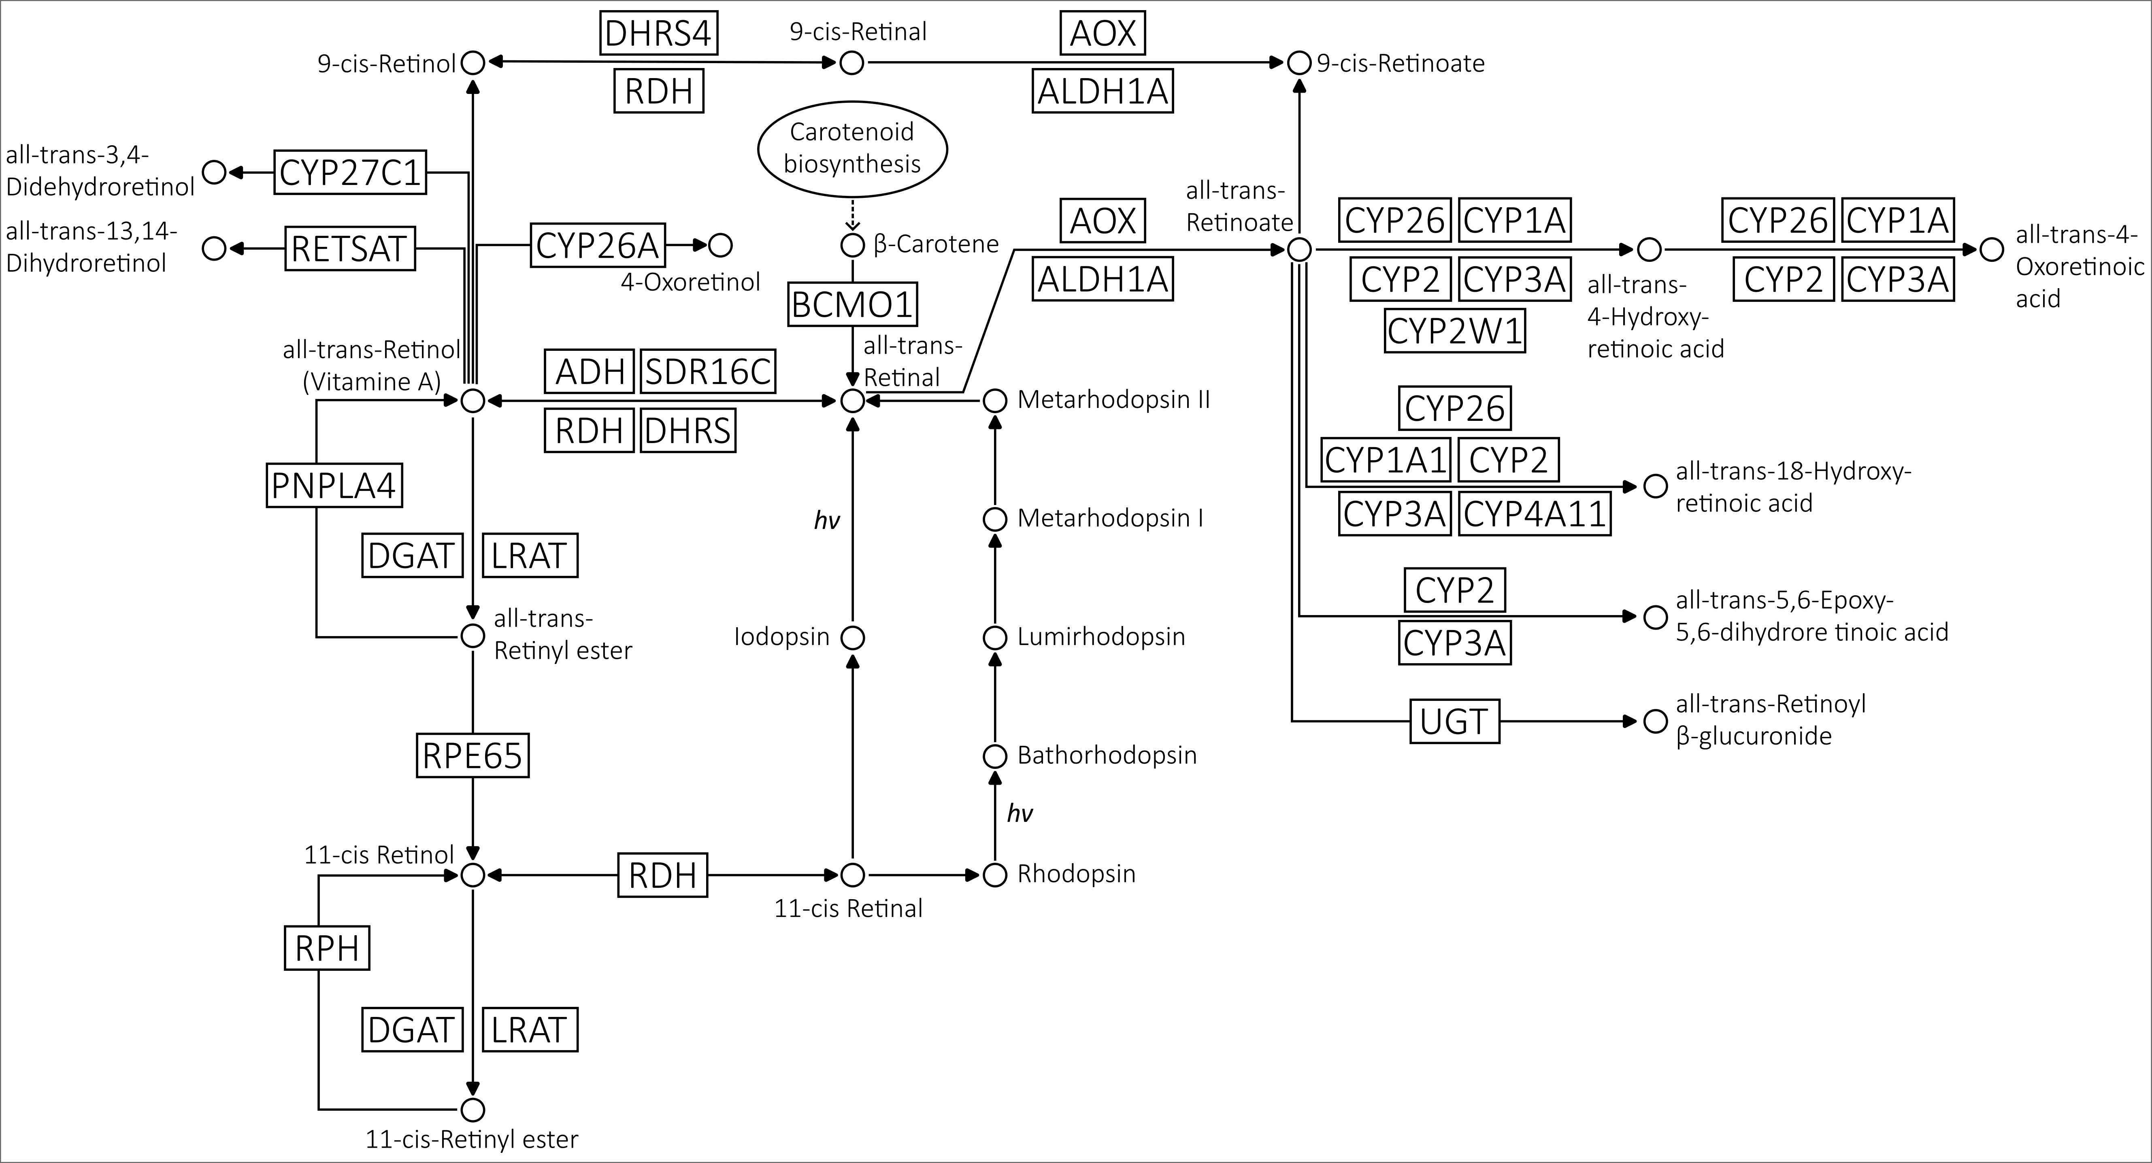

**Figure 4.1. Retinol metabolism pathway.** The pathway used as reference in this study is based on the KEGG map00830 (Kanehisa et al. 2021).

molecule that regulates gene expression and is critical for numerous developmental processes (Blomhoff and Blomhoff 2006). The retinol metabolism, particularly as it relates to vision, has been primarily studied in vertebrates, especially mammals, with mouse (*Mus musculus*) and human being the most extensively characterized due to their relevance in medical research (Trifiletti 2014; Widjaja-Adhi and Golczak 2020). Some aspects of retinol metabolism have been studied in the invertebrate model *Drosophila melanogaster*, where vitamin A deficiency hampers the formation of the retinal and overall disrupts the visual system (Dewett, Labaf, et al. 2021; Dewett, Lam-Kamath, et al. 2021). Outside of animals, carotenoid biosynthesis pathways, producing retinol precursors such as beta-carotene, have received more attention than the retinol metabolism itself, especially in plants (Hirschberg 2001).

Given the importance of retinol metabolism, it is compelling to explore its evolutionary history and potential diversity outside of traditional model organisms, especially in the wider context of the evolution of vision. Hence, the work presented in this chapter aimed to unravel this intricate history. The initial step was to identify the genetic components involved and determine their evolutionary relationships to answer questions such as: Do the gene families belong to overarching orthogroups? How closely related are they? The subsequent objective was to uncover the distribution of these components across the animal kingdom and, more broadly, within eukaryotes, to pinpoint the specific point in time when all the components came into place. The final endeavour was to delineate the main evolutionary events characterizing each orthogroup, to discern, for instance, if certain gene families have undergone a greater number of evolutionary events and contextualizing them within the evolutionary tree of life.

**Table 4.1. Enzymes involved in retinol metabolism listed in order of number of pathways they are involved in according to KEGG, as a measure of their specificity to the retinol metabolism pathway.**

|  |  |  |  |  |
| --- | --- | --- | --- | --- |
| **Gene Family** | **Kegg map00830** | | | **No Kegg Pathways** |
| **Entry** | **Symbol** | **Name** |
| RETSAT | K09516 | RETSAT | all-trans-retinol 13,14-reductase | 1 |
| RPH | EC3.1.1.63 | ? | 11-cis-retinyl-palmitate hydrolase | 1 |
| PNPLA4 | K11157 | PNPLA4 | patatin-like phospholipase domain-containing protein 4 | 2 |
| RDH | K00061 | RDH5 | 11-cis-retinol dehydrogenase | 2 |
| K11150 | RDH8 | retinol dehydrogenase 8 | 2 |
| K11151 | RDH10 | retinol dehydrogenase 10 | 2 |
| K11152 | RDH11 | retinol dehydrogenase 11 | 3 |
| K11153 | RDH12 | retinol dehydrogenase 12 | 3 |
| K11161 | RDH13 | retinol dehydrogenase 13 | 3 |
| ALDH1 | K07249 | ALDH1A | retinal dehydrogenase | 2 |
| RPE65 | K11158 | RPE65 | retinoid isomerohydrolase / lutein isomerase | 2 |
| BCMO1 | K00515 | BCMO1 | beta-carotene 15,15'-dioxygenase | 3 |
| LRAT | K00678 | LRAT | phosphatidylcholine-retinol O-acyltransferase | 3 |
| DHRS | K11148 | DHRS4L2 | dehydrogenase/reductase SDR family member 4-like protein 2 | 2 |
| K11149 | DHRS9 | dehydrogenase/reductase SDR family member 9 | 2 |
| K11146 | DHRS3 | short-chain dehydrogenase/reductase 3 | 3 |
| K11147 | DHRS4 | dehydrogenase/reductase SDR family member 4 | 3 |
| K15734 | SDR16C5 | all-trans-retinol dehydrogenase (NAD+) | 3 |
| K13369 | HSD17B6 | 17beta-estradiol 17-dehydrogenase / all-trans-retinol dehydrogenase (NAD+) | 4 |
| DGAT | K11156 | DGAT2L4 | diacylglycerol O-acyltransferase 2-like protein 4 | 3 |
| K11155 | DGAT1 | diacylglycerol O-acyltransferase 1 | 4 |
| CYP | K17951 | CYP27C1 | all-trans-retinol 3,4-desaturase | 1 |
| K07411 | CYP2A | cytochrome P450 family 2 sub-family A | 2 |
| K07423 | CYP2W1 | cytochrome P450 family 2 sub-family W1 | 2 |
| K07437 | CYP26A | cytochrome P450 family 26 sub-family A | 2 |
| K12664 | CYP26B | cytochrome P450 family 26 sub-family B | 2 |
| K12665 | CYP26C | cytochrome P450 family 26 sub-family C | 2 |
| K07420 | CYP2S1 | cytochrome P450 family 2 sub-family S1 | 3 |
| K17691 | CYP3A7 | cytochrome P450 family 3 sub-family A7 | 4 |
| K17720 | CYP2C18 | cytochrome P450 family 2 sub-family C18 | 4 |
| K07412 | CYP2B | cytochrome P450 family 2 sub-family B | 5 |
| K07424 | CYP3A | cytochrome P450 family 3 sub-family A | 6 |
| K17690 | CYP3A5 | cytochrome P450 family 3 sub-family A5 | 6 |
| K07425 | CYP4A | long-chain fatty acid omega-monooxygenase | 7 |
| K17709 | CYP2B6 | cytochrome P450 family 2 sub-family B6 | 7 |
| K07413 | CYP2C | cytochrome P450 family 2 sub-family C | 8 |
| K17683 | CYP2A6 | cytochrome P450 family 2 sub-family A6 | 8 |
| K17718 | CYP2C8 | cytochrome P450 family 2 sub-family C8 | 8 |
| K17719 | CYP2C9 | cytochrome P450 family 2 sub-family C9 | 9 |
| K07408 | CYP1A1 | cytochrome P450 family 1 sub-family A1 | 10 |
| K17689 | CYP3A4 | cytochrome P450 family 3 sub-family A4 | 10 |
| K07409 | CYP1A2 | cytochrome P450 family 1 sub-family A2 | 12 |
| AOX | K00157 | AOX | aldehyde oxidase | 10 |
| ADH | K13980 | ADH4 | alcohol dehydrogenase 4 | 9 |
| K13951 | ADH1_7 | alcohol dehydrogenase 1/7 | 10 |
| K13952 | ADH6 | alcohol dehydrogenase 6 | 10 |
| K00001 | adh | alcohol dehydrogenase | 13 |
| K13953 | adhP | alcohol dehydrogenase, propanol-preferring | 13 |
| K00121 | ADH5 | alcohol dehydrogenase 5 | 16 |
| UGT | K00699 | UGT | glucuronosyltransferase | 14 |

### Results and Discussion

#### Enzymes involved in retinol metabolism belong to 12 major orthogroups.

To gain insights into the evolution of retinol metabolism, it is essential to trace the evolutionary history of each of the enzymes in the pathway. For this I used as reference the pathway described by KEGG (Kanehisa et al. 2021) (Figure 4.1 and Table 4.1) and explored the genes encoding these enzymes across 101 species spanning all major eukaryotic groups (Table 4.2 and Extended Table 4.2). KEGG ortholog lists (Kanehisa 2019) for each enzyme were used as starting point for the data mining (see more details in the Methods section of this Chapter). It is worth noting that the only enzyme from the KEGG pathway excluded from this analysis was RPH (11-cis-retinyl-palmitate hydrolase) (Figure 4.1 and Table 4.1). Despite its hypothesized role in hydrolysing stored 11-cis-retinyl esters to 11-cis retinol is pertinent to vision (Blaner et al. 1984; Blaner et al. 1987), there is a significant knowledge gap surrounding this putative enzyme. The human gene encoding it remains unidentified, and KEGG does not list any orthologs for it. Given the nebulous nature of this enzyme, this study chose to prioritize better-understood enzymes, including RPE65 that catalyses the extremely similar reaction of hydrolysing all-trans-retinyl esters to 11-cis retinol (Moiseyev et al. 2005).

Although many enzymes partake in the pathway, some might belong to a same larger gene family. Therefore, to study their evolution, the initial task was to identify their respective orthogroup – a collection of orthologs and paralogs that originated from the same initial gene duplication. An orthogroup can be considered as a phylogenetically defined gene family. Orthogroup inference methods often rely on computing sequence similarity scores amongst sequences as a measure of protein distances and then using these scores for clustering the sequences (e.g., OrthoMCL (Li et al. 2003)). Here, two alternative software for orthogroup inference were used to independently infer orthogroups (see details in Methods). The first was OrthoFinder that implements a method that eliminates gene length bias during similarity score assessment (Emms and Kelly 2015) and uses a

**Table 4.2. List of species used in this study with respective proteome BUSCO scores.**phylogenetic framework to detect orthologs (Emms and Kelly 2019); the second was Broccoli that uses phylogenetic relationships instead of protein distances for clustering sequences and then applies machine learning algorithms to extract orthologous relationships from this network (Derelle et al. 2020). By comparing results from these distinct strategies, the chances of comprehensively identifying orthogroups for retinol metabolism enzymes was enhanced.

OrthoFinder identified a total of 50 orthogroups, while Broccoli provided 58. After annotating the orthogroups and filtering out the ones not involved in the retinol metabolism (see Methods), we were left with 14 OrthoFinder and 21 Broccoli orthogroups (Figure 4.2). Results were compared by assessing the percentage of shared sequences between OrthoFinder and Broccoli orthogroups (see Methods for details). Generally, there is substantial agreement between OrthoFinder and Broccoli results, with many orthogroups displaying one-to-one correspondence. However, while OrthoFinder yielded fewer, larger orthogroups, Broccoli in some cases produced more and smaller ones. As a result, some gene families were fragmented into multiple smaller orthogroups exclusively in Broccoli's output. Collectively, the OrthoFinder and Broccoli results delineated 12 orthogroups encompassing retinol metabolism enzymes (Table 4.3). While the primary purpose of the orthogroup inference step was to identify gene families to investigate further with phylogenetic analyses, it also provided some preliminary insights into the evolution of some of the enzymes involved in retinol metabolism. For example, both OrthoFinder and Broccoli place DGAT1 and DGAT2L4 into distinct orthogroups. Additionally, RDH and DHRS enzymes, sub-families of a larger group, display a complex substructure, suggesting intricate phylogenetic relationships.



**Figure 4.2. Orthogroup inference analysis.** Orthogroups inferred from two different software (OrthoFinder and Broccoli) are compared.



**Table 4.3. Summary of the comparison between OrthoFinder and Broccoli orthogroup inference results. In the last column, the final orthogroups used for phylogenetic analyses are shown.**

#### Reconstructing phylogenetic histories of retinol metabolism orthogroups.

All retinol metabolism related orthogroups were further examined with phylogenetic analyses to understand the details of their evolutionary histories. After constructing phylogenetic trees (see Methods), two distinct but complementary approaches were applied for analysing each orthogroup tree. The first approach employs the software Possvm (Grau-Bové and Sebé-Pedrós 2021), which identifies orthologs within the gene tree through species overlap algorithms, defines sub-orthogroups within the primary orthogroup, and annotates the tree based on these sub-orthogroups. The second employs GeneRax (Morel et al. 2020), which reconciles the gene tree to a species tree using a maximum-likelihood framework. Possvm offers the advantage of swiftly annotating large trees, facilitating their interpretation. As it infers orthologs using implicit taxonomic information from the gene tree, it eliminates the need for a species tree and avoids potential biases from contentious species relationships. GeneRax, in contrast, delivers a precise reconciled tree detailing speciation, duplication, and loss events at each node. However, it demands more computation time and necessitates a species tree. The detailed results for each orthogroup, presented in order of specificity to the retinol metabolism, are described below.

##### RETSAT

The Retinol Saturase (RETSAT) enzyme catalyses the reaction that saturates the 13-14 double bond of all-trans-retinol to produce all-trans-13,14-dihdriretinol (Moise et al. 2004) (Figure 4.1). This enzyme appears to be involved only in retinol metabolism according to the KEGG Database (Table 4.1), meaning it is very specific to this pathway.

The orthogroups identified for RETSAT by OrthoFinder and Broccoli present a clear one-to-one relationship with high degree of identity (Figure 4.2), indicating no mixture with any other orthogroup examined. The merged RETSAT orthogroup contained 338 sequences distributed throughout all major eukaryotic clades (Figure 4.3A).

Phylogenetic analysis identified a monophyletic clade containing RETSAT genes from various species of eukaryotes, as well as other clades of related enzymes (Figure 4.3 B and C). Ortholog sorting with Possvm identified 7 orthogroups within the RETSAT family, with one orthogroup containing RETSAT, PYRD2 (Pyridine Nucleotide-Disulphide Oxidoreductase Domain 2) and CRT enzymes that are involved in carotenoid metabolism (Figure 4.3B). Gene tree to species tree reconciliation with GeneRax confirmed the overall topology and revealed a high number of evolutionary events (especially losses) in proportion to the size of the orthogroup (Figure 4.3C).

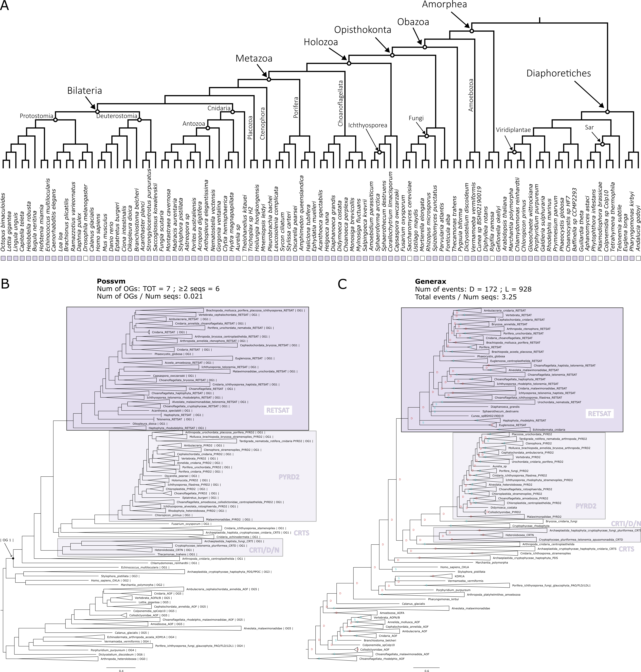

**Figure 4.3. Phylogenetic analysis for the RETSAT orthogroup. (A)** Distribution of the orthogroup throughout Eukarya. **(B)** Phylogenetic tree analysed with Possvm for identification of sub-orthogroups.Number of Possvm orthogroups identified (Total, and with ≥ 2 sequences) are provided, as well as the ratio between number of Possvm sub-orthogroups per number of sequences in full orthogroup are indicated. **(C)** Gene tree to species tree reconciliation using GeneRax highlighting speciation and duplication events at each node. Numbers of duplications (D) and losses (L) are provided, as well as the ratio of total events (D+L) per number of sequences in the orthogroup.

##### PNPLA4

The Patatin Like Phospholipase Domain Containing 4 (PNPLA4) enzyme plays a role in the hydrolysis of retinyl esters to retinol (Holmes 2012; Schreiber et al. 2012) (Figure 4.1). It is involved in one other pathway according to KEGG (Table 4.1).

Both OrthoFinder and Broccoli identify one distinct orthogroup for PNPLA4 independent from all other orthogroups (Figure 4.2). The final PNPLA4 orthogroup contains 215 sequences. While being present in both major eukaryotic clades, this orthogroup appears to be missing in some groups of Amorphea, such as the Holomycota branch that includes Fungi (Figure 4.4A).

The phylogenetic analysis clarified the relationship between PNPLA4 and other PNPLA enzymes present in the orthogroup (Figure 4.4 B and C). Possvm identified 9 orthogroups within this family. PNPLA1-5 belonged to the same orthogroup, with PNPLA4 being sister group to the other genes (Figure 4.4B). The GeneRax reconciled tree recovered the same topology and identified a moderate number of events (Figure 4.4C). The phylogenetic analysis also revealed that while the broad PNPLA4 orthogroup included sequences from a wide range of eukaryotic organisms, the PNPLA1-5 sub-clades contained primarily animal sequences. The tight relationship between PNPLA4 and other PNPLA genes is in accordance with evidence suggesting that some of them are also involved in retinol metabolism (Kienesberger et al. 2009; Pingitore and Romeo 2019). Similarly, one cannot rule out the possibility that even more distantly related sequences from non-animal species within the overarching orthogroup might also perform similar functions.

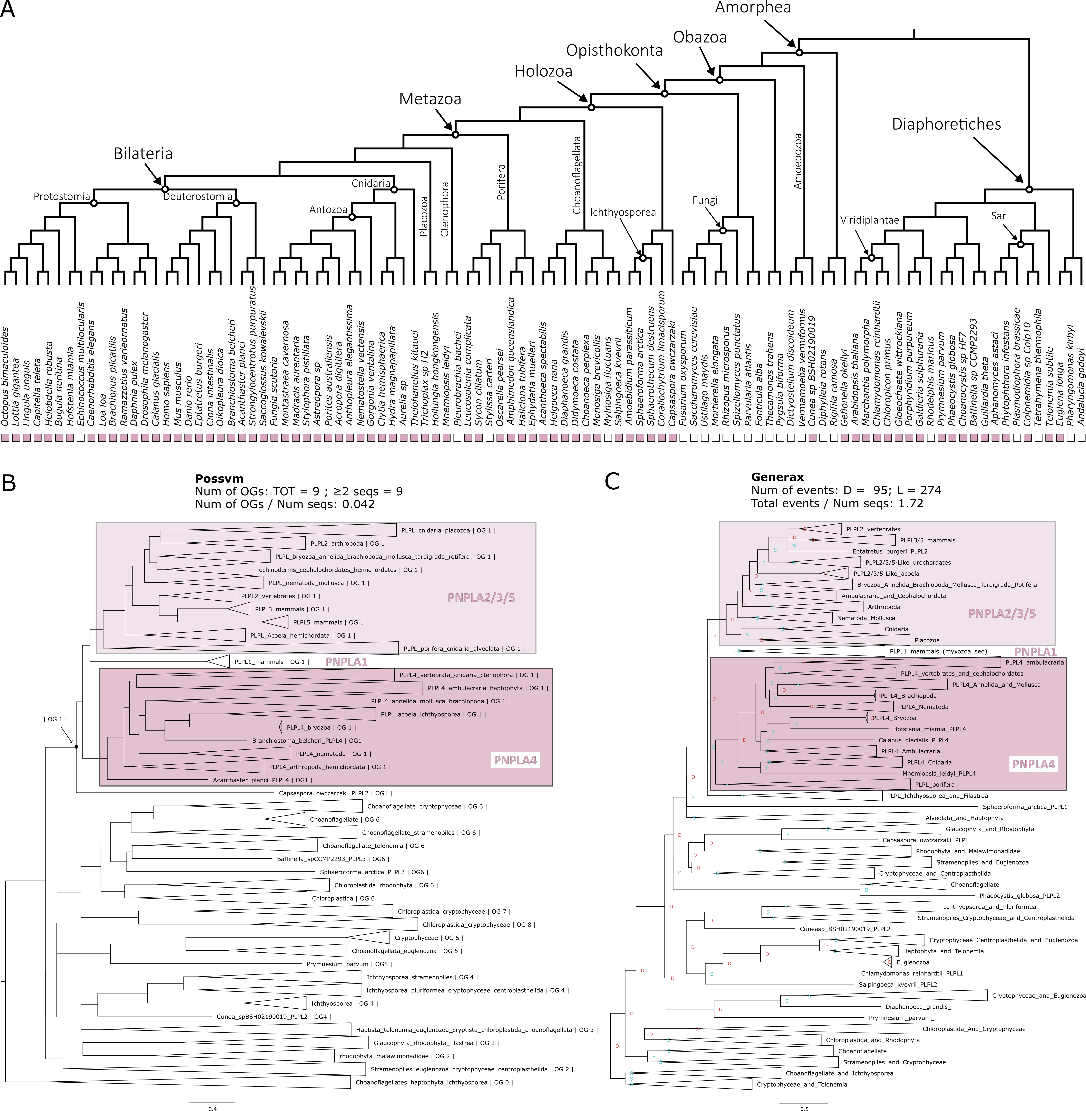

**Figure 4.4. Phylogenetic analysis for the PNPLA4 orthogroup. (A)** Distribution of the orthogroup throughout Eukarya. **(B)** Phylogenetic tree analysed with Possvm for identification of sub-orthogroups.Number of Possvm orthogroups identified (Total, and with ≥ 2 sequences) are provided, as well as the ratio between number of Possvm sub-orthogroups per number of sequences in full orthogroup are indicated. **(C)** Gene tree to species tree reconciliation using GeneRax highlighting speciation and duplication events at each node. Numbers of duplications (D) and losses (L) are provided, as well as the ratio of total events (D+L) per number of sequences in the orthogroup.

##### ALDH1

Aldehyde Dehydrogenase 1 Family Member A1 (ALDH1A1 or ALDH1), also known as Retinaldehyde Dehydrogenase 1 (RALDH1), is an enzyme that can catalyse the oxidation of retinal to retinoic acid (or retinoate) (Duester 2000) (Figure 4.1). ALDH1 is involved in two KEGG pathways (Table 4.1).

Both OrthoFinder and Broccoli identify ALDH1 as its own distinct orthogroup (Figure 4.2) and the final merged orthogroup consists of 765 sequences. This orthogroup is ubiquitous, with only a handful of eukaryotic species lacking it (Figure 4.5A).

The phylogenetic analyses revealed a complex substructure within the ALDH1 orthogroup (Figure 4.5 B and C), with Possvm subdividing it into 44 orthogroups, a high number relative to total sequences. ALDH1A, ALDH1B and ALDH2 all coalesce to a same Possvm orthogroup. While the full orthogroup includes other aldehyde dehydrogenases, including ALDH1L, ALDH8A1, ALDH16A1, ALDH9A1 and ALDH5A1. The GeneRax reconciled tree found a very similar topology and identified a relatively high number of evolutionary events (Figure 4.5C). Interestingly, the ALDH1/2 sub-orthogroup predominantly features animal sequences, whereas other ALDH clades encompass a diverse range of eukaryotic species. This suggests a link between the ALDH1/2 expansion within animals and the emergence of vision in these organisms.

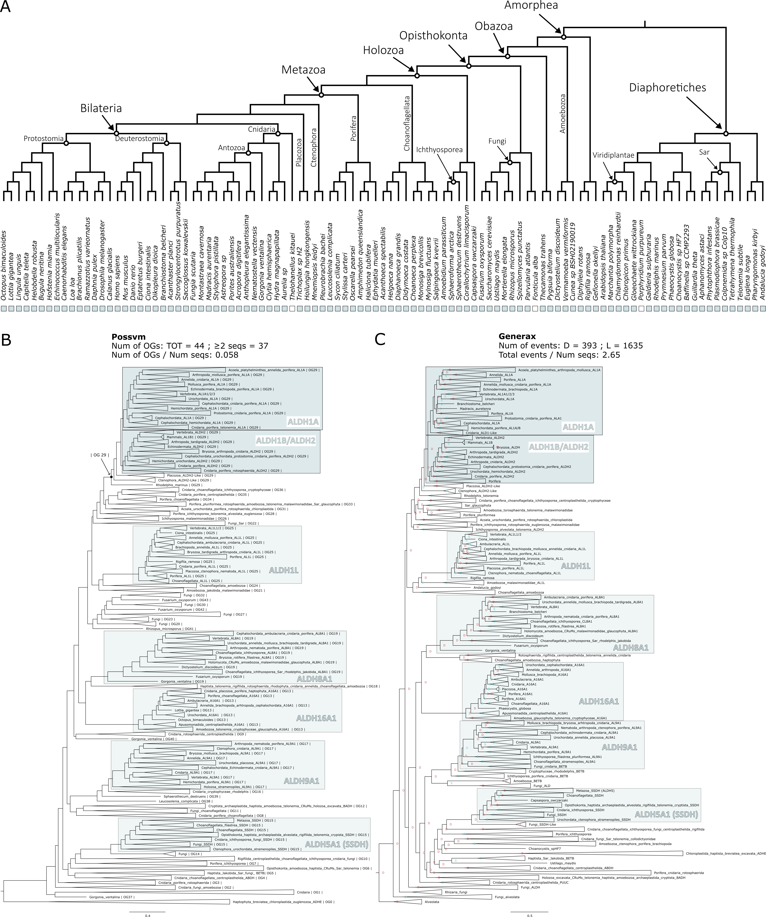

**Figure 4.5. Phylogenetic analysis for the ALDH1 orthogroup. (A)** Distribution of the orthogroup throughout Eukarya. **(B)** Phylogenetic tree analysed with Possvm for identification of sub-orthogroups.Number of Possvm orthogroups identified (Total, and with ≥ 2 sequences) are provided, as well as the ratio between number of Possvm sub-orthogroups per number of sequences in full orthogroup are indicated. **(C)** Gene tree to species tree reconciliation using GeneRax highlighting speciation and duplication events at each node. Numbers of duplications (D) and losses (L) are provided, as well as the ratio of total events (D+L) per number of sequences in the orthogroup.

##### BCMO1/RPE65

Beta-carotene 15–15′-monooxygenase (BCMO1), more recently known as Beta-Carotene Oxygenase 1 (BCO1) (Seña et al. 2014), plays a crucial role in converting dietary beta-carotene into retinal by catalysing the symmetric cleavage of beta-carotene to produce two all-trans-retinal molecules (Harrison 2012) (Figure 4.1). Another carotenoid cleavage oxygenase (CCO) enzyme is Retinoid Isomerohydrolase RPE65. RPE65 is expressed in retinal pigment epithelium (RPE) cells where it catalyses the conversion of all-trans-retinyl ester to 11-cis-retinol (Jin et al. 2005; Moiseyev et al. 2005; Redmond et al. 2005). These two essential enzymes are both quite specific to the pathway, with RPE65 being present in only two KEGG pathways and BCMO1 in three (Table 4.1).

BCMO1 and RPE65 are placed in the same orthogroup both by OrthoFinder and by Broccoli (Figure 4.2) confirming that they belong to the same family of enzymes. The complete orthogroup consists in 322 sequences. This orthogroup has a patchy presence throughout most eukaryotic clades (Figure 4.6A).

The phylogenetic analysis for this orthogroup revealed several sub-families. Possvm identified 16 orthogroups within this family, with BCO1, RPE65, as well as BCO2, belonging to the same orthogroup (Figure 4.6B). GeneRax recovers a fairly similar topology and a moderately high number of events (Figure 4.6C). Also in this case, the BCMO1/RPE65 specific subclade appears to be animal-specific; while other subgroups are either widely distributed (like ACOX) or specific to eukaryotic clades distantly related to animals (such as CCD8 and NCED/CCD1).

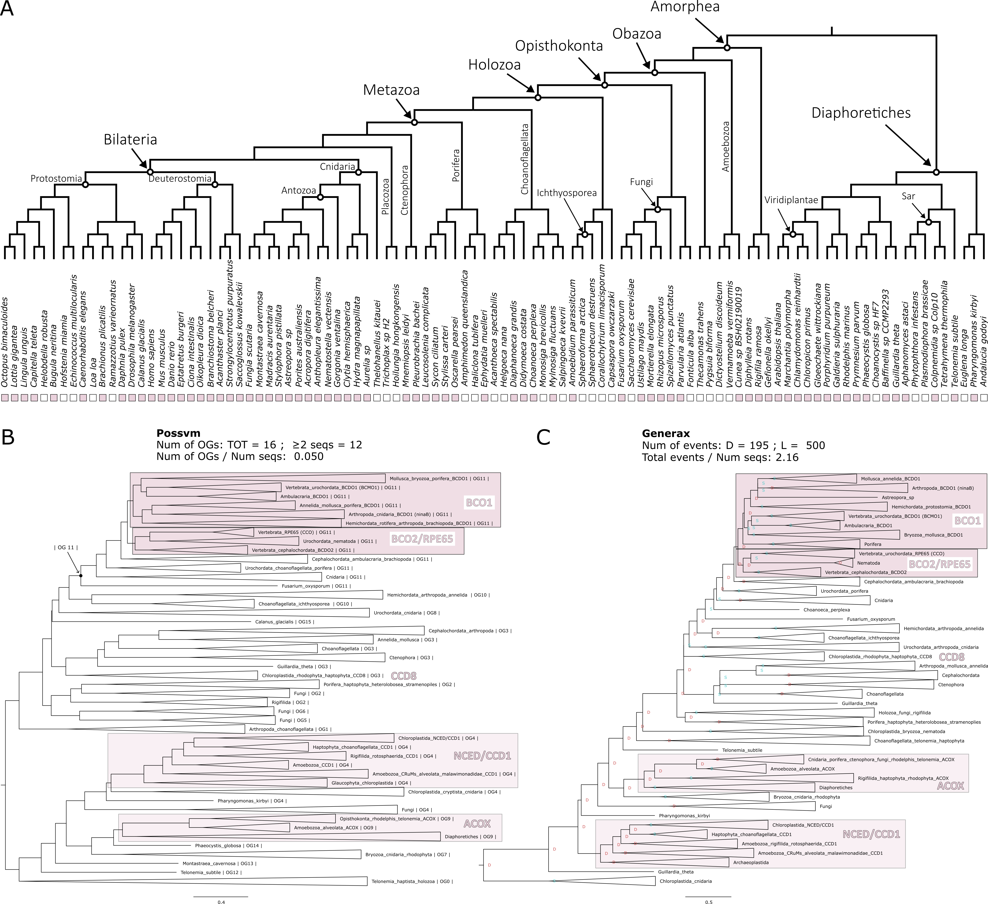

**Figure 4.6. Phylogenetic analysis for the BCMO1/RPE65 orthogroup. (A)** Distribution of the orthogroup throughout Eukarya. **(B)** Phylogenetic tree analysed with Possvm for identification of sub-orthogroups.Number of Possvm orthogroups identified (Total, and with ≥ 2 sequences) are provided, as well as the ratio between number of Possvm sub-orthogroups per number of sequences in full orthogroup are indicated. **(C)** Gene tree to species tree reconciliation using GeneRax highlighting speciation and duplication events at each node. Numbers of duplications (D) and losses (L) are provided, as well as the ratio of total events (D+L) per number of sequences in the orthogroup.

##### LRAT

Lecithin Retinol Acyltransferase (LRAT), also known as Phosphatidylcholine--Retinol O-Acyltransferase, catalyses the esterification of all-trans-retinol into all-trans-retinyl ester (Ruiz et al. 1999; Batten et al. 2004) (Figure 4.1). It belongs to three KEGG pathways (Table 4.1).

OrthoFinder and GeneRax orthogroups for this enzyme correspond to each other with high identity (Figure 4.2). The LRAT orthogroup is the smallest, including only 93 sequences. This is reflected in its limited distribution throughout eukaryotes. It is present in most animal clades, with exception of placozoans and ctenophores. However, outside of animals there seems to be very sparse and uneven distribution (Figure 4.7A).

Possvm identifies only 6 orthogroups within LRAT (Figure 4.7B). Interestingly, apart from the orthogroup containing LRAT, there is also an orthogroup containing the related Phospholipase A And Acyltransferase (PLAAT) family of enzymes (Hussain et al. 2017). GeneRax confirms a similar tree topology and identifies a rather high number of events relative to the low number of sequences (Figure 4.7C). The few non-metazoan sequences within the LRAT orthogroup belong neither to the LRAT nor the PLAAT clades in the tree, making it another case in which one of the enzymes most specific to retinol metabolism appears animal specific.

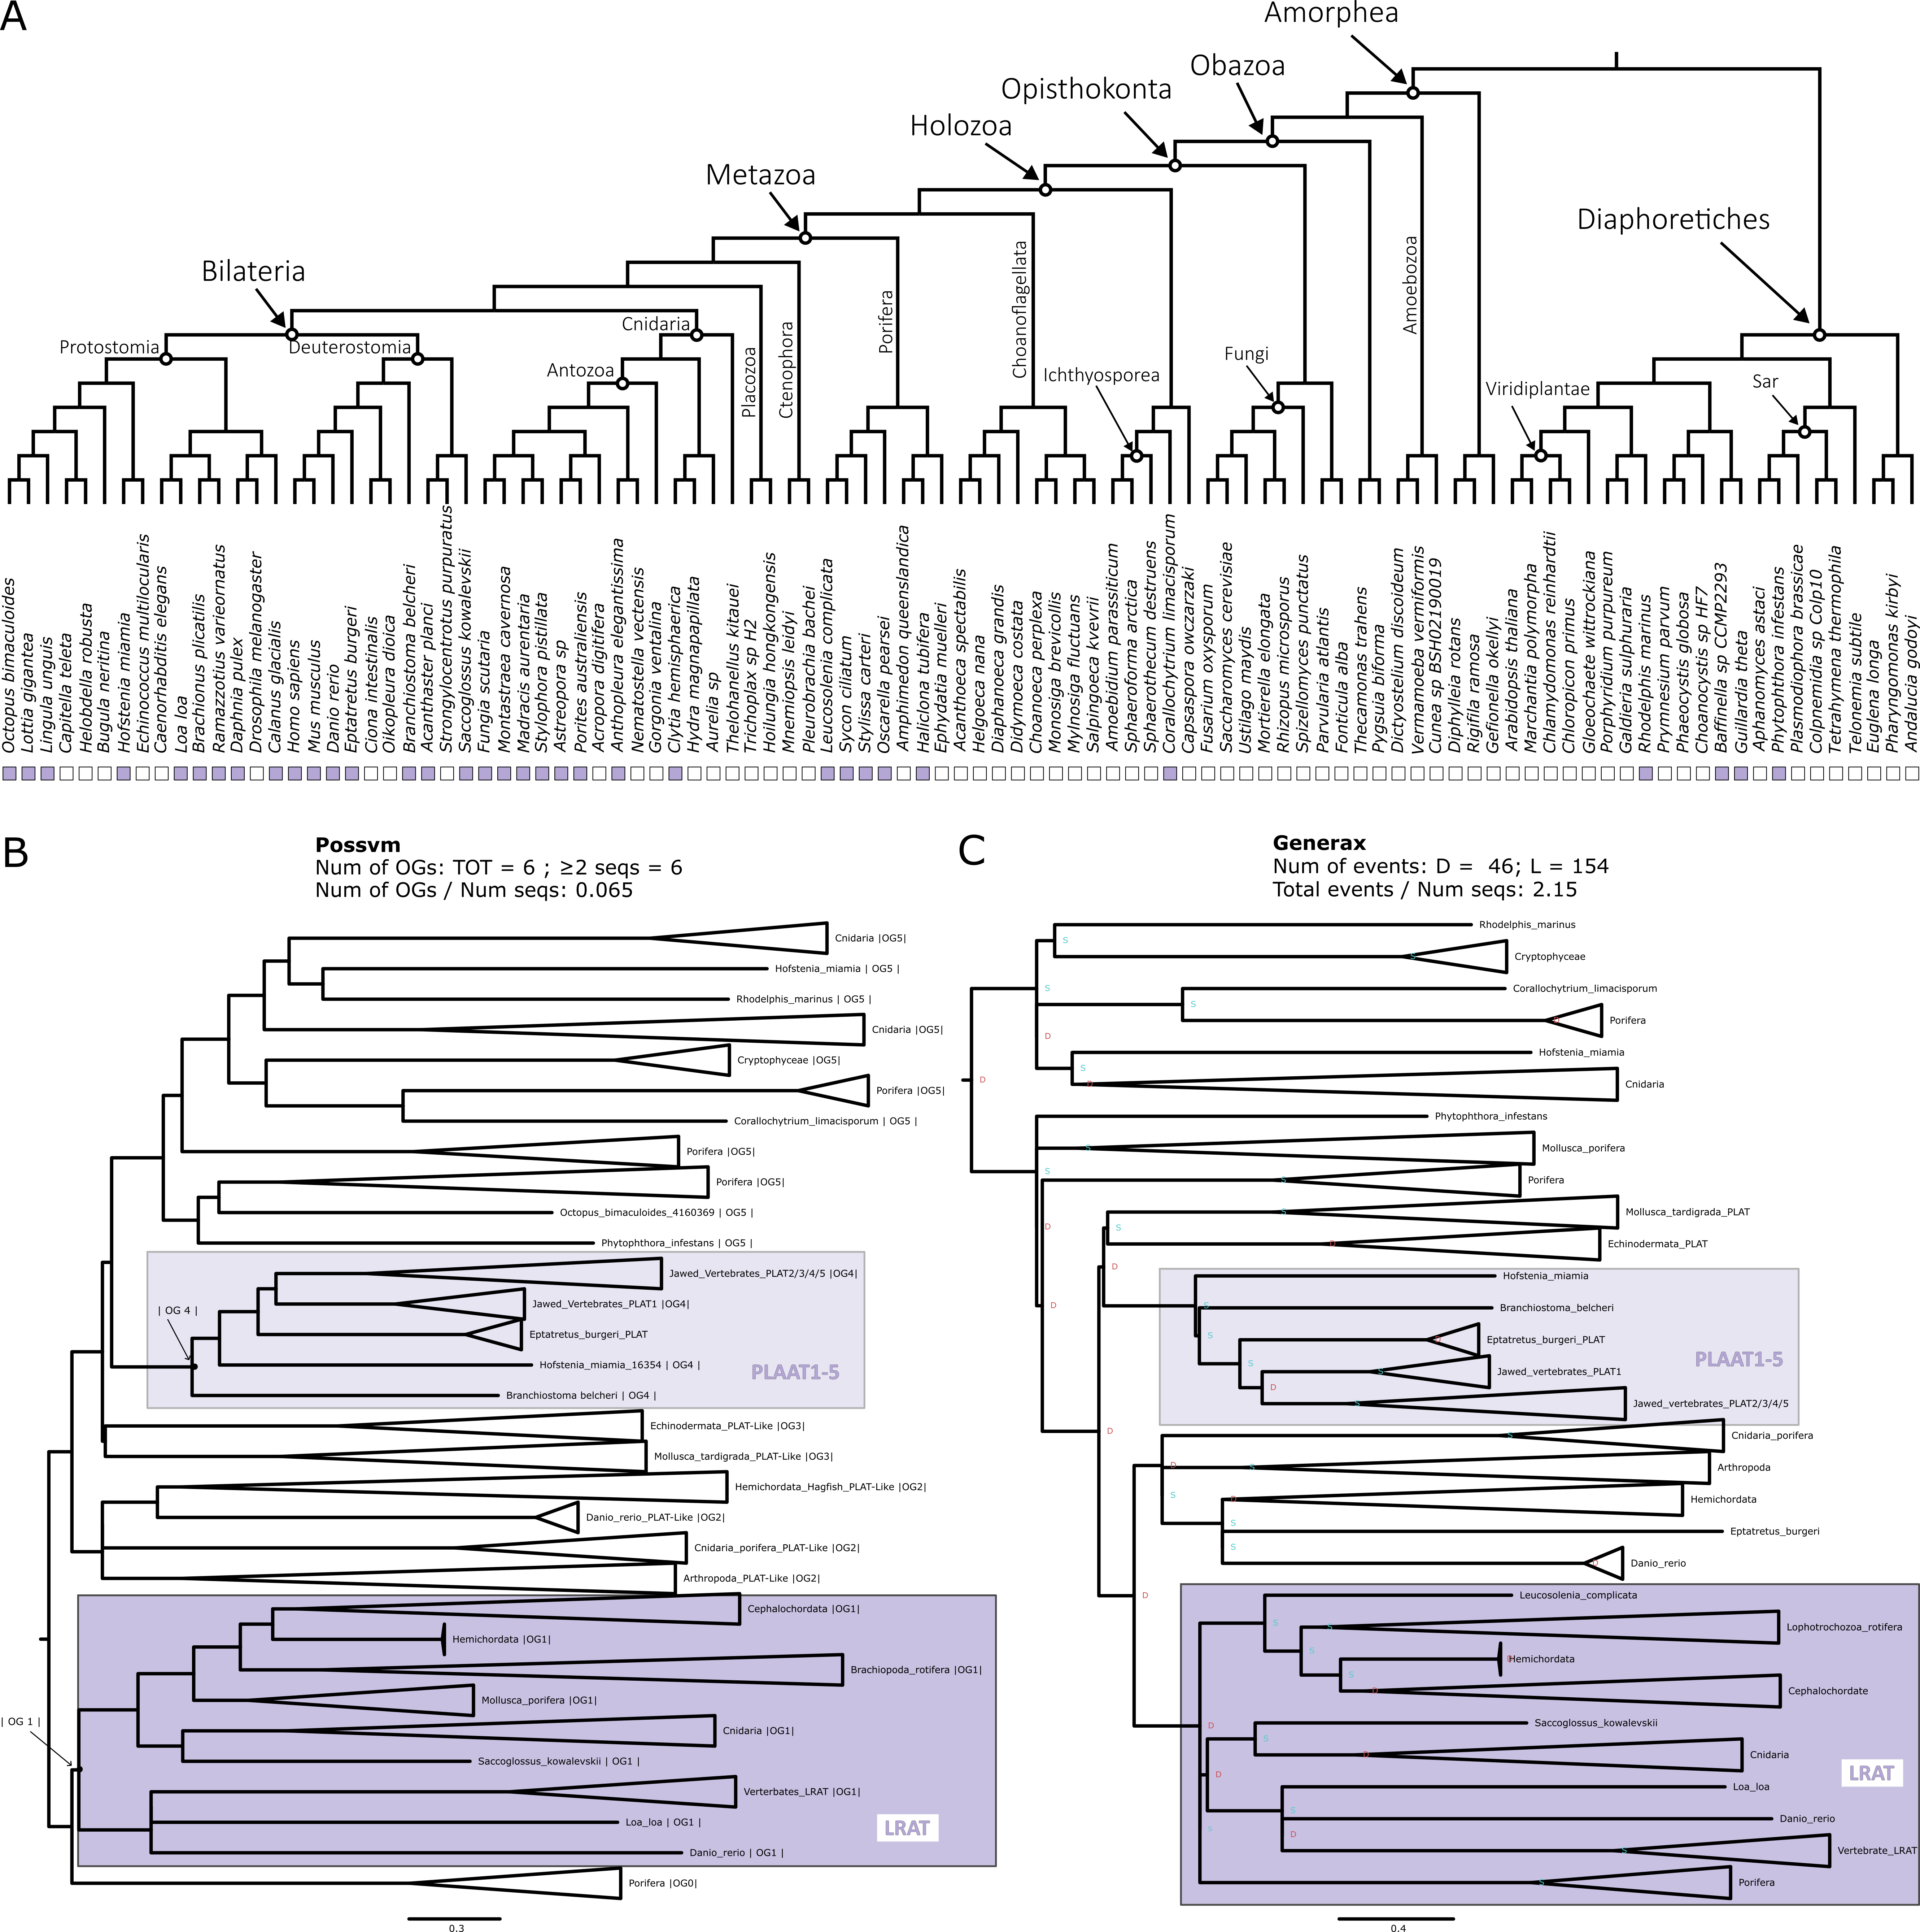

**Figure 4.7. Phylogenetic analysis for the LRAT orthogroup. (A)** Distribution of the orthogroup throughout Eukarya. **(B)** Phylogenetic tree analysed with Possvm for identification of sub-orthogroups.Number of Possvm orthogroups identified (Total, and with ≥ 2 sequences) are provided, as well as the ratio between number of Possvm sub-orthogroups per number of sequences in full orthogroup are indicated. **(C)** Gene tree to species tree reconciliation using GeneRax highlighting speciation and duplication events at each node. Numbers of duplications (D) and losses (L) are provided, as well as the ratio of total events (D+L) per number of sequences in the orthogroup.

##### RDH/DHRS

Retinol Dehydrogenase (RDH) enzymes are responsible for the oxidation of retinol to retinal (Sahu and Maeda 2016). RDH5 in particular is responsible for the conversion of 11-cis-retinol to 11-cis-retinal, the visual chromophore (Duester 2000). Other RDHs involved in the retinol metabolism are listed in Table 4.1. These enzymes are quite specific to retinol metabolism, being involved in either two or three KEGG pathways (Table 4.1). RDHs are in turn classified within the broader short-chain dehydrogenases/reductases (SDR) family (Duester 2000; Lhor and Salesse 2014). Other enzymes within this family include members of the Dehydrogenase/Reductases SDR family (DHRS), several of which are also implicated in retinol metabolism (Figure 4.1 and Table 4.1). The DHRS enzymes involved in retinol metabolism belong to a minimum of two up to a maximum of four KEGG pathways (Table 4.1).

The orthogroup analyses reveals a very complex situation for RDH and DHRS enzymes (Figure 4.2). First, there is a substantial difference in results between OrthoFinder that identifies two orthogroups and Broccoli that identifies seven orthogroups containing RDH and DHRS enzymes. Both methods pinpointed two primary orthogroups: one consisting solely of RDH enzymes and another comprising a mix of RDH and DHRS enzymes. Beyond these, Broccoli detected several smaller orthogroups, some leaning towards an RDH profile, while others were more DHRS-specific. Two of the Broccoli orthogroups even share a very small number of sequences with the GUK orthogroup which, being unrelated to the retinol metabolism, was discarded from further analysis. Furthermore, the OrthoFinder DHRS+RDH orthogroup had a small connection with the ADH orthogroup. However, this was negligible (0.09% of identity) and ADH can confidently be regarded as a distinct orthogroup. All these considerations led to the decision to include all RDH and DHRS orthogroups into one big orthogroup for phylogenetic analysis, even when this meant dealing with a large number of sequences. This is in fact the second largest orthogroup examined in this study with a total of 4476 sequences and the only one that is present in every single species examined (Figure 4.8A).

The complexity outlined by the OrthoFinder and Broccoli orthogroup detection is reflected in the complexity of the phylogenetic tree (Figure 4.8 B and C). 207 Possvm orthogroups were defined (Figure 4.8B). The RDH and DHRS enzymes described by KEGG to be involved in retinol metabolism (Table 4.1) are distributed across 6 different possvm orthogroups, which further clade with other members of this expansive family. GeneRax recovered a largely compatible substructure and revealed a very large number of evolutionary events even for the size of the orthogroup (Figure 4.8C). Overall, not all RDH enzymes belong to a monophyletic clade, and neither do all DHRS enzymes. Instead, monophyletic clades within this broad gene family include enzymes that have been described (based primarily on structure and function) to belong to different sub-families. This underscores the need for a phylogenetic approach to clarify the evolutionary relationships among these enzymes. As mentioned, RDH and DHRS families are part of the extensive SDR super family. Delving deeper into the relationships within other SDR members might shed more light on sub-family connections. However, that would present an extremely challenging task. The current orthogroup (~4500 sequences) already proved to be very demanding between the extensive computational resources needed for certain steps (e.g., GeneRax) and the significant amount of time required to examine the gene trees in detail. Finally, regarding the distribution of specific subgroups, while most subgroups spanned eukaryotes, a handful were animal specific, such as RDH11/12, RDH13, and RDH16/H17B6/DRC7/RDH5/DHRS9. Yet, examining the larger clades these smaller orthogroups are part of reveals the presence of other eukaryotes.

**Figure 4.8. Phylogenetic analysis for the RDH/DHRS orthogroup. (A)** Distribution of the orthogroup throughout Eukarya. **(B)** Phylogenetic tree analysed with Possvm for identification of sub-orthogroups.Number of Possvm orthogroups identified (Total, and with ≥ 2 sequences) are provided, as well as the ratio between number of Possvm sub-orthogroups per number of sequences in full orthogroup are indicated. **(C)** Gene tree to species tree reconciliation using GeneRax highlighting speciation and duplication events at each node. Numbers of duplications (D) and losses (L) are provided, as well as the ratio of total events (D+L) per number of sequences in the orthogroup.



##### DGAT1

Diacylglycerol O-Acyltransferase 1 (DGAT1) is known primarily for its role in triacylglycerol synthesis (Bhatt-Wessel et al. 2018). However, it has also been implicated in the retinol metabolism as an alternative to LRAT in the esterification of retinol to retinyl esters (Orland et al. 2005) (Figure 4.1). DGAT1 is involved in four metabolic pathways according to KEGG (Table 4.1).

KEGG places both DGAT1 and DGAT2L4 (see below) within the same generic “DGAT” node in the pathway (Figure 4.1 and Table 4.1). While they are involved in catalysing the same reaction, the orthogroup detection analysis clearly indicates that DGAT1 and DGAT2L4 are independent orthogroups, with both OrthoFinder and Broccoli keeping them separate (Figure 4.2). Therefore, the phylogenetic analysis was performed separately for these two orthogroups. The DGAT1 orthogroup contains 246 sequences and appears to be present throughout all eukaryotes with only a handful of species missing it (Figure 4.9A).

The Possvm analyses revealed a relatively simple substructure with only 7 orthogroups (Figure 4.9B). DGAT1 itself is monophyletic and belonging to one orthogroup. The Sterol O-Acyltransferase (SOAT) family appears to be closely related to DGAT1. The same substructure was described by GeneRax that also revealed a relatively low number of evolutionary events within this orthogroup (Figure 4.9C). The DGAT1 sub-orthogroup defined by Possvm includes sequences from across eukaryotes.

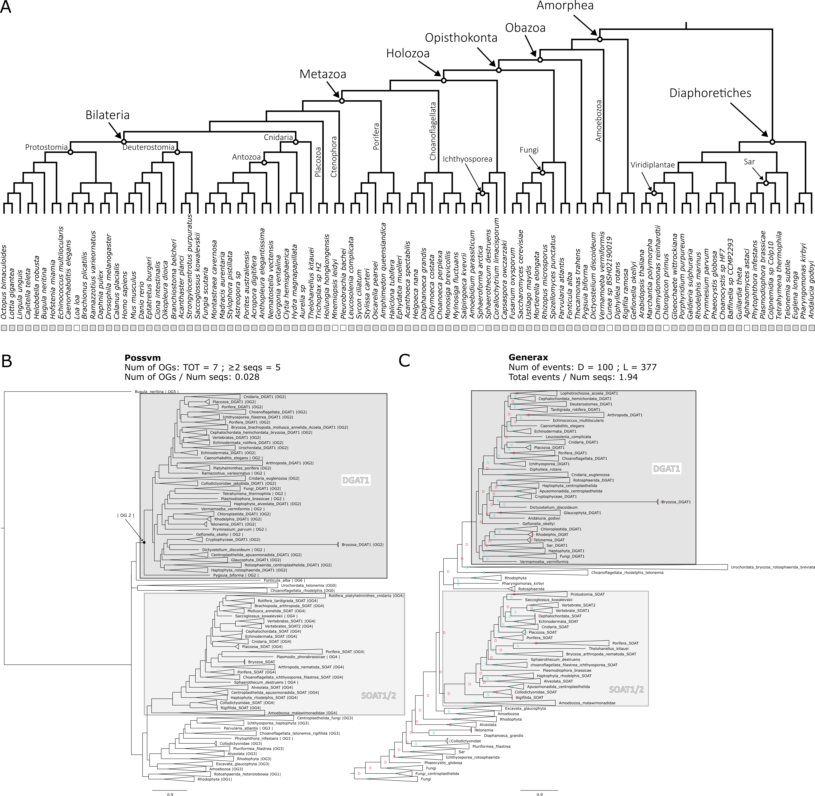

**Figure 4.9. Phylogenetic analysis for the DGAT1 orthogroup. (A)** Distribution of the orthogroup throughout Eukarya. **(B)** Phylogenetic tree analysed with Possvm for identification of sub-orthogroups.Number of Possvm orthogroups identified (Total, and with ≥ 2 sequences) are provided, as well as the ratio between number of Possvm sub-orthogroups per number of sequences in full orthogroup are indicated. **(C)** Gene tree to species tree reconciliation using GeneRax highlighting speciation and duplication events at each node. Numbers of duplications (D) and losses (L) are provided, as well as the ratio of total events (D+L) per number of sequences in the orthogroup.

##### DGAT2LA4

Diacylglycerol O-Acyltransferase 2-Like Protein 4 (DGAT2L4), also known as Acyl-CoA Wax Alcohol Acyltransferase 2 (AWAT2), is primarily known for its role in the production of wax esters (Cheng and Russell 2004). It has also been recently implicated in the conversion of retinol to retinyl ester (Kaylor et al. 2014; Arne et al. 2017; Blaner 2017) (Figure 4.1). According to KEGG this enzyme is involved in three metabolic pathways (Table 4.1).

Although DGAT2LA4 indeed seems to be involved in the same step as DGAT1 (and LRAT), it appears to form its own distinct orthogroup (see above) (Figure 4.2). This orthogroup includes 372 sequences and is present in all eukaryotes with few species missing it (Figure 4.10A).

Possvm identified 23 orthogroups, which quite high for the number of sequences (Figure 4.10B). DGAT2L4 forms a monophyletic clade with DGAT2L2, DGAT2L3, DGAT2L6 and DGAT2. While DGAT2L1 and DGAT2L5 form another monophyletic clade, sister group to the previous one (Figure 4.10B). Both clades, together with other less well characterized sequences, belong to one Possvm orthogroup. The same relationships are maintained in the reconciled tree by GeneRax that calculated quite a high number of events (Figure 4.10C). While the clades encompassing the DGAT2L and DGAT2 genes are specific to animals, the same Possvm orthogroup contains various non-metazoan sequences. This implies that this gene family existed anciently, even if animal-specific expansions gave rise to the recognized enzymes with a marginal role in retinol metabolism.

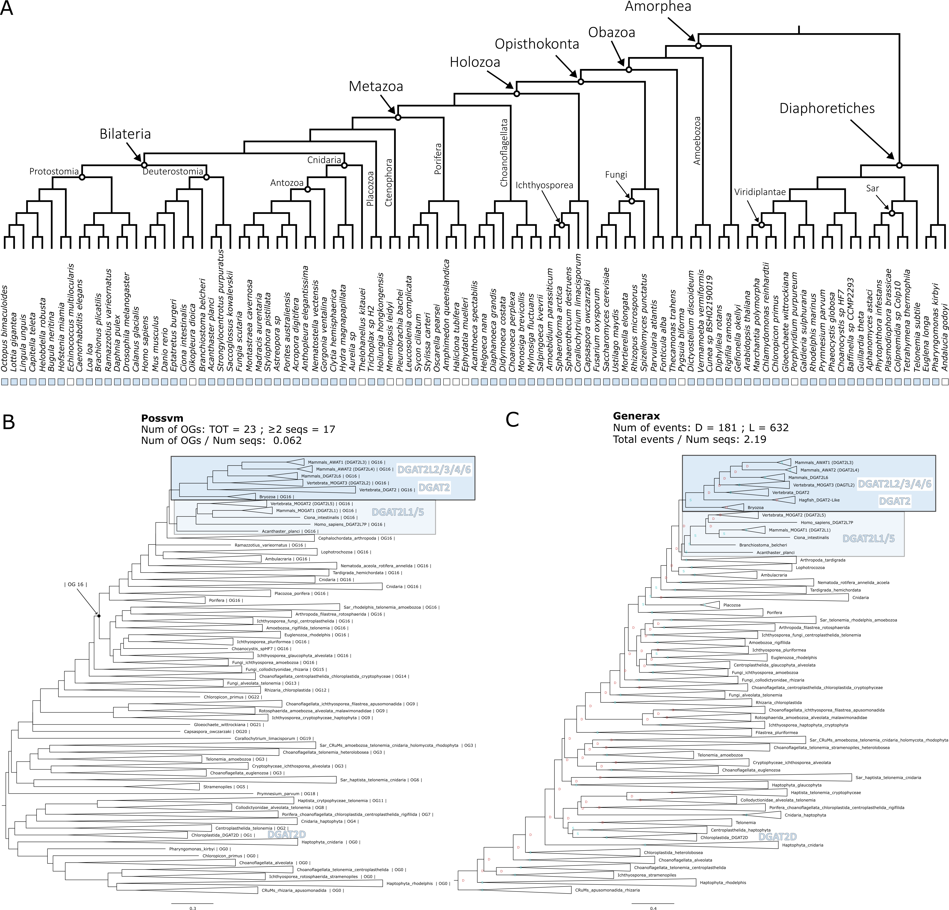

**Figure 4.10. Phylogenetic analysis for the DGAT2L4 orthogroup. (A)** Distribution of the orthogroup throughout Eukarya. **(B)** Phylogenetic tree analysed with Possvm for identification of sub-orthogroups.Number of Possvm orthogroups identified (Total, and with ≥ 2 sequences) are provided, as well as the ratio between number of Possvm sub-orthogroups per number of sequences in full orthogroup are indicated. **(C)** Gene tree to species tree reconciliation using GeneRax highlighting speciation and duplication events at each node. Numbers of duplications (D) and losses (L) are provided, as well as the ratio of total events (D+L) per number of sequences in the orthogroup.

##### CYP

Cytochrome P450 (CYP) enzymes represent a large and diverse family of heme-containing enzymes involved in the synthesis and metabolism of a wide range of compounds (Zhao et al. 2021). The number of CYP enzymes is so vast that it is generally considered to be a super family in turn subdivided into families and sub-families (Nelson 2018). For example, the CYP27C1 enzyme, the most specific to the retinol metabolism (Table 4.1), belongs to the family 27, sub-family C, and is the member 1. It catalyses the 3,4 desaturation of all-trans-retinol to all-trans-3,4-didehydroretinol (Enright et al. 2015; Kramlinger et al. 2016; Corbo 2021) (Figure 4.1). The other CYP enzymes involved in the retinol metabolism have varied degree of specificity and are listed in Table 4.1.

While being a vast family, the orthogroup identification was straightforward, with OrthoFinder and Broccoli results coinciding (Figure 4.2). The total orthogroup contained 4499 sequences, making it the largest group examined in this study. The distribution also spans all of Eukarya with only three species of the 101 examined lacking it (Figure 4.11A).

Possvm identified 74 orthogroups (Figure 4.11B), meaning that while being slightly larger than the RDH/DHRS orthogroup, it is overall much less fragmented. Nevertheless, the CYP enzymes described to be involved in the retinol metabolism (Table 4.1) are not all belonging to the same Possvm orthogroup, nor to one monophyletic clade, but rather span 5 separate monophyletic clades. These groups are confirmed with the GeneRax reconciliation (Figure 4.11C) that also identifies a relatively low amount of duplication and loss events considering the number of sequences in the orthogroup. Overall, monophyletic clades encompassing CYP enzymes implicated in retinol metabolism contain sequences spanning most eukaryotic groups.

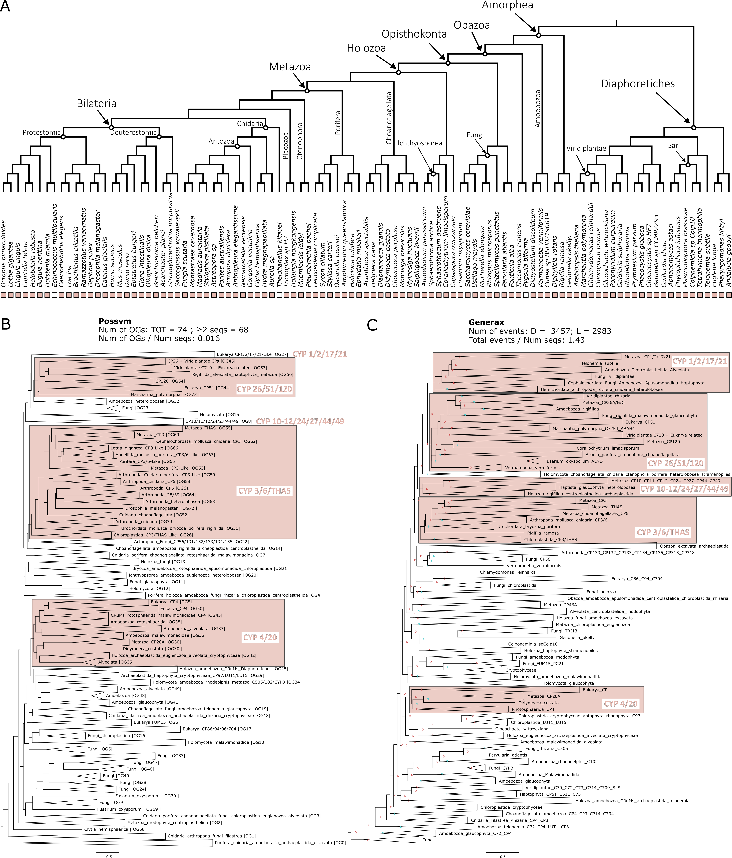

**Figure 4.11. Phylogenetic analysis for the CYP orthogroup. (A)** Distribution of the orthogroup throughout Eukarya. **(B)** Phylogenetic tree analysed with Possvm for identification of sub-orthogroups.Number of Possvm orthogroups identified (Total, and with ≥ 2 sequences) are provided, as well as the ratio between number of Possvm sub-orthogroups per number of sequences in full orthogroup are indicated. **(C)** Gene tree to species tree reconciliation using GeneRax highlighting speciation and duplication events at each node. Numbers of duplications (D) and losses (L) are provided, as well as the ratio of total events (D+L) per number of sequences in the orthogroup.

##### AOX

Aldehyde Oxidase 1 (AOX1) is responsible for the oxidation of a wide variety of aldehydes to their corresponding carboxylic acids (Terao et al. 2016). Within the retinol metabolism it can oxidise retinal to retinoate (Terao et al. 2016) (Figure 4.1), although the primary enzyme for this is ALDH1 (see above). Overall AOX1 is not to be considered specific to the retinol metabolism (Table 4.1).

The identification of the AOX orthogroup presented slight differences between OrthoFinder, which found one orthogroup, and Broccoli, that split the family into two orthogroups, the AOX and the AAO (Abscisic-aldehyde oxidase), a group of aldehyde oxidases primarily known in plants (Seo et al. 2000). The total orthogroup of AOX includes 599 sequences. It is overall present in all eukaryotes with some exceptions, e.g., ctenophores (Figure 4.12A).

Possvm identified 25 orthogroups (Figure 4.12B). The phylogenetic analysis uncovered how the Xanthine Dehydrogenase (XDH) family is closely related to the AOX. While the AAO (present primarily in Diaphoretiches) is more distantly related. This is confirmed in the reconciled GeneRax tree that also revealed a moderate number of events (Figure 4.12C). Interestingly, while the AOX clade is limited to a specific subset of animal species, the closely related XDH clade encompasses sequences from a diverse array of eukaryotes.

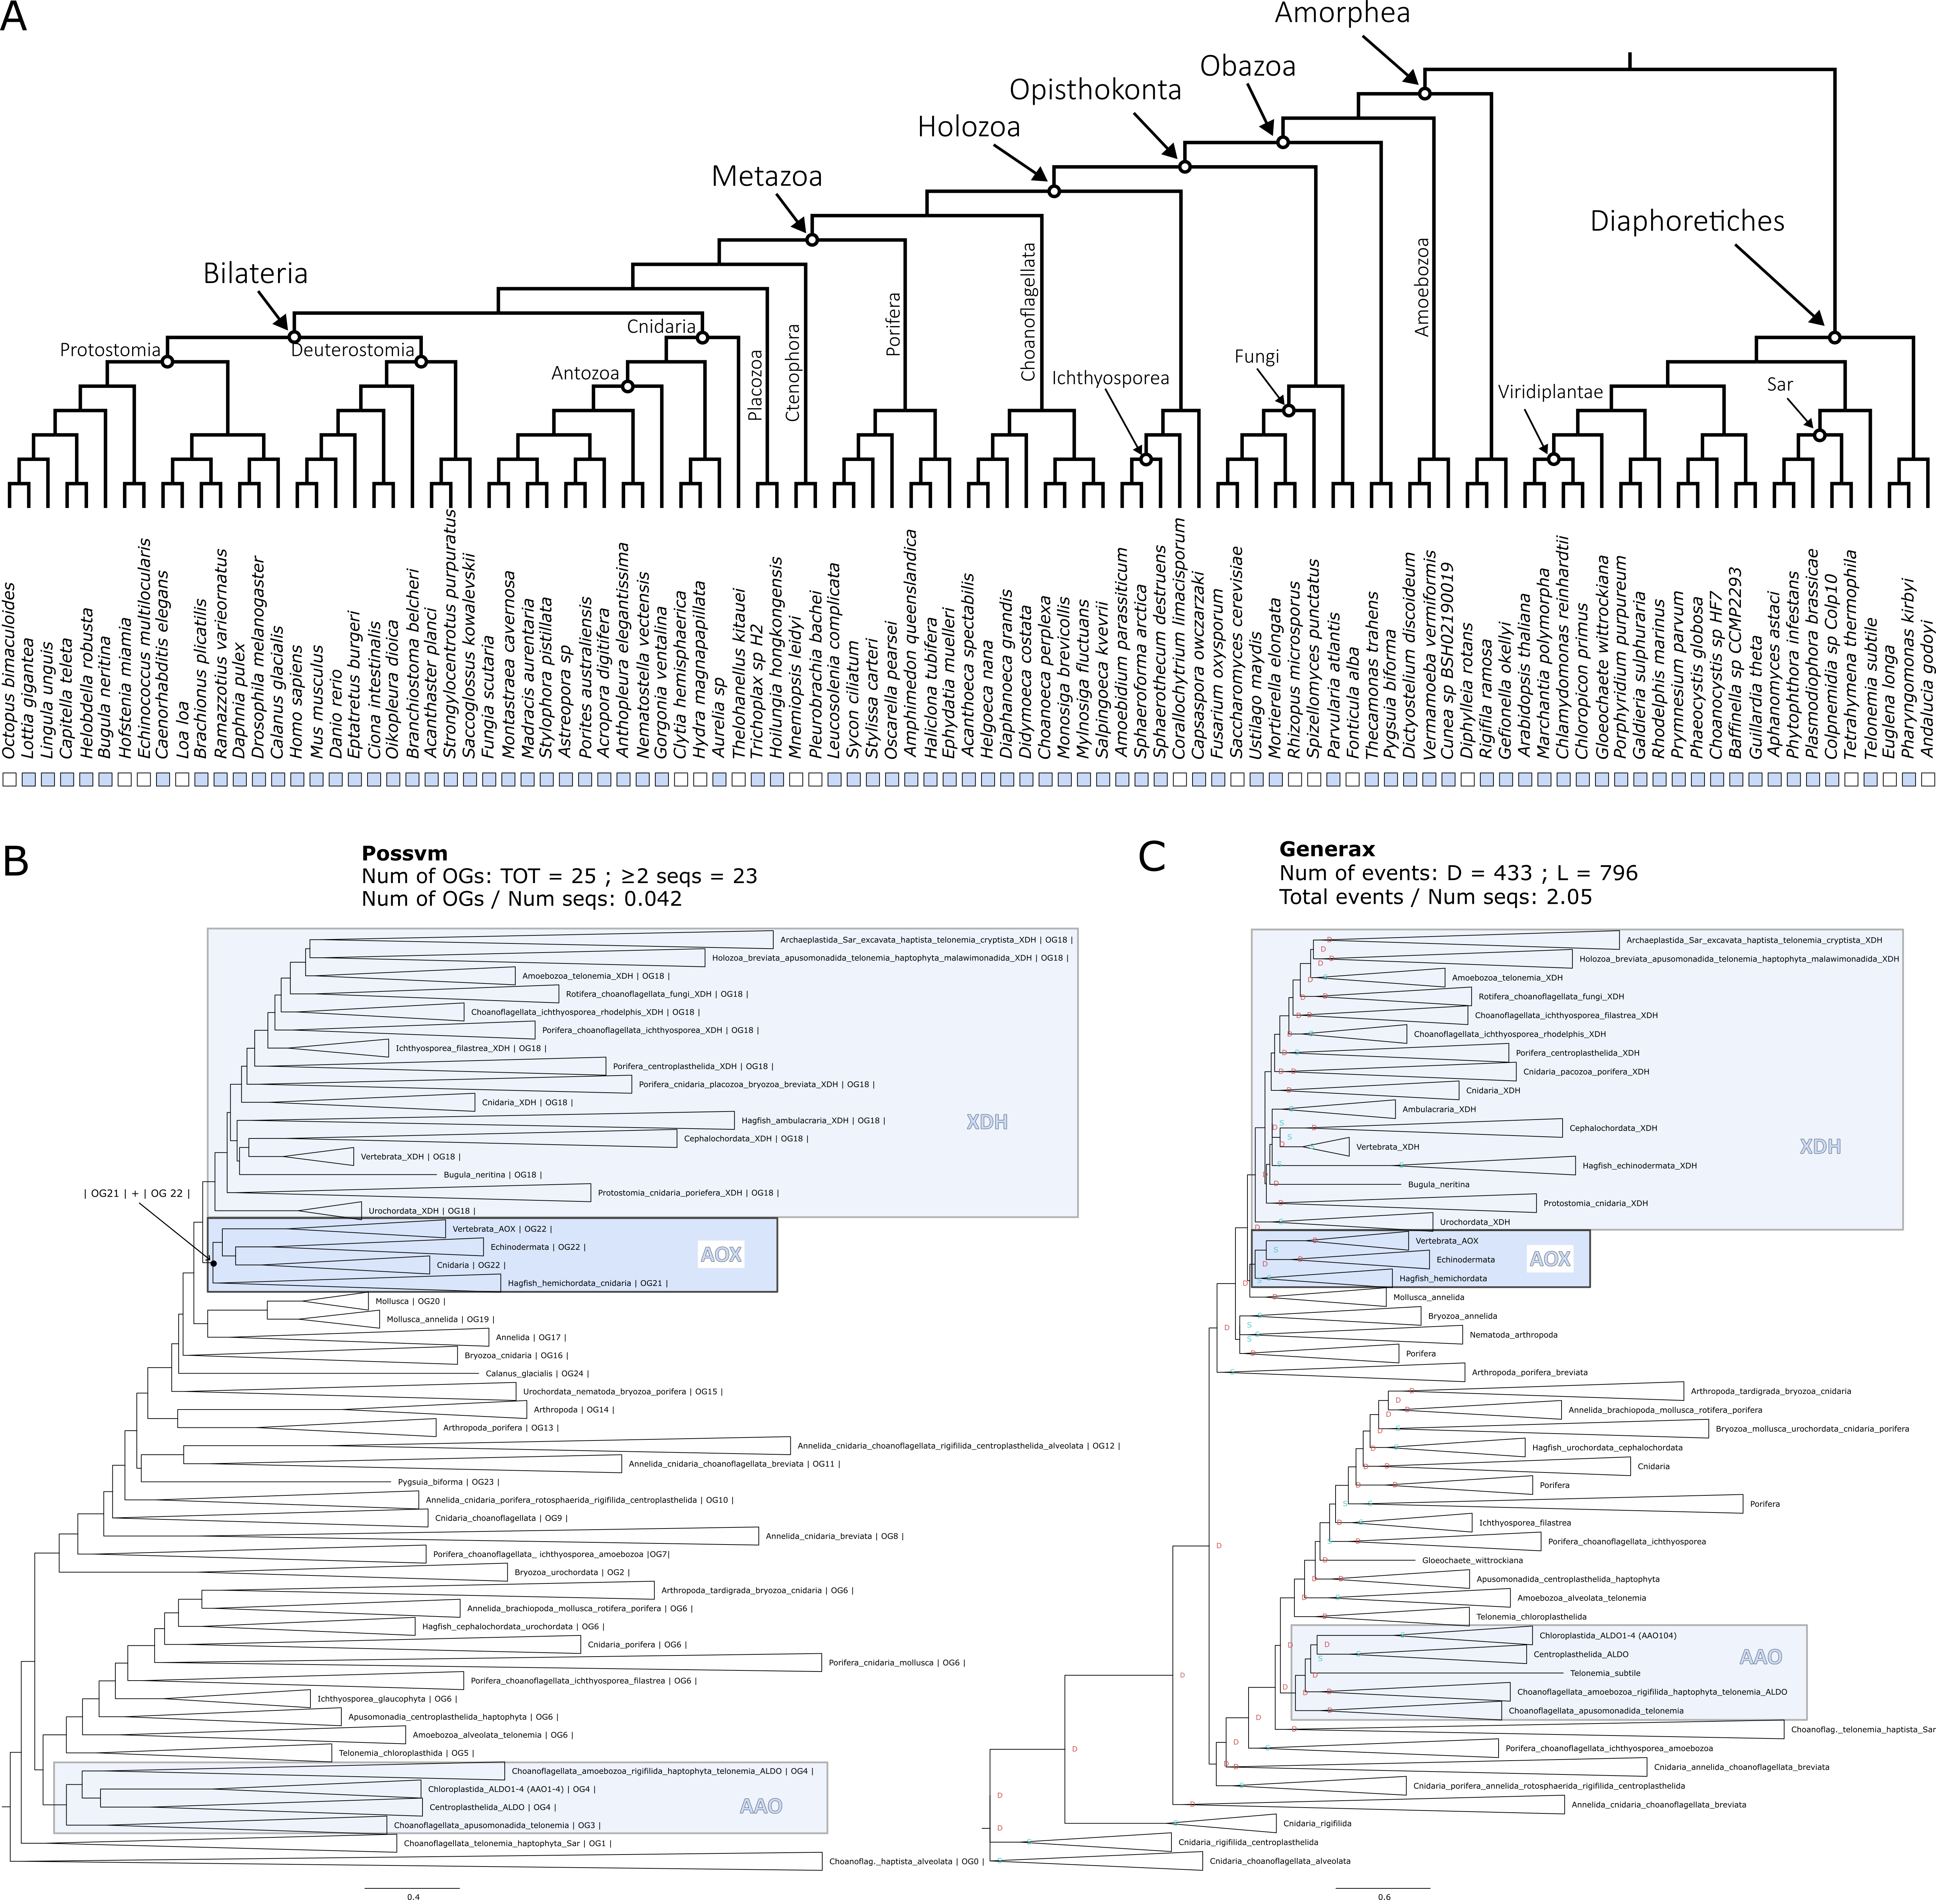

**Figure 4.12. Phylogenetic analysis for the AOX orthogroup. (A)** Distribution of the orthogroup throughout Eukarya. **(B)** Phylogenetic tree analysed with Possvm for identification of sub-orthogroups.Number of Possvm orthogroups identified (Total, and with ≥ 2 sequences) are provided, as well as the ratio between number of Possvm sub-orthogroups per number of sequences in full orthogroup are indicated. **(C)** Gene tree to species tree reconciliation using GeneRax highlighting speciation and duplication events at each node. Numbers of duplications (D) and losses (L) are provided, as well as the ratio of total events (D+L) per number of sequences in the orthogroup.

##### ADH

Alcohol dehydrogenase (ADH) enzymes play crucial roles in the metabolism of alcohols (Edenberg 2007). In the retinol metabolism ADHs play a role in the oxidation of retinol to retinal (Duester 2000) (Figure 4.1). Although RDH is the primary enzyme for this reaction, particularly within the retina, ADHs can also contribute and within humans are especially used in non-visual related tissues such as the liver (Duester 2000). Seeing as ADHs are involved in metabolising a wide variety of alcohols it is not surprising that they are involved in numerous other pathways other than the retinol metabolism (Table 4.1).

During the identification of an orthogroup for ADH, OrthoFinder placed all sequences in one orthogroup, while Broccoli split the family into two orthogroups. One primarily comprised ADH sequences, while the other was a mixed group that incorporated the related Sorbitol Dehydrogenase (SORD) (Figure 4.2). The merged orthogroup consisted of 955 sequences and was present in all but one species (Figure 4.13A).

Ortholog analysis with Possvm revealed a complex substructure, with 59 orthogroups identified (one of the highest numbers relative to orthogroup size) (Figure 4.13B). Possvm split the various ADH enzymes into different orthogroups, with ADH5 being the most distantly related. Nevertheless, all ADHs belonged to a larger monophyletic group. Other families picked up in this broad orthogroup are Cinnamyl alcohol dehydrogenase (CADH), Succinate-semialdehyde dehydrogenase (SUCD), and Sorbitol Dehydrogenase (SORD). The GeneRax reconciled tree maintains the same overall topology and a large number of events were calculated, one of the highest relative to number of sequences (Figure 4.13C). The ADH1/4/6/7 group seems to represent a mammalian-specific expansion within the family. In contrast, ADH5 appears ancient, comprising sequences from many different eukaryotic groups.

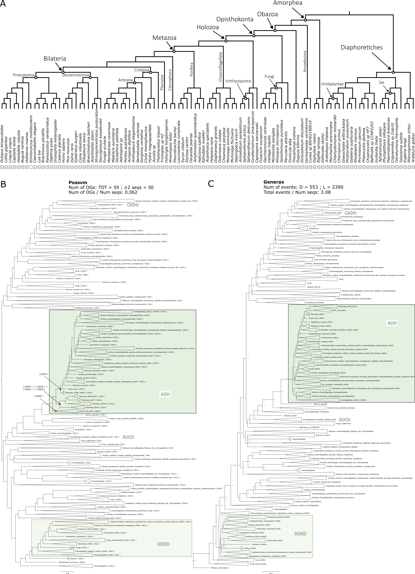

**Figure 4.13. Phylogenetic analysis for the ADH orthogroup. (A)** Distribution of the orthogroup throughout Eukarya. **(B)** Phylogenetic tree analysed with Possvm for identification of sub-orthogroups.Number of Possvm orthogroups identified (Total, and with ≥ 2 sequences) are provided, as well as the ratio between number of Possvm sub-orthogroups per number of sequences in full orthogroup are indicated. **(C)** Gene tree to species tree reconciliation using GeneRax highlighting speciation and duplication events at each node. Numbers of duplications (D) and losses (L) are provided, as well as the ratio of total events (D+L) per number of sequences in the orthogroup.

##### UGT

UDP-glucuronosyltransferase (UGT) enzymes are involved in the process of glucuronidation of small lipophilic molecules, whereby a glucuronic acid is transferred from a UDP-glucuronic acid to the small molecule, making it more water soluble and therefore easier to excrete from the body (Rowland et al. 2013). In mammals there are four UGT families: UGT1; UGT2; UGT3; and UGT8 (Meech et al. 2019). UGTs are involved in the regulation of retinoid levels in the body; by glucuronidating all-trans-retinoate to all-trans-retinoyl beta-glucuronide it facilitates the excretion of this molecule (Meech et al. 2019) (Figure 4.1). Overall, this enzyme family is very broad spectrum (Table 4.1) and involved only marginally in the retinol metabolism, nevertheless we included it in our evolutionary study.

UGTs are clearly identified as being an independent orthogroup by both OrthoFinder and Broccoli (Figure 4.2). This orthogroup consists of many sequences (1005 sequences). Interestingly, while present in both major branches of eukaryotes, it appears to be missing in several clades, including several unicellular holozoans (such as ichthyosporeans) that are closely related to animals, although it is present in the sister group to animals, the choanoflagellates (Figure 4.14A).

The phylogenetic analysis uncovers that UGT1 and UGT2 are closely related to each other, as are UGT3 and UGT8. However, all of them belong to a single monophyletic clade, which Possvm identifies as one orthogroup (Figure 4.13B). The GeneRax reconciled tree maintains this topology (Figure 4.14C). Overall, Possvm identifies a total of 21 orthogroups and GeneRax identifies the lowest ratio of events to sequences from all orthogroups examined. Collectively, this indicates that the UGT orthogroup is rather conserved. The UGT1/2/3/8 monophyletic clade predominantly consists of deuterostome (vertebrates and their close relatives) sequences within a Possvm orthogroup that includes only animal sequences. Nevertheless, the rest of the broad orthogroup contains a diverse array of eukaryotic sequences, including an apparently plant specific clade of UGTs.

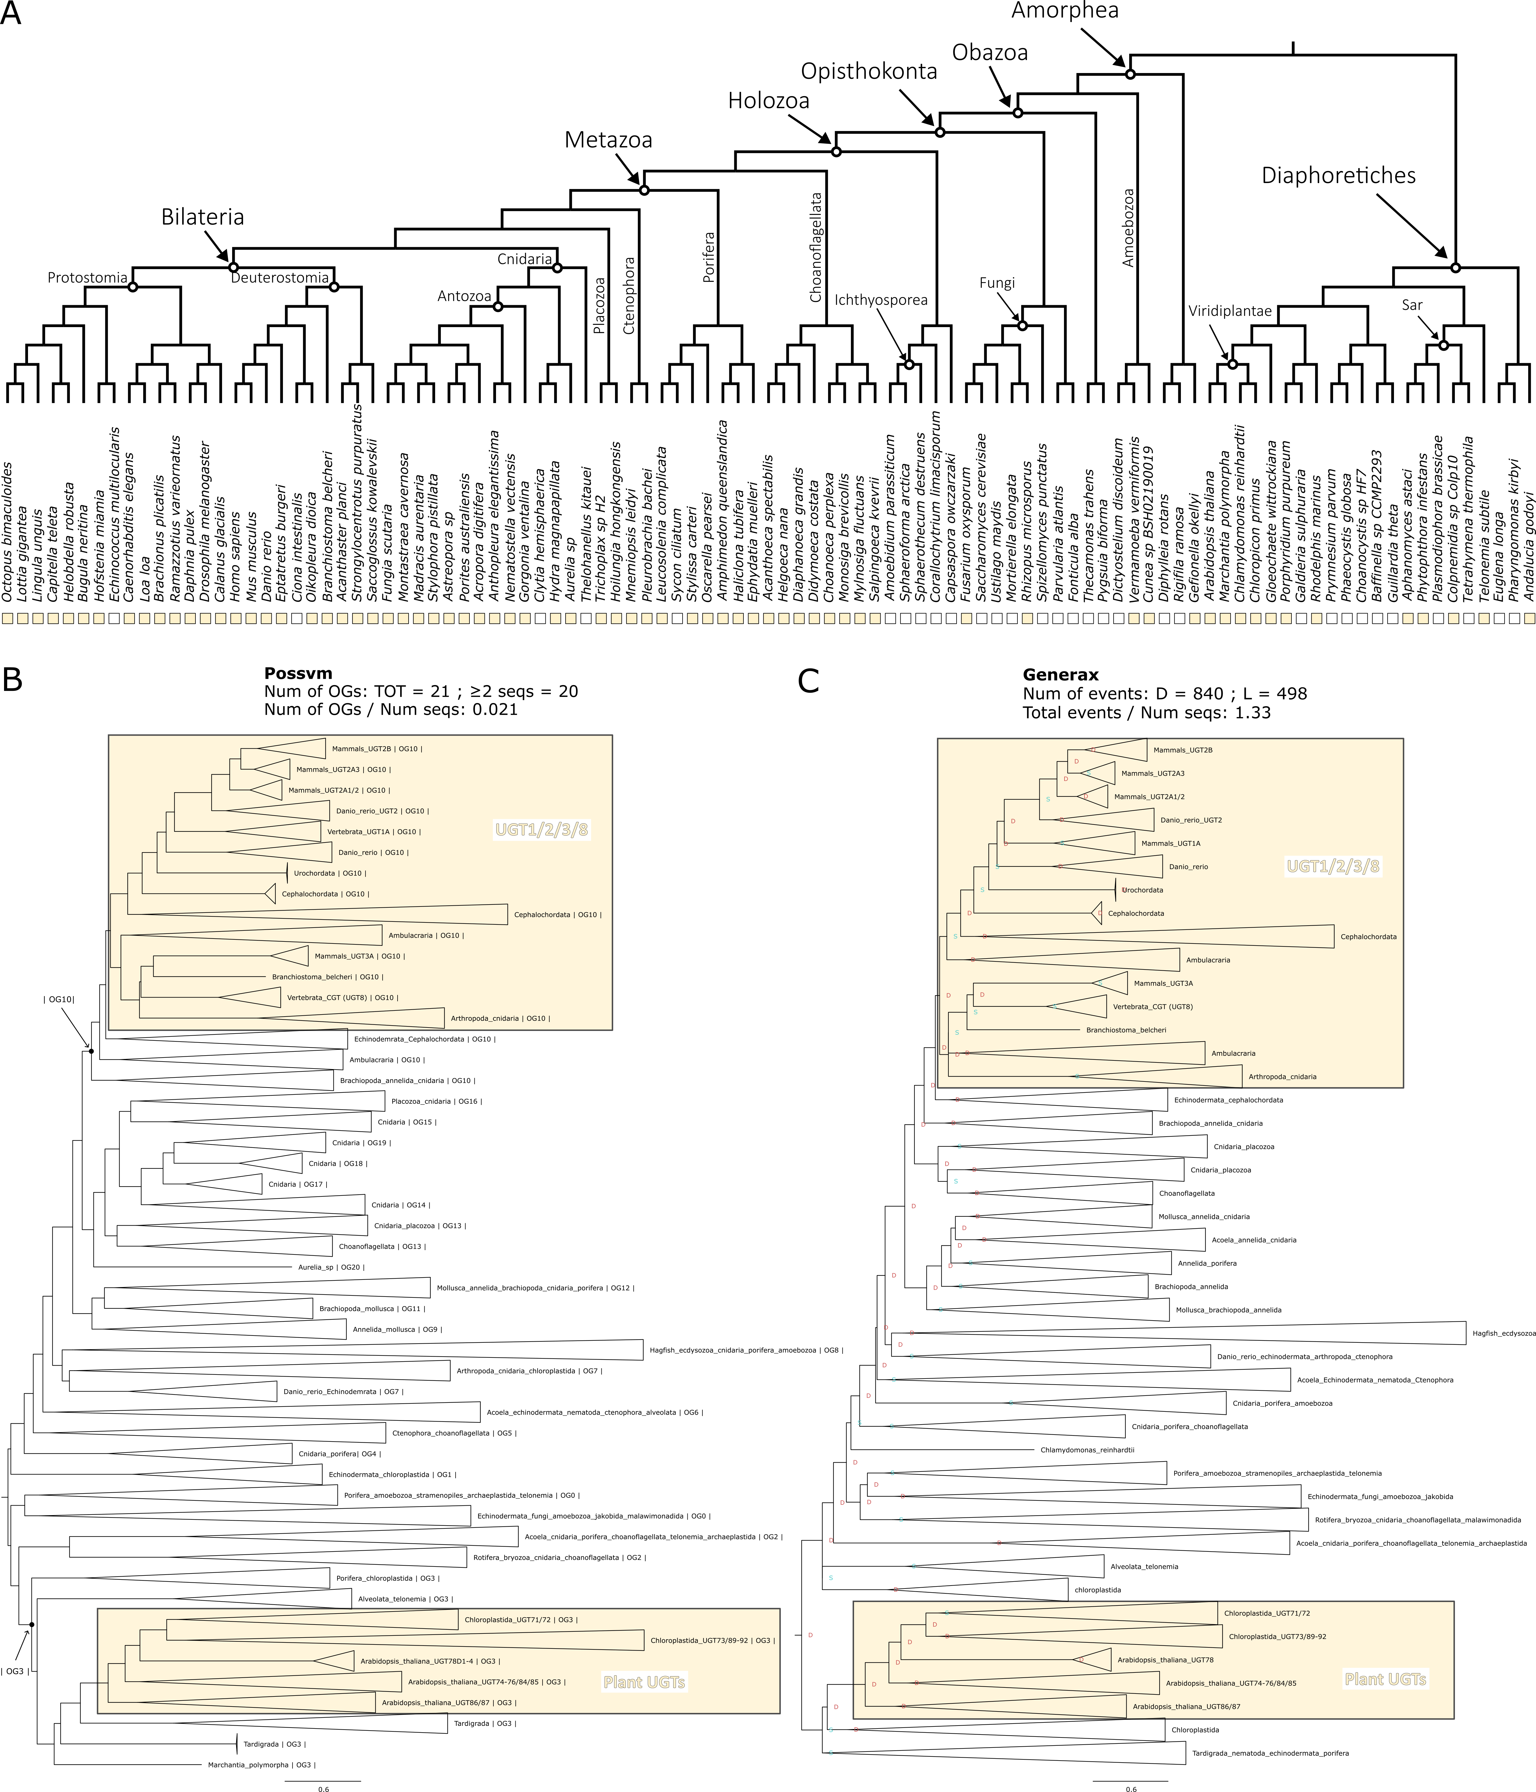

**Figure 4.13. Phylogenetic analysis for the UGT orthogroup. (A)** Distribution of the orthogroup throughout Eukarya. **(B)** Phylogenetic tree analysed with Possvm for identification of sub-orthogroups.Number of Possvm orthogroups identified (Total, and with ≥ 2 sequences) are provided, as well as the ratio between number of Possvm sub-orthogroups per number of sequences in full orthogroup are indicated. **(C)** Gene tree to species tree reconciliation using GeneRax highlighting speciation and duplication events at each node. Numbers of duplications (D) and losses (L) are provided, as well as the ratio of total events (D+L) per number of sequences in the orthogroup.

### Conclusions

Vision, a distinguishing feature of the animal kingdom, hinges on a specific light-sensitive molecule initiating the phototransduction pathway. This molecule is the visual chromophore 11-cis-retinal bound to the membrane protein opsin in photoreceptor cells. When 11-cis-retinal absorbs light, it isomerises into all-trans-retinal, setting off the phototransduction process (Lamb 2020). Continuous light detection demands that this chromophore be perpetually restored to its original 11-cis state. This is obtained through the retinol metabolism, a pathway essential to both vision and other biological functions (Blomhoff and Blomhoff 2006). Thus, understanding the origins and evolution of vision necessitates exploring the evolution of retinol metabolism, which sustains our light sensitivity.

The aim of this chapter was to comprehensively explore the evolution of retinol metabolism genes to provide insights on the origin of the pathway. Initially, I explored the relationships among the enzymes integral to the pathway, grouping them into overarching gene families or orthogroups. Subsequently, I analysed the distribution of these orthogroups across eukaryotes. Finally, I outlined the evolutionary events that have shaped the history of each respective orthogroup.

Enzymes can be classified into families based on several criteria, with enzymatic activity being one of the most predominant (Webb 1992). Through my orthogroup analyses, I sought to determine if the enzymes involved in retinol metabolism could be grouped according to their evolutionary relationships and how these groups align with established enzymatic families. My results suggest that enzymes integral to retinol metabolism can be categorized into 12 distinct orthogroups (Figure 4.2, Table 4.3). Some of these enzymes play pivotal roles in the critical steps for recycling 11-cis-retinal, while others have more peripheral functions (Figure 4.15A). This analysis generally aligned with the established enzymatic families, yet it also shed light on some unexpected findings. For instance, while Diacylglycerol O-Acyltransferase enzymes have conventionally been classified under a single overarching family, my findings provide compelling evidence that DGAT1 exhibits significant evolutionary divergence from DGAT2 and its related molecules, such as DGAT2L4, warranting their categorization into distinct orthogroups (Figure 4.2). Another example involves the enzymes responsible for converting retinol to retinal, which belong to sub-families within the expansive SDR family. While prevailing nomenclatures suggest a distinction between RDH and DHRS, the orthogroup analyses suggested a more complex web of relationships (Figure 4.2), subsequently corroborated by phylogenetic analyses (Figure 4.8). Ultimately all this suggests that within the SDR family, phylogenetic relationships may define different sub-families compared to the currently established ones.

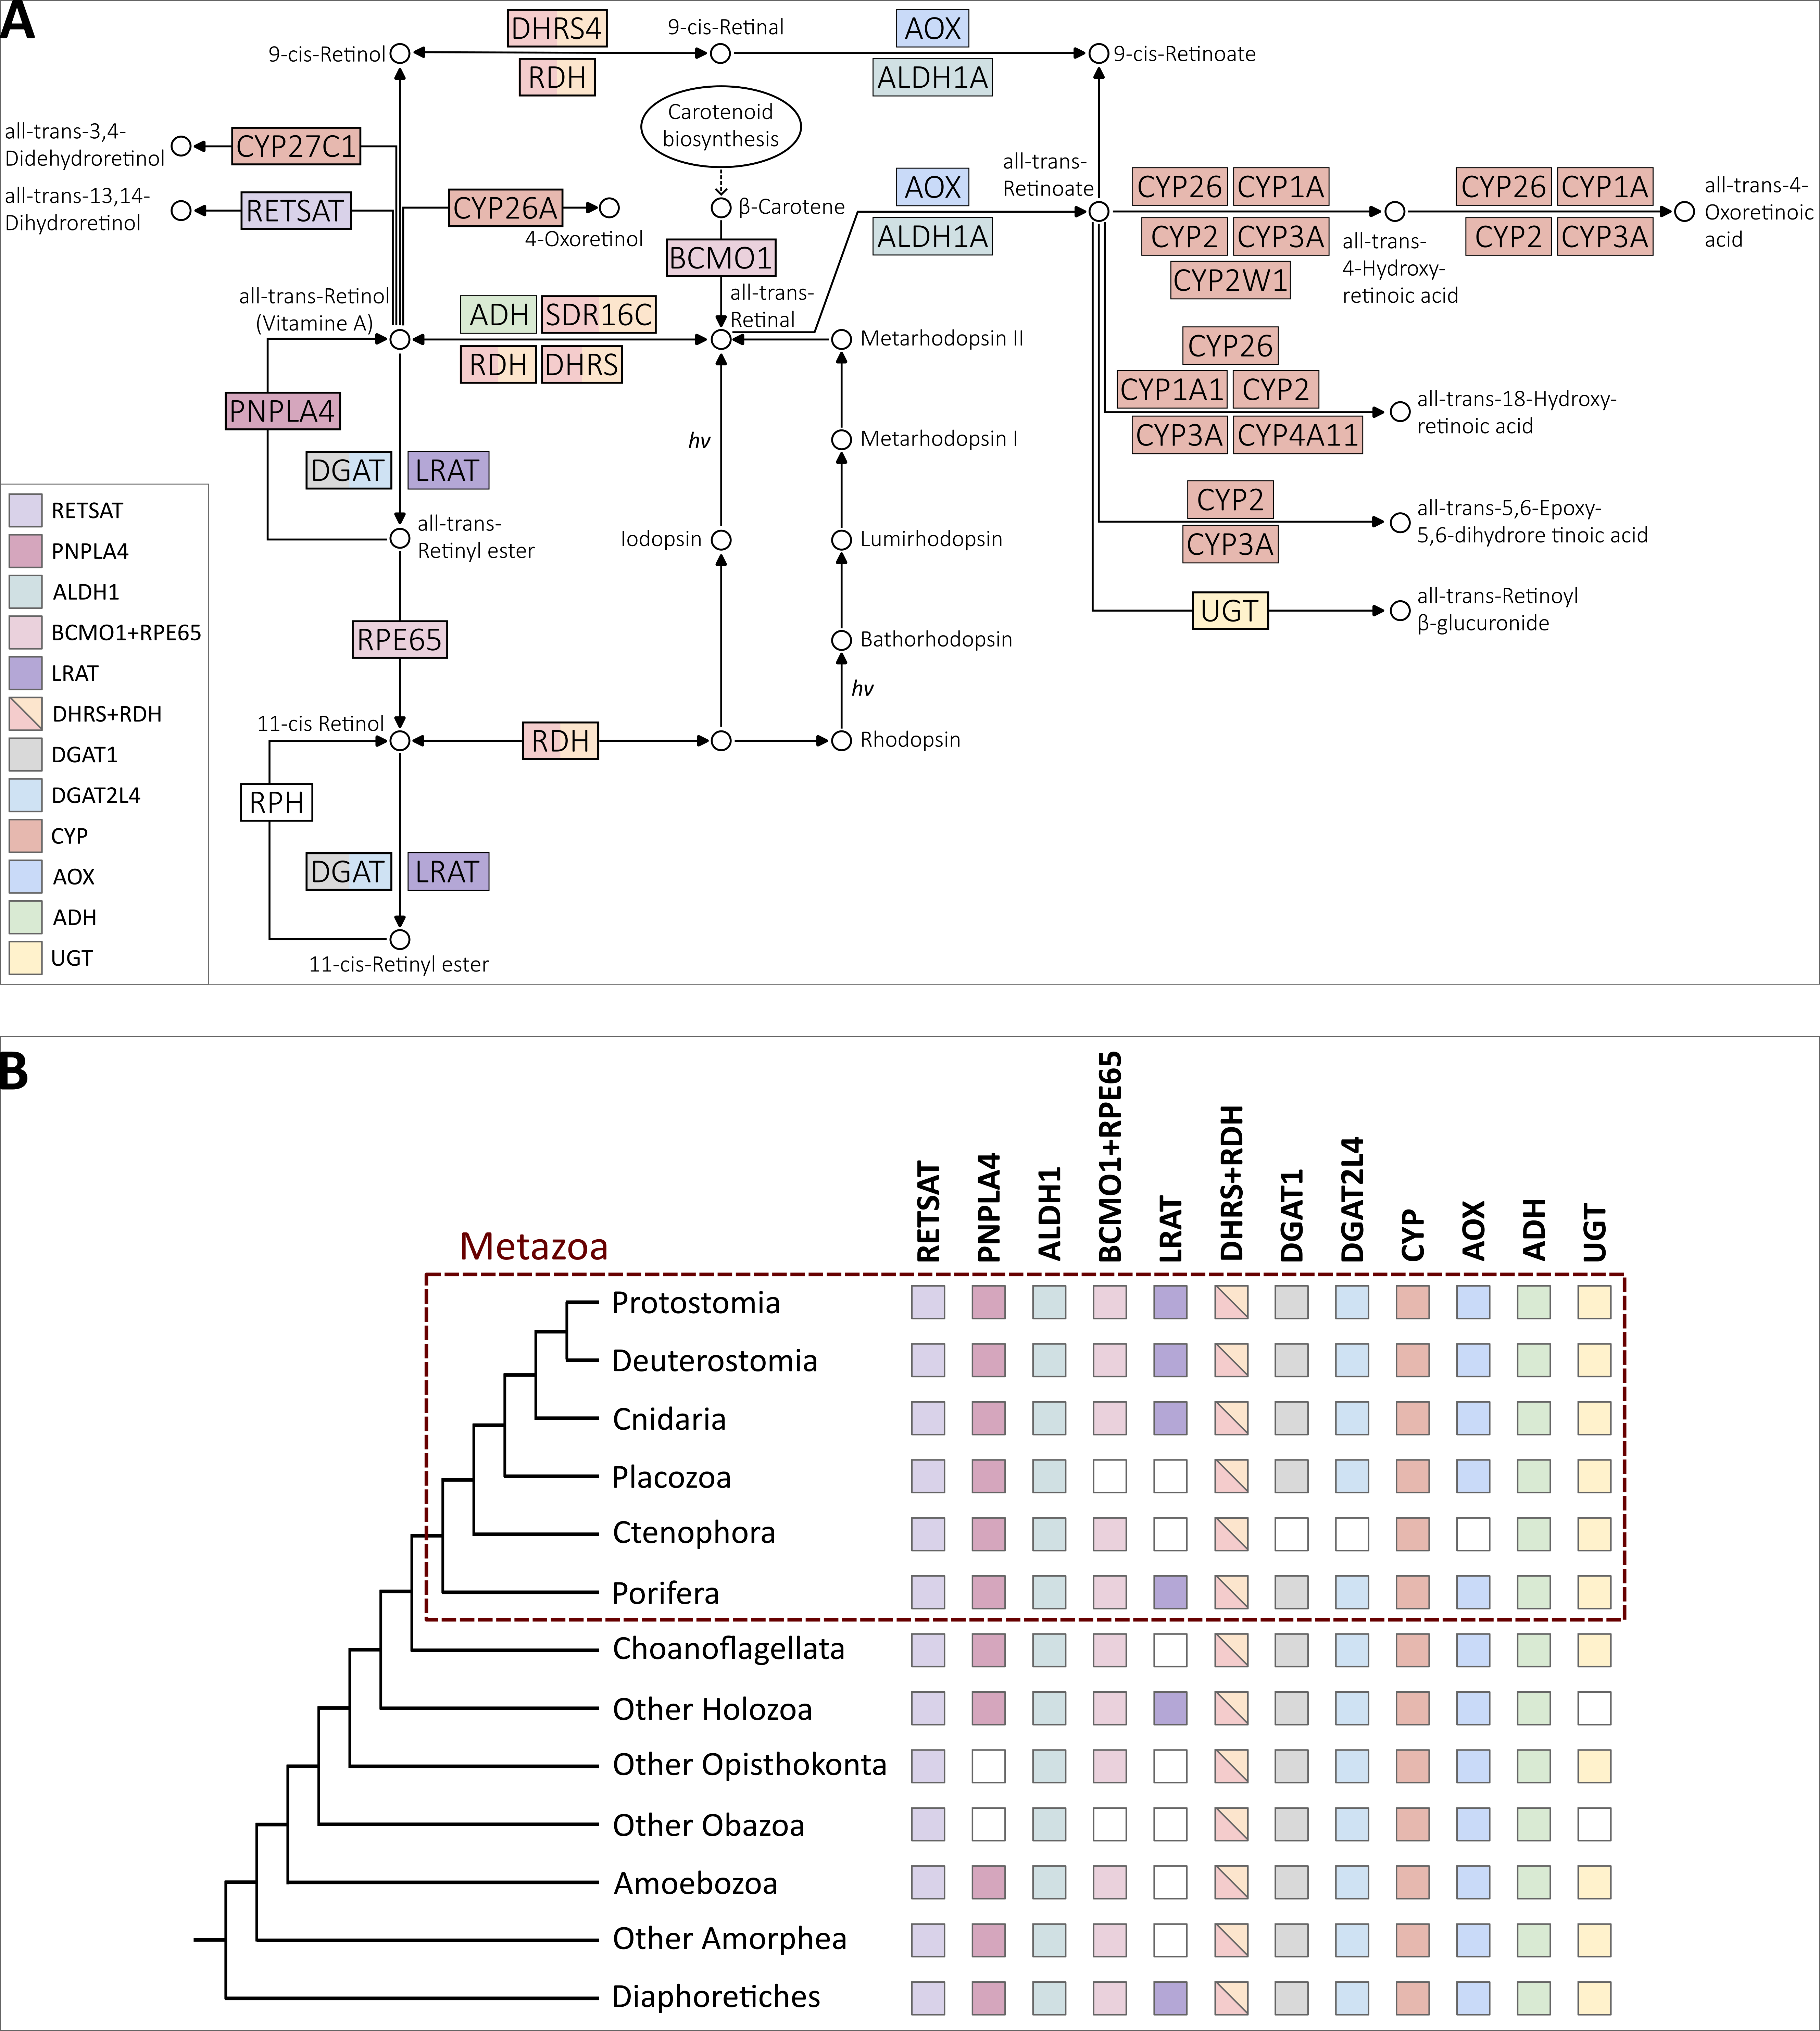

**Figure 4.15. Summary of the orthogroups to which enzymes involved in retinol metabolism belong to and their distribution. (A)** Overlap of the retinol metabolism related orthogroups identified in this study with the KEGG map00830 pathway components. Some enzymes belong to the same orthogroup (e.g., RDH and DHRS) while some are split into different orthogroups (e.g., DGAT1 and DGAT2L4). **(B)** Orthogroups are ancient and widely distributed throughout Eukarya, except LRAT.

Examining the distribution of orthogroups throughout eukaryotes, the first consideration is that most orthogroups have ancient origins, spanning the major eukaryotic clades (Figure 4.15B). The only exception is LRAT that appears to be present primarily in animals (except placozoans and ctenophores) and in a handful of other species. While orthogroups tend to be present in all major eukaryotic clades, only one orthogroup (RDH/DHRS) was present in every single species examined (Figure 4.8). Within animals, only the two non-bilaterian phyla of placozoans and ctenophores seem to lack some key orthogroups, notably BCMO1/RPE65 and LRAT, which are integral to the retinol metabolism pathway. This observation is intriguing for two main reasons. First, the absence of these enzymes might suggest that these two phyla have evolved a variant of the retinol metabolism where these missing enzymes are replaced by others. For instance, the function of LRAT can also be carried out by DGAT1 and DGAT2L4. Secondly, even though sponges lack opsins, they possess all the retinol metabolism orthogroups (although not every sponge species has all orthogroups). This has interesting implications in understanding the origin of vision. It reinforces the growing interest surrounding potential opsin-independent light-sensing processes in sponges (Wong et al. 2022), as discussed in Chapter 3.

Further insights came with the detailed phylogenetic analyses. The approach of using both Possvm and GeneRax provided a dual advantage: Possvm facilitated the swift identification and annotation of sub-orthogroups; while GeneRax ensured a thorough and accurate description of evolutionary events of duplication, speciation, and losses. These events serve as a gauge of the evolutionary intricacies (as opposed to a more linear progression) and can also account for the degree of sub-family diversity observed within orthogroups. These analyses facilitated the identification of orthogroups with particularly complex evolutionary histories. For instance, the ADH orthogroup showcased one of the highest ratios of sub-orthogroups to sequences and also had one of the highest ratios of evolutionary events to sequences. Furthermore, through these analyses, we can juxtapose orthogroups of comparable sizes. This allows, for example, to discriminate between large orthogroups with simple subgroup structure, such as CYP, and large orthogroups with more intricate substructures, like RDH/DHRS.

Another compelling insight from the phylogenetic analyses was the refined understanding of distribution patterns within Eukarya, allowing for a detailed mapping of subgroup distributions beyond just the overarching orthogroups. An intriguing observation that emerged was that precisely the enzymes that are most specific to retinol metabolism (PNPALA4, ALDH1, BCMO1/RPE65) presented a distinctive pattern where the overarching orthogroups spanned across Eukarya, but the sub-families actively utilized in the pathway were predominantly animal specific. This suggests that animal specific expansions of these enzyme families may have evolved concurrently with the development of vision. However, it should be noted that other sub-families within those orthogroups might still hold the potential to execute similar functions.

To conclude, the ancient origin of the enzyme families involved in the replenishment of 11-cis-retinal suggest that the foundational molecular framework was already in place well before the emergence of vision. Expansions in these enzymes families during early animal evolution could have steered this pathway towards its specialized role in visual functions. This study’s detailed reconstruction of retinol metabolism enzyme families paves the way for exploring a whole new set of questions regarding the evolution of vision. One vital question that arises is whether the enzymes identified bioinformatically within early-branching animals, truly operate in a physiological setting to facilitate the recycling of 11-cis-retinal in these animals. This is an especially fascinating enquiry to pursue for organisms like sponges which, lacking opsins, in theory should not rely on this pathway for vision. Another intriguing avenue for future research is to understand the evolution of the cell types involved in this pathway. In the human retina, for instance, several cell types, including the Retinal Pigment Epithelium (RPE) cells and Mueller cells, play roles in the visual chromophore replenishment (Arshavsky 2002; Mata et al. 2002; Thompson and Gal 2003; Moiseyev et al. 2005; Strauss 2005). It would be interesting to determine whether homologous functions are carried out by homologous cell types throughout animals, including in early-branching animals. Alternatively, different animals might manage parts of the pathway using unrelated cell types or execute the functions within a single cell type. Thus, future research on the evolution of vision should expand their focus beyond just the evolution of photoreceptor cells, which perform phototransduction, to also include cell types implicated in retinol metabolism.

### Methods

#### Identification of orthogroups for retinol metabolism enzymes.

##### Species list and species tree

To understand the evolution of the retinol metabolism, I selected 101 eukaryotic species (Table 4.2 and Extended Table 4.2) in which to search for the genes involved in the pathway. The choice of species was based on a combination of balanced taxonomic sampling throughout Eukarya and quality of the proteomes. The latter was assessed using BUSCO (v4.0.6) (Simão et al. 2015; Waterhouse et al. 2018) with the eukaryota_odb10 database. The final selection included 50 animals, of which 25 non-bilaterians, 13 unicellular holozoans closely related to animals, and various other species from all major eukaryotic clades.

The single-copy BUSCO genes obtained from the BUSCO analysis were also used to construct a species tree. This is because knowledge of species relationships can be used both for orthogroup inference with the OrthoFinder software (Emms and Kelly 2015; Emms and Kelly 2019) and to construct species-tree-aware gene trees (Boussau and Scornavacca 2020) using software such as GeneRax (Morel et al. 2020) (see more details below). The species tree was constructed by: aligning single-copy BUSCO genes with MAFFT v7.470 (--auto) (Katoh et al. 2002; Katoh and Standley 2013); trimming alignments with Trimal v1.4.rev22 (-automated1) (Capella-Gutiérrez et al. 2009); concatenating alignments into a super-matrix using FASconCAT v1.11 (Kück and Meusemann 2010); maximum-likelihood tree construction using IQTREE v2.0.6 (Hoang et al. 2018; Minh et al. 2020) after identifying the best-fitting phylogenetic model with the IQTREE2 Model Finder (Kalyaanamoorthy et al. 2017). The resulting tree was inspected to confirm that species and phyla relationships were compatible with the known literature and where necessary Mesquite v3.6.1 (Maddison and Maddison 2008) was used to correct branch positions. The species tree used in this chapter (available on GitHub) places sponges as sister-group to all other animals as this is one of the currently accepted scenarios (Feuda et al. 2017; McCarthy et al. 2023; Schultz et al. 2023). Furthermore, my previous work presented in Chapter 3 showed that no substantial difference was detected between sponge-first and ctenophore-first scenarios when performing gene-tree to species-tree reconciliations using a eukaryotic-wide set of organisms (see Supplementary Table S3.2).

##### Data mining

Enzymes for the retinol metabolism were chosen based on the pathway described on KEGG Database (KEGG map00830) (Kanehisa et al. 2021). Queries for BLASTP were collected from the KEGG Orthology lists (Kanehisa 2019) for each component of the pathway. BLASTP (Camacho et al. 2009) was conducted (with e-value threshold of 1e-5) for each query against the species database. To provide a preliminary annotation also for sequences from non-annotated non-model organisms, these were BLASTed versus the SwissProt Database (Poux et al. 2017) and the top hit was used as an approximate annotation.

##### Orthogroup inference

The results from BLASTP, organised by species, were used as “mini-proteomes” for orthogroup inference. By having reduced species proteomes by narrowing down to sequences with sequence similarity with the target enzymes of interest, it is in fact possible to reduce the computational load which is quite extensive for this type of analysis on large numbers of species. Two alternative methodologies for orthogroup inferences were used and compared in this work. In this way it was possible to verify the consistency of results when using different software. It also allowed to make sure not to miss out any potential sequences belonging to the orthogroups for the enzymes under investigation.

###### OrthoFinder

To insure best possible accuracy, OrthoFinder v.2.5.4 (Emms and Kelly 2015; Emms and Kelly 2019) was run with BLAST search (instead of default DIAMOND) and with the MSA workflow (using the default MAFFT for alignment and FastTree for tree inference). Furthermore, the species tree was provided (see above) rather than inferred by OrthoFinder. The inflation parameter used for MCL clustering was 1.3.

###### Broccoli

Broccoli v1.2.1 (Derelle et al. 2020) was run with kmer length for sequence clustering set to 80 to account for the distantly related species analysed; for the phylogeny step, maximum likelihood was chosen to maximise accuracy. Finally, regarding the species overlap parameter, several values were tested and finally the value of 0.9 was found to be the best compromise between orthogroup accuracy (usually obtained with lower values) and avoidance of orthogroup fragmentation.

##### Filtering and annotation of orthogroups

To reach the goal of identifying orthogroups for the enzymes involved in the retinol metabolism, the orthogroups inferred by OrthoFinder and Broccoli must be annotated and potential unrelated orthogroups discarded. As a first step, all orthogroups that contained less than 4 sequences, or less than 4 species were discarded. Then, all sequences from each orthogroup were annotated using EggNog mapper (Cantalapiedra et al. 2021). One of the annotation fields outputted by EggNog is KEGG_pathways. Therefore, this was used to filter out any orthogroup that did not contain at least one sequence that obtained the KEGG map00830 (retinol metabolism) annotation. In this way it was possible to narrow down the number of orthogroups to analyse to identify orthogroups for our target enzymes. The remaining orthogroups were annotated by identifying the human sequences contained in them.

##### Comparison of OrthoFinder and Broccoli results and definition of final orthogroups

All enzymes known to be involved in the retinol metabolism were recovered as one or more orthogroup by both OrthoFinder and Broccoli. To assess the consistency between the results of the two methods, the next step was to compare the orthogroups by checking percentage of shared identical sequences amongst all OrthoFinder and Broccoli orthogroups (Figure 4.2). This comparison was visualised using Cytoscape v3.9.1 (Shannon et al. 2003), where orthogroups are represented as nodes and edges connecting the nodes represent the percentage of identical sequences shared between orthogroups. One-to-one correspondence with high percentage of identify was recovered in most cases and overall, it was possible to clearly establish the correspondence between OrthoFinder and Broccoli orthogroups. Final orthogroups used for subsequent phylogenetic analyses were the combined sequences collected with OrthoFinder and Broccoli. Cd-hit (Li et al. 2001; Fu et al. 2012) was used to remove duplicates with 100% identity after merging OrthoFinder and Broccoli orthogroups.

#### Reconstructing the evolutionary history for each orthogroup.

##### Phylogenetic Trees

A phylogenetic analysis was conducted for each orthogroup separately. Sequences from each orthogroup were aligned using MAFFT (--auto) (Katoh et al. 2002; Katoh and Standley 2013) and then trimmed using Trimal (with -gt 0.3 to remove columns with more than 70% gaps) (Capella-Gutiérrez et al. 2009). Resulting multiple sequence alignments were used for phylogenetic tree construction under maximum-likelihood using IQTREE2 (Hoang et al. 2018; Minh et al. 2020) after best-fit model testing (Kalyaanamoorthy et al. 2017).

##### Identifying clusters of orthologs with Possvm

The resulting gene trees were then further examined with Possvm (Grau-Bové and Sebé-Pedrós 2021), a tool that aids in identifying clusters of orthologs within gene trees facilitating the annotation process which, especially for large trees, can be very time consuming. A further advantage of this method is that it does not require a species tree as input for the ortholog sorting, eliminating potential biases related to disputed species relationships. Possvm was run using default parameters. As a result, each orthogroup corresponding to a broad enzyme family was further subdivided into smaller orthogroups corresponding to specific sub-families.

##### Reconstructing evolutionary events with GeneRax

Each gene tree was also reconciled to a species tree using GeneRax (Morel et al. 2020) enabling tree rooting and the discerning of speciation, duplication and loss events characterising each gene tree. The species tree used for reconciliation places sponges as sister-group to all other animals (see above) as this is one of the current accepted scenarios. Moreover, by comparing the reconciled trees with the Possvm-annotated tree, it is possible to control for potential inconsistencies and further investigate if the placement of sponges influenced them. Before running GeneRax, any polytomy in the gene trees were randomly resolved using ETE3 (Huerta-Cepas et al. 2016). GeneRax was run with the UndatedDL model that accounts for duplication and losses but not horizontal gene transfer events.

### Data Availability

Additional supplementary material and raw output files are available at the GitHub

repository: https://github.com/AAleotti/PhD_Thesis.

### Acknowledgements

For this chapter I would like to thank Riccardo Kyriacou who during his time as a summer intern assisted me in optimising Broccoli parameters for orthogroup detection and then comparing Broccoli orthogroups with those from OrthoFinder using Cytoscape. My thanks also go to Julien Devilliers for his invaluable coding assistance, which facilitated the automation of various steps within this chapter.

### References

Arne JM, Widjaja-Adhi MAK, Hughes T, Huynh KW, Silvaroli JA, Chelstowska S, Moiseenkova-Bell VY, Golczak M. 2017. Allosteric modulation of the substrate specificity of acyl-CoA wax alcohol acyltransferase 2. *Journal of Lipid Research* [Internet] 58:719–730. Available from: https://www.jlr.org/article/S0022-2275(20)33849-9/abstract

Arshavsky VY. 2002. Like Night and Day: Rods and Cones Have Different Pigment Regeneration Pathways. *Neuron* [Internet] 36:1–3. Available from: https://www.sciencedirect.com/science/article/pii/S0896627302009376

Batten ML, Imanishi Y, Maeda T, Tu DC, Moise AR, Bronson D, Possin D, Gelder RNV, Baehr W, Palczewski K. 2004. Lecithin-retinol Acyltransferase Is Essential for Accumulation of All-trans-Retinyl Esters in the Eye and in the Liver *. *Journal of Biological Chemistry* [Internet] 279:10422–10432. Available from: https://www.jbc.org/article/S0021-9258(17)47699-X/abstract

Bhatt-Wessel B, Jordan TW, Miller JH, Peng L. 2018. Role of DGAT enzymes in triacylglycerol metabolism. *Archives of Biochemistry and Biophysics* [Internet] 655:1–11. Available from: https://www.sciencedirect.com/science/article/pii/S0003986118301905

Blaner WS. 2017. Acyl-CoA wax alcohol acyltransferase 2: its regulation and actions in support of color vision1. *Journal of Lipid Research* [Internet] 58:633–635. Available from: https://www.jlr.org/article/S0022-2275(20)33841-4/abstract

Blaner WS, Das SR, Gouras P, Flood MT. 1987. Hydrolysis of 11-cis- and all-trans-retinyl palmitate by homogenates of human retinal epithelial cells. *Journal of Biological Chemistry* [Internet] 262:53–58. Available from: https://www.sciencedirect.com/science/article/pii/S0021925819758864

Blaner WS, Prystowsky JH, Smith JE, Goodman DS. 1984. Rat liver retinyl palmitate hydrolase activity. Relationship to cholesteryl oleate and triolein hydrolase activities. *Biochimica et Biophysica Acta (BBA) - Lipids and Lipid Metabolism* [Internet] 794:419–427. Available from: https://www.sciencedirect.com/science/article/pii/0005276084900080

Blomhoff R, Blomhoff HK. 2006. Overview of retinoid metabolism and function. *Journal of Neurobiology* [Internet] 66:606–630. Available from: https://onlinelibrary.wiley.com/doi/abs/10.1002/neu.20242

Boussau B, Scornavacca C. 2020. Reconciling Gene trees with Species Trees. In: Scornavacca C, Delsuc F, Galtier N, editors. Phylogenetics in the Genomic Era. No commercial publisher | Authors open access book. p. 3.2:1-3.2:23. Available from: https://hal.science/hal-02535529

Camacho C, Coulouris G, Avagyan V, Ma N, Papadopoulos J, Bealer K, Madden TL. 2009. BLAST+: architecture and applications. *BMC Bioinformatics* [Internet] 10:421. Available from: https://doi.org/10.1186/1471-2105-10-421

Cantalapiedra CP, Hernández-Plaza A, Letunic I, Bork P, Huerta-Cepas J. 2021. eggNOG-mapper v2: Functional Annotation, Orthology Assignments, and Domain Prediction at the Metagenomic Scale. Available from: https://www.biorxiv.org/content/10.1101/2021.06.03.446934v2

Capella-Gutiérrez S, Silla-Martínez JM, Gabaldón T. 2009. trimAl: a tool for automated alignment trimming in large-scale phylogenetic analyses. *Bioinformatics* [Internet] 25:1972–1973. Available from: https://doi.org/10.1093/bioinformatics/btp348

Cheng JB, Russell DW. 2004. Mammalian Wax Biosynthesis: II. EXPRESSION CLONING OF WAX SYNTHASE cDNAs ENCODING A MEMBER OF THE ACYLTRANSFERASE ENZYME FAMILY *. *Journal of Biological Chemistry* [Internet] 279:37798–37807. Available from: https://www.jbc.org/article/S0021-9258(20)73052-8/abstract

Corbo JC. 2021. Vitamin A1/A2 chromophore exchange: Its role in spectral tuning and visual plasticity. *Developmental Biology* [Internet] 475:145–155. Available from: https://www.sciencedirect.com/science/article/pii/S0012160621000543

Derelle R, Philippe H, Colbourne JK. 2020. Broccoli: Combining Phylogenetic and Network Analyses for Orthology Assignment. *Molecular Biology and Evolution* [Internet] 37:3389–3396. Available from: https://doi.org/10.1093/molbev/msaa159

Dewett D, Labaf M, Lam-Kamath K, Zarringhalam K, Rister J. 2021. Vitamin A deficiency affects gene expression in the Drosophila melanogaster head. *G3 Genes|Genomes|Genetics* [Internet] 11:jkab297. Available from: https://doi.org/10.1093/g3journal/jkab297

Dewett D, Lam-Kamath K, Poupault C, Khurana H, Rister J. 2021. Mechanisms of vitamin A metabolism and deficiency in the mammalian and fly visual system. *Developmental Biology* [Internet] 476:68–78. Available from: https://www.sciencedirect.com/science/article/pii/S0012160621000762

Duester G. 2000. Families of retinoid dehydrogenases regulating vitamin A function. *European Journal of Biochemistry* [Internet] 267:4315–4324. Available from: https://onlinelibrary.wiley.com/doi/abs/10.1046/j.1432-1327.2000.01497.x

Edenberg HJ. 2007. The Genetics of Alcohol Metabolism: Role of Alcohol Dehydrogenase and Aldehyde Dehydrogenase Variants. *Alcohol Res Health* [Internet] 30:5–13. Available from: https://www.ncbi.nlm.nih.gov/pmc/articles/PMC3860432/

Emms DM, Kelly S. 2015. OrthoFinder: solving fundamental biases in whole genome comparisons dramatically improves orthogroup inference accuracy. *Genome Biology* [Internet] 16:157. Available from: https://doi.org/10.1186/s13059-015-0721-2

Emms DM, Kelly S. 2019. OrthoFinder: phylogenetic orthology inference for comparative genomics. *Genome Biology* [Internet] 20:238. Available from: https://doi.org/10.1186/s13059-019-1832-y

Enright JM, Toomey MB, Sato S, Temple SE, Allen JR, Fujiwara R, Kramlinger VM, Nagy LD, Johnson KM, Xiao Y, et al. 2015. Cyp27c1 Red-Shifts the Spectral Sensitivity of Photoreceptors by Converting Vitamin A1 into A2. *Current Biology* [Internet] 25:3048–3057. Available from: https://www.cell.com/current-biology/abstract/S0960-9822(15)01246-4

Feuda R, Dohrmann M, Pett W, Philippe H, Rota-Stabelli O, Lartillot N, Wörheide G, Pisani D. 2017. Improved Modeling of Compositional Heterogeneity Supports Sponges as Sister to All Other Animals. *Current Biology* [Internet] 27:3864-3870.e4. Available from: https://www.sciencedirect.com/science/article/pii/S0960982217314537

Fu L, Niu B, Zhu Z, Wu S, Li W. 2012. CD-HIT: accelerated for clustering the next-generation sequencing data. *Bioinformatics* [Internet] 28:3150–3152. Available from: https://doi.org/10.1093/bioinformatics/bts565

Grau-Bové X, Sebé-Pedrós A. 2021. Orthology Clusters from Gene Trees with Possvm. *Molecular Biology and Evolution* [Internet] 38:5204–5208. Available from: https://doi.org/10.1093/molbev/msab234

Hardie RC, Juusola M. 2015. Phototransduction in Drosophila. *Current Opinion in Neurobiology* [Internet] 34:37–45. Available from: https://www.sciencedirect.com/science/article/pii/S0959438815000173

Harrison EH. 2012. Mechanisms involved in the intestinal absorption of dietary vitamin A and provitamin A carotenoids. *Biochimica et Biophysica Acta (BBA) - Molecular and Cell Biology of Lipids* [Internet] 1821:70–77. Available from: https://www.sciencedirect.com/science/article/pii/S1388198111000849

Hirschberg J. 2001. Carotenoid biosynthesis in flowering plants. *Current Opinion in Plant Biology* [Internet] 4:210–218. Available from: https://www.sciencedirect.com/science/article/pii/S1369526600001631

Hoang DT, Chernomor O, von Haeseler A, Minh BQ, Vinh LS. 2018. UFBoot2: Improving the Ultrafast Bootstrap Approximation. *Molecular Biology and Evolution* [Internet] 35:518–522. Available from: https://doi.org/10.1093/molbev/msx281

Holmes RS. 2012. Vertebrate patatin-like phospholipase domain-containing protein 4 (PNPLA4) genes and proteins: a gene with a role in retinol metabolism. *3 Biotech* [Internet] 2:277–286. Available from: https://doi.org/10.1007/s13205-012-0063-7

Huerta-Cepas J, Serra F, Bork P. 2016. ETE 3: Reconstruction, Analysis, and Visualization of Phylogenomic Data. *Molecular Biology and Evolution* [Internet] 33:1635–1638. Available from: https://doi.org/10.1093/molbev/msw046

Hussain Z, Uyama T, Tsuboi K, Ueda N. 2017. Mammalian enzymes responsible for the biosynthesis of N-acylethanolamines. *Biochimica et Biophysica Acta (BBA) - Molecular and Cell Biology of Lipids* [Internet] 1862:1546–1561. Available from: https://www.sciencedirect.com/science/article/pii/S1388198117301737

Jin M, Li S, Moghrabi WN, Sun H, Travis GH. 2005. Rpe65 Is the Retinoid Isomerase in Bovine Retinal Pigment Epithelium. *Cell* [Internet] 122:449–459. Available from: https://www.cell.com/cell/abstract/S0092-8674(05)00696-3

Kalyaanamoorthy S, Minh BQ, Wong TKF, von Haeseler A, Jermiin LS. 2017. ModelFinder: fast model selection for accurate phylogenetic estimates. *Nat Methods* [Internet] 14:587–589. Available from: https://www.nature.com/articles/nmeth.4285

Kanehisa M. 2019. Toward understanding the origin and evolution of cellular organisms. *Protein Science* [Internet] 28:1947–1951. Available from: https://onlinelibrary.wiley.com/doi/abs/10.1002/pro.3715

Kanehisa M, Sato Y, Kawashima M. 2021. KEGG mapping tools for uncovering hidden features in biological data. *Protein Science* [Internet] n/a. Available from: https://onlinelibrary.wiley.com/doi/abs/10.1002/pro.4172

Katoh K, Misawa K, Kuma K, Miyata T. 2002. MAFFT: a novel method for rapid multiple sequence alignment based on fast Fourier transform. *Nucleic Acids Research* [Internet] 30:3059–3066. Available from: https://doi.org/10.1093/nar/gkf436

Katoh K, Standley DM. 2013. MAFFT Multiple Sequence Alignment Software Version 7: Improvements in Performance and Usability. *Molecular Biology and Evolution* [Internet] 30:772–780. Available from: https://doi.org/10.1093/molbev/mst010

Kaylor JJ, Cook JD, Makshanoff J, Bischoff N, Yong J, Travis GH. 2014. Identification of the 11-cis-specific retinyl-ester synthase in retinal Müller cells as multifunctional O-acyltransferase (MFAT). *Proceedings of the National Academy of Sciences* [Internet] 111:7302–7307. Available from: https://www.pnas.org/doi/abs/10.1073/pnas.1319142111

Kienesberger PC, Oberer M, Lass A, Zechner R. 2009. Mammalian patatin domain containing proteins: a family with diverse lipolytic activities involved in multiple biological functions. *Journal of Lipid Research* [Internet] 50:S63–S68. Available from: https://www.sciencedirect.com/science/article/pii/S0022227520305885

Kramlinger VM, Nagy LD, Fujiwara R, Johnson KM, Phan TTN, Xiao Y, Enright JM, Toomey MB, Corbo JC, Guengerich FP. 2016. Human cytochrome P450 27C1 catalyzes 3,4-desaturation of retinoids. *FEBS Letters* [Internet] 590:1304–1312. Available from: https://onlinelibrary.wiley.com/doi/abs/10.1002/1873-3468.12167

Kück P, Meusemann K. 2010. FASconCAT, Version 1.0, Zool. Forschungsmuseum A. Koenig, Germany, 2010.

Lamb TD. 2020. Evolution of the genes mediating phototransduction in rod and cone photoreceptors. *Progress in Retinal and Eye Research* [Internet] 76:100823. Available from: https://www.sciencedirect.com/science/article/pii/S1350946219301107

Lhor M, Salesse C. 2014. Retinol dehydrogenases: Membrane-bound enzymes for the visual function. *Biochem. Cell Biol.* [Internet] 92:510–523. Available from: https://cdnsciencepub.com/doi/abs/10.1139/bcb-2014-0082

Li L, Stoeckert CJ, Roos DS. 2003. OrthoMCL: Identification of Ortholog Groups for Eukaryotic Genomes. *Genome Res.* [Internet] 13:2178–2189. Available from: https://genome.cshlp.org/content/13/9/2178

Li W, Jaroszewski L, Godzik A. 2001. Clustering of highly homologous sequences to reduce the size of large protein databases. *Bioinformatics* [Internet] 17:282–283. Available from: https://doi.org/10.1093/bioinformatics/17.3.282

Maddison W, Maddison D. 2008. Mesquite: A modular system for evolutionary analysis. *Evolution* 62:1103–1118.

Mata NL, Radu RA, Clemmons RS, Travis GH. 2002. Isomerization and Oxidation of Vitamin A in Cone-Dominant Retinas: A Novel Pathway for Visual-Pigment Regeneration in Daylight. *Neuron* [Internet] 36:69–80. Available from: https://www.sciencedirect.com/science/article/pii/S0896627302009121

McCarthy CGP, Mulhair PO, Siu-Ting K, Creevey CJ, O’Connell MJ. 2023. Improving Orthologous Signal and Model Fit in Datasets Addressing the Root of the Animal Phylogeny. *Molecular Biology and Evolution* [Internet] 40:msac276. Available from: https://doi.org/10.1093/molbev/msac276

Meech R, Hu DG, McKinnon RA, Mubarokah SN, Haines AZ, Nair PC, Rowland A, Mackenzie PI. 2019. The UDP-Glycosyltransferase (UGT) Superfamily: New Members, New Functions, and Novel Paradigms. *Physiological Reviews* [Internet] 99:1153–1222. Available from: https://journals.physiology.org/doi/full/10.1152/physrev.00058.2017

Minh BQ, Schmidt HA, Chernomor O, Schrempf D, Woodhams MD, von Haeseler A, Lanfear R. 2020. IQ-TREE 2: New Models and Efficient Methods for Phylogenetic Inference in the Genomic Era. *Molecular Biology and Evolution* [Internet] 37:1530–1534. Available from: https://doi.org/10.1093/molbev/msaa015

Moise AR, Kuksa V, Imanishi Y, Palczewski K. 2004. Identification of All-trans-Retinol:All-trans-13,14-dihydroretinol Saturase *. *Journal of Biological Chemistry* [Internet] 279:50230–50242. Available from: https://www.jbc.org/article/S0021-9258(20)67817-6/abstract

Moiseyev G, Chen Y, Takahashi Y, Wu BX, Ma J. 2005. RPE65 is the isomerohydrolase in the retinoid visual cycle. *Proceedings of the National Academy of Sciences* [Internet] 102:12413–12418. Available from: https://www.pnas.org/doi/abs/10.1073/pnas.0503460102

Morel B, Kozlov AM, Stamatakis A, Szöllősi GJ. 2020. GeneRax: A Tool for Species-Tree-Aware Maximum Likelihood-Based Gene  Family Tree Inference under Gene Duplication, Transfer, and Loss. *Molecular Biology and Evolution* [Internet] 37:2763–2774. Available from: https://doi.org/10.1093/molbev/msaa141

Nelson DR. 2018. Cytochrome P450 diversity in the tree of life. *Biochimica et Biophysica Acta (BBA) - Proteins and Proteomics* [Internet] 1866:141–154. Available from: https://www.sciencedirect.com/science/article/pii/S1570963917300857

Orland MD, Anwar K, Cromley D, Chu C-H, Chen L, Billheimer JT, Hussain MM, Cheng D. 2005. Acyl coenzyme A dependent retinol esterification by acyl coenzyme A:diacylglycerol acyltransferase 1. *Biochimica et Biophysica Acta (BBA) - Molecular and Cell Biology of Lipids* [Internet] 1737:76–82. Available from: https://www.sciencedirect.com/science/article/pii/S1388198105002210

Palczewski K, Kiser PD. 2020. Shedding new light on the generation of the visual chromophore. *Proc Natl Acad Sci U S A* [Internet] 117:19629–19638. Available from: https://www.ncbi.nlm.nih.gov/pmc/articles/PMC7443880/

Pingitore P, Romeo S. 2019. The role of PNPLA3 in health and disease. *Biochimica et Biophysica Acta (BBA) - Molecular and Cell Biology of Lipids* [Internet] 1864:900–906. Available from: https://www.sciencedirect.com/science/article/pii/S1388198118301458

Poux S, Arighi CN, Magrane M, Bateman A, Wei C-H, Lu Z, Boutet E, Bye-A-Jee H, Famiglietti ML, Roechert B, et al. 2017. On expert curation and scalability: UniProtKB/Swiss-Prot as a case study. *Bioinformatics* [Internet] 33:3454–3460. Available from: https://doi.org/10.1093/bioinformatics/btx439

Redmond TM, Poliakov E, Yu S, Tsai J-Y, Lu Z, Gentleman S. 2005. Mutation of key residues of RPE65 abolishes its enzymatic role as isomerohydrolase in the visual cycle. *Proceedings of the National Academy of Sciences* [Internet] 102:13658–13663. Available from: https://www.pnas.org/doi/abs/10.1073/pnas.0504167102

Rowland A, Miners JO, Mackenzie PI. 2013. The UDP-glucuronosyltransferases: Their role in drug metabolism and detoxification. *The International Journal of Biochemistry & Cell Biology* [Internet] 45:1121–1132. Available from: https://www.sciencedirect.com/science/article/pii/S1357272513000654

Ruiz A, Winston A, Lim Y-H, Gilbert BA, Rando RR, Bok D. 1999. Molecular and Biochemical Characterization of Lecithin Retinol Acyltransferase *. *Journal of Biological Chemistry* [Internet] 274:3834–3841. Available from: https://www.jbc.org/article/S0021-9258(19)88015-8/abstract

Sahu B, Maeda A. 2016. Retinol Dehydrogenases Regulate Vitamin A Metabolism for Visual Function. *Nutrients* [Internet] 8:746. Available from: https://www.mdpi.com/2072-6643/8/11/746

Schreiber R, Taschler U, Preiss-Landl K, Wongsiriroj N, Zimmermann R, Lass A. 2012. Retinyl ester hydrolases and their roles in vitamin A homeostasis. *Biochimica et Biophysica Acta (BBA) - Molecular and Cell Biology of Lipids* [Internet] 1821:113–123. Available from: https://www.sciencedirect.com/science/article/pii/S1388198111000680

Schultz DT, Haddock SHD, Bredeson JV, Green RE, Simakov O, Rokhsar DS. 2023. Ancient gene linkages support ctenophores as sister to other animals. *Nature* [Internet]:1–8. Available from: https://www.nature.com/articles/s41586-023-05936-6

Seña C dela, Riedl KM, Narayanasamy S, Curley RW, Schwartz SJ, Harrison EH. 2014. The Human Enzyme That Converts Dietary Provitamin A Carotenoids to Vitamin A Is a Dioxygenase *. *Journal of Biological Chemistry* [Internet] 289:13661–13666. Available from: https://www.jbc.org/article/S0021-9258(20)38842-6/abstract

Seo M, Koiwai H, Akaba S, Komano T, Oritani T, Kamiya Y, Koshiba T. 2000. Abscisic aldehyde oxidase in leaves of Arabidopsis thaliana. *The Plant Journal* [Internet] 23:481–488. Available from: https://onlinelibrary.wiley.com/doi/abs/10.1046/j.1365-313x.2000.00812.x

Shannon P, Markiel A, Ozier O, Baliga NS, Wang JT, Ramage D, Amin N, Schwikowski B, Ideker T. 2003. Cytoscape: A Software Environment for Integrated Models of Biomolecular Interaction Networks. *Genome Res.* [Internet] 13:2498–2504. Available from: https://genome.cshlp.org/content/13/11/2498

Simão FA, Waterhouse RM, Ioannidis P, Kriventseva EV, Zdobnov EM. 2015. BUSCO: assessing genome assembly and annotation completeness with single-copy orthologs. *Bioinformatics* [Internet] 31:3210–3212. Available from: https://doi.org/10.1093/bioinformatics/btv351

Strauss O. 2005. The Retinal Pigment Epithelium in Visual Function. *Physiological Reviews* [Internet] 85:845–881. Available from: https://journals.physiology.org/doi/full/10.1152/physrev.00021.2004

Terao M, Romão MJ, Leimkühler S, Bolis M, Fratelli M, Coelho C, Santos-Silva T, Garattini E. 2016. Structure and function of mammalian aldehyde oxidases. *Arch Toxicol* [Internet] 90:753–780. Available from: https://doi.org/10.1007/s00204-016-1683-1

Thompson DA, Gal A. 2003. Vitamin A metabolism in the retinal pigment epithelium: genes, mutations, and diseases. *Progress in Retinal and Eye Research* [Internet] 22:683–703. Available from: https://www.sciencedirect.com/science/article/pii/S135094620300051X

Trifiletti RR. 2014. Vitamin A. In: Aminoff MJ, Daroff RB, editors. Encyclopedia of the Neurological Sciences (Second Edition). Oxford: Academic Press. p. 717–718. Available from: https://www.sciencedirect.com/science/article/pii/B9780123851574001172

Waterhouse RM, Seppey M, Simão FA, Manni M, Ioannidis P, Klioutchnikov G, Kriventseva EV, Zdobnov EM. 2018. BUSCO Applications from Quality Assessments to Gene Prediction and Phylogenomics. *Mol Biol Evol* 35:543–548.

Webb EC. 1992. Enzyme nomenclature 1992. Recommendations of the Nomenclature Committee of the International Union of Biochemistry and Molecular Biology on the Nomenclature and Classification of Enzymes. *Enzyme nomenclature 1992. Recommendations of the Nomenclature Committee of the International Union of Biochemistry and Molecular Biology on the Nomenclature and Classification of Enzymes.* [Internet]. Available from: https://www.cabdirect.org/cabdirect/abstract/19930457289

Widjaja-Adhi MAK, Golczak M. 2020. The molecular aspects of absorption and metabolism of carotenoids and retinoids in vertebrates. *Biochim Biophys Acta Mol Cell Biol Lipids* 1865:158571.

Wong E, Anggono V, Williams SR, Degnan SM, Degnan BM. 2022. Phototransduction in a marine sponge provides insights into the origin of animal vision. *iScience* [Internet] 25:104436. Available from: https://www.sciencedirect.com/science/article/pii/S2589004222007076

Zhao M, Ma J, Li M, Zhang Y, Jiang B, Zhao X, Huai C, Shen L, Zhang N, He L, et al. 2021. Cytochrome P450 Enzymes and Drug Metabolism in Humans. *International Journal of Molecular Sciences* [Internet] 22:12808. Available from: https://www.mdpi.com/1422-0067/22/23/12808